We will be talking about Hard tissues that require surgery.
Hard tissues; we mainly mean bone, teeth are also considered hard tissues but since we’re dealing with completely edentulous patients we will not worry about them, for example, sometimes we do Enameloplasty for teeth in the partial dentures.
Routine dental procedures.
Sometimes we discover upon taking an OPG (Panoramic radiograph) for complete denture patient we discover:
- Buried roots /remaining roots.
- Un-erupted teeth.
- Dental cysts.
Management is taking them out.
*Now, if the remaining roots were embedded inside the alveolar ridge and there was no communication between the oral cavity and the remaining roots and they were not associated with any pathological processes we leave them especially if the patient was an elderly patient with fear of extraction.
For example it’s common to have elderly patients with impacted lower 3rd molars without their knowledge that they even exist, so we leave them after informing the patient about them, while if there was any pathology (ex: periapical lesion) or communication between them and the oral cavity (ex: sinus tract) we have to take them out.
Regarding the cysts, they must be taken out, either by Enucleation “removal of the entire cyst” or Marsupialization “the creation of a window into the wall of a cysts allowing its contents to be drained”.

Ridge irregularities.
Classifying the ridge according to morphology and size:
- Well developed (it’s the ideal one in means of height and width).
- Knife edge.
- Highly resorbed or atrophic ridge (diminished ridge height and width and shallow sulcus).
- Feather-ridge.
Ridges might also be associated with:
- Presence of Torus mandibularis or palatinus.
- Undercuts in the ridges.
- Prominent mylohyoid ridge.
- Pain upon pressure on the mental foramen.

Discrepencies in Jaw size
That’s a major one, such as in the cases of skeletal class 2 division one and skeletal class 3 relations.

Diagnosis:
Diagnosis in the case of remaining roots or wisdoms, is done by taking periapical radiographs (in case of a localized area of remaining root) or an OPG, in order to detect if there was a sinus tract (communication) place a gutta-percha (which is radio opaque) in that location and take a radiograph to see if it shows communication or not.

Conditions that require minor surgery:
- Ridge irregularities: it’s the prosthodontist decision and it’s like other oral minor surgical procedures, therefore a proper diagnostic cast and radiographs are needed, to calculate the amount of bone that needs to be removed, proper instruments (rongeurs, bone files, mallet, and acrylic bur, chisel) in addition to an aseptic field need to be available.
Fundamental steps in oral surgery like local anesthesia, reflection of flaps, sutures and such will be performed.
Post-operative instructions as well are important.

- Feather ridge: classical features after an immediate denture and following multiple extractions in patients especially with chronic periodontal disease due to irregular bone resorption. (ex: a patient with grade 3 mobility with periodontal disease we decide to go for an immediate denture “ teeth are extracted at the same time of insertion” and the consequences after healing would be a “scalloped” appearance of up and down elevations of the ridge (up = interdental papilla bulging upwards, down = socket sinking downwards). This is the classical appearance of an immediate denture.

Diagnosis and management:
Painful upon palpation, x-ray shows radiolucent cancellous bone, and management would be reshaping and recontouring by cutting those irregularities and bone filing, sometimes the patient denies the fact that he extracted his teeth recently, so you have to examine the ridge by yourself, by applying pressure on the ridge and asking the patient to open his eyes wide and look at you, if he felt pain it means bone remodeling is still taking place and he had a recent extraction.
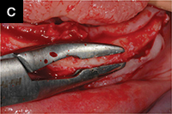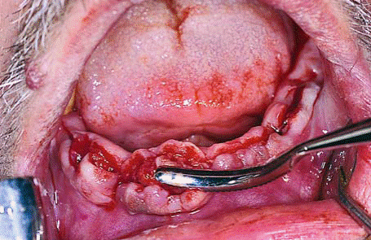

So we open the flap and then we do recontouring either by a bone rongeur (rarely) or by using a bone file then we suture the flap back.
*management of specules is done either by relieving the denture (if multiple specules are present it wouldn’t be a preferable prognosis for the future denture) or by smoothening them.

- Knife edge ridge: more common in the mandible, painful when pressure is applied on it due to thin mucosa on top of the ridge, it appears thin but smooth ridge, it occurs either in a new denture wearer due to bone resorptionbuccally and lingually or in an old denture wearer where it’s called “unemployed ridge” because the load is mainly directed towards the buccal shelves so the centre of the ridge is not being loaded (unemployed).

Management:
Either by relieving the fitting surface of the denture and avoiding surgery, or if discomfort persists with recurrent sores and ulcers surgery “by means of roundation and smoothening” would be indicated.
Same idea as what we did in the feather ridge.

Tori:
Torus Palatinus: is bony exostosis or overgrowth of bone that lies in the centre of the hard palate. It may be single or multiple covered by thin firm mucosa.
Management:
If it’s a small one (doesn’t interfere with the upper denture’s stability) we relieve the denture around it, if it’s large the denture would be rocking around it as it acts as a fulcrum and thus it would interfere with the denture’s stability (not retention) so we go for surgery.
During surgical management of the Torus palatinus we have to be very careful not to injure the Greater palatine nerve.
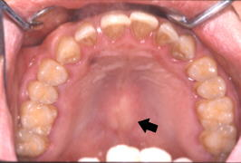
In this case we have a single nodule on the middle part of the palate not close to the vibrating line, either we can relieve the denture or we go for surgery.
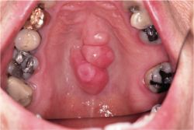
Here it’s a multinodular, very large and needs surgery to be taken out.

*Once it extends to the soft palate, it will interfere with speech (resonance in speech).
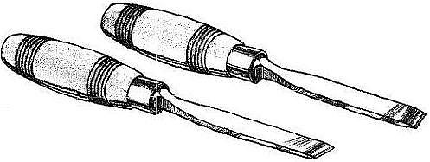
The chisel should be used with the bevel towards the hard palate otherwise you would perforate into the nasal cavity.

This is a picture showing gutta-percha with retainer (clasps), gutta-percha’s soft consistency acts as a cushion, it was used in the old times, and on the gutta-percha we place a tissue conditioner to absorb forces.

Torus Mandibularis:
It’s bony exostosis or overgrowth of bone which is either bilateral (mainly) on both sides of the mandible between the premolars.
Management is by relieving the denture if they are small, if not we’d go for surgery.

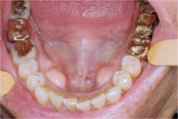
Torus mandibularis can interfere with both retention and stability as well, retention if it extends in the area of the lingual flanges so when we relieve the lingual flanges the retention will be compromised as well as stability.

Prominent mylohyoid ridge
It lies distal to the 7, it’s a structure which cannot be resorbed throughout life, and because of resorption around them they become sharp and it might cause pain and discomfort, most of the time we prefer to relieve it rather than going for surgery, why? Because it’s the area of the Lingual nerve.
Management:
Diagnosis is by palpation with index finger, try to relieve the denture, surgical removal is very rare and dangerous.

Pressure on the mental foramina
Some patients complain of lower lip numbness upon wearing their dentures, clinically you can only see a resorbed ridge, on an OPG you can see that due to advanced resorption the mental foramen’s location became very close to the ridge (it’s more superior in postion) we either 1)relieve the area, or do 2)transposition to the mental nerve itself, or we do an 3)implant overdenture (2 implants in the canine area, and relieve the denture at that area so less pressure is exerted on the nerve).

Management of undercuts

We have to relieve the denture from the areas of undercuts whether buccally or lineally, if the undercuts were large and deep enough then we go for surgical excision which is not recommended in the mandible; we try not to remove any bone from the mandible because by nature it has a higher rate of resorption so we always try to go for other solutions other than bone removal in the mandible.
- If we have two posterior undercuts (right and left) in the maxilla, we surgically remove one and leave the other for mechanical retention.
- If we have one anterior undercut in the pre-maxilla and two posterior undercuts, we surgically remove the posterior undercuts and leave the anterior one (make the path of insertion of the denture according to the ant. Undercut).
- The way we insert the denture in the presence of an undercut; you insert the denture in the undercut and then rotate it to the other side where there is no undercut, this undercut act as a mechanical lock.
- Any large severe undercut that may interfere with the seating of your denture, remove it surgically before starting constructing your denture otherwise you may end up with under-extended flanges from the excessive relieve which will compromise the retention.
- Undercuts occur either buccal or lingual to the alveolar ridge never on the center or top of the ridge.
Skeletal (jaw) discrepancies
Conditions that require major surgical procedure before constructing a denture include skeletal discrepancies; skeletal class II and class III, these require orthognathic surgery.
To confirm the skeletal discrepancy we need:
- X-ray (cephalometric)
- Taking lower and upper impressions, pour them and then mount them on a semi-adjustable articulator (at least semi-adjustable articulator).
Orthognathic surgery is carried out under GA, this surgery is done for young patients (>17-18 years) and at the middle age, we do it when there are skeletal discrepancies and problems in occlusion, we do this surgery after the bone growth has stopped
In elderly patients we never do this surgery (for edentulous patient) so we can make the occlusion as close as possible to class I by manipulating teeth setting; for example, patient with severe class II will have his teeth set with minimum overjet that wouldn’t affect his phonetics and to be esthetically pleasing at the same time.
Orthognathic surgery includes the sandwich technique that is done for the mandible.
Common errors in recording centric relation
- In the case of severely resorbed ridge especially the lower, the base plate might move (unstable or non retentive) that’s why we use acrylic base and adhesives to make it stable while recording the CR, so you have to stabilize the base with your hand and make sure it doesn’t move while recording the CR, reflect the patient’s lip and make sure that the base didn’t move posteriorly.
- Unequal pressure when rims occlude ( the material you place between the rims to record the CR must be evenly softened)
- Posterior contact or heel clash between the retromolar pad and maxillary tuberosity (you have to remove excess acrylic from the retro molar pad to avoid acrylic to acrylic contact posteriorly)
- Difficult patients having TMJ disorder or are slow learners.

**Some notes about the exam
Impression techniques: 1) mucostatic 2)mucocompressive 3) selective
Common faults while making the lower impression:
- Insufficient depth in the posterior pouch due to: lack of material, short flanges, inadequate pressure.
- Edge of the tray shows through the impression due to incorrect positioning of the tray (not in the center), using too small or large stock tray
- Asymmetrical impression due to failure in centralizing the tray
- Borders that are not rounded, not continuous, thick from one side and thin from the other
Done by: Ahmad Shahin and Salma Khayyat

