prosthodontic lecture #16
As we said , in the diagnostic cast >> Zero tilt is preferable in all cases to determine path of insertion and path of displacement BUT sometimes we have some interferences :
- In a case of lingually tilted tooth (the dr showed us a picture of lower cast with lingualy tilted premolar {at zero tilt} ), so if we try to insert the RPD (lingual bar )>> The lingual bar in this case will hit the most bulbous part of the undercut , the RPD will not seated or will be seated but traumatizing the patient

What we can do??
to solve this problem we have two options either:
1-we change the tilt ,we changed it to lateral tilt (from left to right) to minimized undercut
or
2- Prepared abutment >>(we need to do endo treatment and prepared prosthetic crown for this tooth (Here the problem is treated but the cost will increased!!)

Purposes of dental surveying in general in dentistry:
Surveying the diagnostic cast.1
Contouring wax pattern (fixed prosthesis in cr and br ).2
Surveying ceramic veneer crown.3
Placement of internal attachment.4
Placement of internal rest seat.5
Machining cast restoration.6
7.Surveying the master cast .

{{1&7 elli b3nena bl partial denture}}

Surveying the master cast:
Once we set our treatment plane ….. and we took master impression we need to survey for the final design …..
a. We survey to select the most suitable path of insertion and we do it after we prepare the patient mouth. These preparations are made in our design to satisfy the following.
- To permit measurement of the retentive area(undercut) and by knowing the flexibility of our clasp we can locate the area that will engage the clasp(terminal third)……

b-. to locate the unwanted undercut area which will be crossed by the rigid part of the denture (major connector ) during placement and removal.
c. to trim and block out the material part parallel to the path of insertion before duplication (by wax trimmer)

- Surveying procedure :
This procedure dividing into the following :
- Preliminary or visual assessment of the study cast ( eyeballing)
- Initial surveying (on master or diagnostic cast)
- Analysis and final surveying

1) Preliminary visual assessment of the study cast :
-This stage called also eyeballing
- The cast is held in the hand and inspected from above (occlusally)
-it can give you a clue wither to tilt the cast or not.( give u more than 30-40% about undercut).
-your eyes act as analyzing rod.

-The general form and arrangement of the teeth and ridge can be observed, any obvious problems noted and an idea obtained to whether or not tilted survey should be employed (as we said before in a case of lingually tilted tooth we can tilted laterally to minimize the undercut….)
2) Initial Surveying :
in cast itserf by using a marker
The occlusal plane should be parallel to the horizontal plane or the floor (zero tilt) then we use analyzing rod then teeth and the soft tissue are surveyed.

3) Analysis
Partial denture is normally designed on the zero tilt with the path of placement equals the path of displacement .
We prefer that path of insertion coincides with path of displacemebt ,However tilting sometimes is necessary. Once tilting is indicated we change the graphite marker(with another color) and survey the cast on the new tilt. We end up with two survey lines one for zero tilt and one for the tilt we wanted. This new tilt was made to avoid or eliminate the undercut among other reasons.

Reasons for choosing another tit :
- To achieve Better appearance.
- To obtain retention from guiding surfaces.
- To avoid any anatomical interference or obstruction.
- To preserve tooth structure.
1- Appearance :
-When a maxillary cast containing anterior saddle area and we survey it on zero tilt we most probably end up with a huge undercut
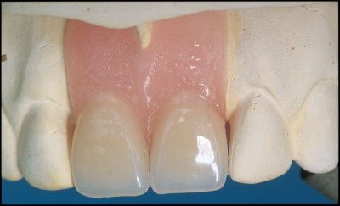
in both soft Tissues and the tooth.
So when a denture is constructed with
this path of insertion we end up with unpleasant
gaps (black triangles) and give the patient
ugly appearance ( as u see in the figure)

in this case the zero tilt is improperly and gives ugly appearance so we have to change it :
-to eliminate this unpleasant space we give the cast posterior-anterior tilt (heels down) to eliminate the undercut
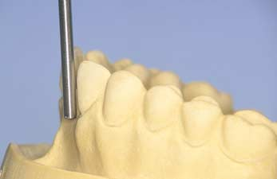

- the analyzing rod is parallel and in intimate
contact with the mesial surface of the tooth

This path of insertion (posterior tilt) allows the saddle to contact the whole mesial surface and the previous gaps are filled and flanges extended to full depth
So by this tilt we will improve the appearance of the denture.
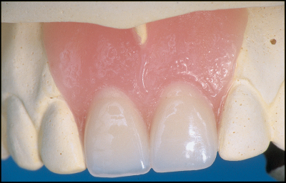

2- Interfarance :
** we can give lingually tilted tooth a lateral tilt…
** in class IV (Undercut mainly labial in ridge) and sectional denture .
- If we ignore this undercut and construct the denture on zero tilt the denture will traumatize he ridge every time he place or remove .
- or we can shortening the flange ( under extended flange) but this will gives ugly appearance
- Ideally we should engage the undercut then we should rotate the denture backward to seat it posteriorly.

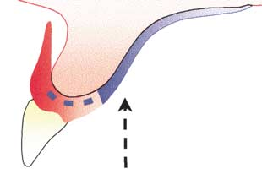
-If the cast is given a posterior tilt so that the rod, and thus the path of insertion, is parallel to the labial surface of the ridge it is possible to insert a flange th that fits the ridge accurately.
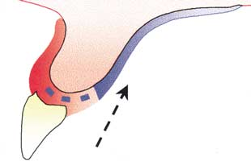

3.Retention:
When we talk about retention in rpd we means clasps.
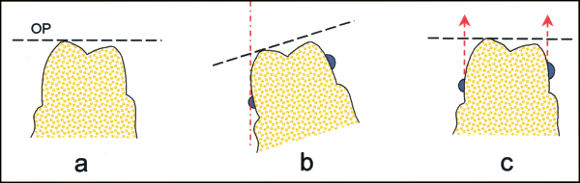
To obtain retention undercut must be present the tooth relative to the horizontal survey line.
Misconceptions believe that changing the tilt would create an undercut !!. this misconception may lead to create a false undercut that is not retentive at all.
- No undercuts on the tooth when the occlusal plane (OP) is horizontal.
- An apparent undercut created by tilting the cast laterally.
- Clasp arms placed in this false undercut do not provide any resistance to movement along the path of displacement
- If we surveying tooth that doesn't contain bulging or undercut >> the clasp will not retentive,
In a such case (when there is no undercut) we can created one by composite build up or by prosthetic crown ( more costly ).
-The principle of tilting the cast to enhance retention is that by altering the path of insertion
As u see in this figure ( rotational path of insertion) we can utilize the tooth for mechanical undercut to enhance the retention from using a clasp.
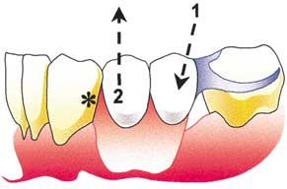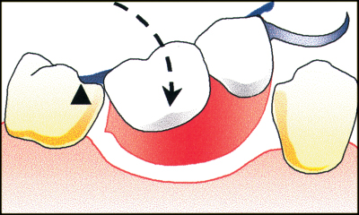

- a rigid part of the denture can enter an area of the tooth surface or an area of the ridge which is undercut relative to the path of displacement .

Final surveying :
-If it is decided that the cast should be tilted,
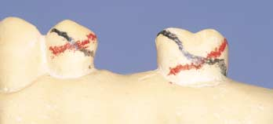
the analyzing rod is exchanged for a marker
different in colour from that used in the first
survey, and the final survey is carried out. It
will then usually be found that the teeth to
be clasped have two separate survey lines
which cross each other. In order to obtain
optimum retention it is necessary to understand how to
position the clasps correctly in relation to the two survey lines .

- Each tooth will have two survey lines crossing each other in order to obtain maximum retention.
- Most deepest part of the undercuts is between the two lines ??
- The terminal one third of the clasp should be placed between the two survey line

- -When guide surfaces are used to provide resistance to displacement of the denture in an occlusal direction, the retentive portion of the clasp needs only to resist movement along the path of withdrawal and therefore can be positioned solely with reference to the red survey line.
- Here We prefer undercut 7nayen , if we engage it too deep, it will act as extractive forces which wil traumatizing to the patient !!
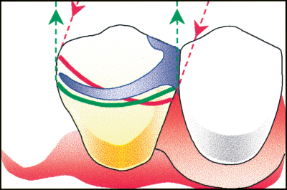

the clasp engages too deep an undercut relative to the path of displacement. Movement of the denture in an occlusal direction is prevented by contact with the guide surface, therefore permanent deformation of the clasp will not occur.
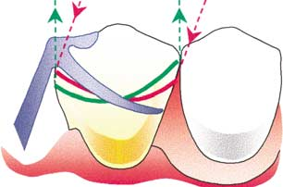

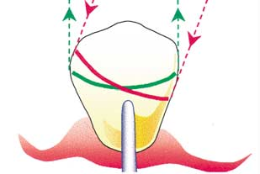
-A gingivally approaching clasp ( I-bar)

----------------------------------------------------------------------
Clasp assembly :
Is composed of body, shoulder, retentive arm …etc
The dr said that body is connect the shoulder with clasp terminal !!!!
but I found in the internet that :
Body is the part of clasp that connect shoulder with the rest
Shoulder is the part that connect body to the clasp terminal

Summary of the clinical objectives of surveying:

Surveying is undertaken to obtain information that will allow decisions to be made concerning the following:

(1)The optimum path of insertion of the denture. The choice of a path of insertion will be influenced by:

- the need to use guiding surfaces to achieve a pleasing appearance.
- the need to avoid interference by the teeth or ridges with correct positioning of denture components.
- the need to use guide surfaces for retention.

(2) The design, material and position of clasps.

Decisions on these aspects of clasps can be arrived at from measurement of the horizontal extent of undercut on abutment teeth and the identification of sites on the teeth to provide reciprocation either from guiding surfaces or from cross-arch reciprocation
--------------------------------------------------------

The dr said :references are :

-Textbook of Mccracken's- RPD and

- Davenport book .

Best wishes.
Haneen kamal allaithi.

