Prosthodontics ..
Date:23/2/2014
Dr.Salah
Surveying
- Dental-surveyor: a mechanical device used to determine the parallelism of teeth surfaces, undercuts in relation to the common path of insertion and removal
When we use a carbon marker, it will draw a line in the most bulbus part of the tooth.
You can use surveying to determine undercut in the soft or hard tissue
History of dental surveying:
- Many types of surveyors are manufactured . The most popular ones are made by the J.M.Ney company in 1923 followed by the J.F.Jelenko and Williams .
- Note that The differences between Ney and Jelenko are:
a. The spring-mounted paralleling tools
b. The swivel at top of vertical arm.
c. Undercut gauge with just one shank caring the 3 measures.
d. Carbon marker without sheath.
- You have to know that it's the dentist's responsibility to do surveying not the technician's because the dentist is the one who looks inside the patient mouth not the technician so ideally it is the dentist’s job not the technician,s

Both acrylic and metallic partial denture should be survey before construction
The different between acrylic and metallic partial denture is the type of material and the rest preperation.
- There are two types of surveyors : Mechanical and electronic .
- A mechanical surveyor consists of three major parts : the surveyor , a cast holder and various surveying tools . :
consists of a The surveyor -
1. Base
2. Vertical arm
3. Horizontal arm (it has a joint )
4. Mandrel hole
5. Table(fixed, portable, magnetic)
-surveying tools.:
1) An Analyzing rod is a parallel sided rod . It is used to analyze the relative parallelism of two or more surfaces of a cast and to identify undercut area. In the soft and hard tissue(no marking on the cast). .
2) Undercut gauges are parallel sided rod with lips or heads of specific sizes . They are used to measure the depth(Horizontal) of the undercut .
Note: undercut gauges: .when 25mm we use(co-cr material) ,5 mm (wrought wire),75mm(type 4 gold,very flexible)

3) A carbon marker (graohite marker)is a parallel sided carbon rod used to mark the survey line on a cast or a crown on a cast . ( The bevel should be toward the edentulous area, in order not to introduce a false or high undercut ).
You should start . on the gingival margin and move all around the teeth in both direction left right mesially and lingually ,when you surveying the alveolar ridge you put the tip of the marker to the deepest part of the sulcus
4) Wax-carving knives are sharp-edged tools used to contour wax pattern .
5) The protective sheath is a metal sheath used with the carbon marker to protect it from fracture when its secured in the chuck .
6) Blockout tools are rod with sides having a specific degree of tapper . They are used to make a specific degree of blockout of undercuts when blocking out and relieving the cast for denture construction .
- So by drawing the survey line the relative height of contour or greatest circumference of each tooth is determined . All of the area below the height of contour is undercut , and this
is the area in which a clasp tip must lie in order to provide retention for RPD . Other undercut areas are undesirable and must be eliminated before a partial denture is made , either by mouth preparation or by blocking out these undercuts on the master cast prior to duplication .
- Note: that the undercut gauges worked by a spring action , you located it near the edentulous area at the gingival margin of the tooth to be surveyed then you leave it , now the lip of the gauge will catch the most bulbous area of the tooth ( Height of contour ) and the flange of the gauge is touching the tooth and this is the correct position of the undercut gauges .
You should know that the true undercut is created by it self (present on the teeth)but the fulse under cut we creat it by tilting
lThere are two types of surveying : initial on diagnostic cast(primary) to put treartment plan and final surveying on the master cast.
- The purposes of Diagnostic cast are :
1) Surveying 2) Treatment plan and patient learning 3) communication between the dentist and his technician
4) to produce a special tray 5) as a reference during mouth preparation .
. note:the most impression material we use to produce diagnostic cast is alginate but the most ideal one is silicon
Note:the only part of the rpd that should engage the undercut (below the surveying line )is the last flexible one third of the clasp to provide retention ,any other parts are rigid and should not engage the undercut because it will act as extraction forces.
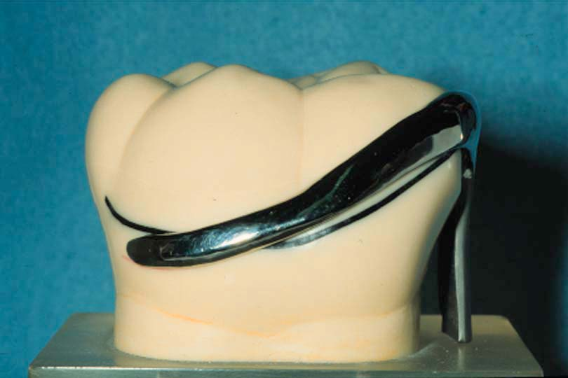
- Before we go in surveying procedure details , we have to know three basic concepts in RPD : Guiding surfaces , path of insertion and path of displacement .
1) Guiding surfaces : (guiding planes)
* Two or more parallel axial surfaces on abutment teeth which can be used to limit the path of insertion and improve the stability of a removable prosthesis. Guide surfaces may occur naturally on teeth but more commonly need to be prepared ,either in the middle one third or in all the proximal surface.
2) Path of insertion : * The path followed by the denture from its first contact with the teeth until it is fully seated.
* This path coincides with the path of withdrawal and may or may not coincide with the path of displacement. There may be a single path or multiple paths of insertion.
A)* A single path of insertion may be created if sufficient guide surfaces are contacted by the denture and the guiding planes are parallel to each other ; it is most likely to exist when bounded edentulous areas are present.
In this path mainly the abutment teeth will be upright and the path of insertion will be straight.
B)* Multiple paths of insertion will exist where guide surfaces are not utilized, for example where the abutment teeth are divergent .
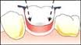

* Multiple paths will also exist where point contacts between the saddle of the denture and the abutment teeth are employed in the ‘open’ design of saddle.
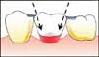
-Here we can do rct for the 2 abutments,make crowns on both in a way we can do a single path of insertion!.

* Two distinct paths of insertion will be employed for a sectional, or two-part denture illustrated here by a diagram in the sagittal plane of a Kennedy Class IV denture. The abutment teeth on either side of the saddle are not shown . (the doc said that this design is rarely to construct).
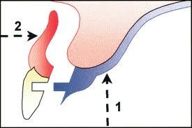
In pre maxilla undercut: one of the solution two part denture we use it where there is an undercut in premaxilla,another solution is to eliminate the undercut by a surgical procedure or by changing the tilt.
a rotational path of insertion can be used
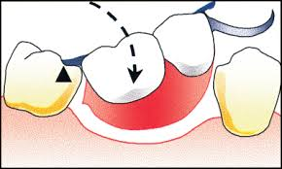
The idea of this design is to utilize the mesial undercut(as the first molar in the picture is drifted and has sever undercut) providing retention, the rest here called long rest it has no clasp.so the design always utilize the mesial undercut and minimize the number of clasps.
c) Path of displacement : * This is the direction in which the denture tends to be displaced in function .
* The path is at right angles to the occlusal plane
* The magnitude of displacement is directly proportional to the stickiness of food .

The doc start talking about tilting of the cast he said that a zero tilt mean that the occlusal surface of the teeth is parallel to the floor , ground or bench you can take any reference and to know the amount of the undercut we put the cast on the surveyor and use the analyzing rod(the doc said that he will talk more about this issue next lecture).

Done by:tawfiek abumariam,:D

.

