Periodontics, lecture 14
Dr.Murad
Patient interview and examination

Before we start, we should remember that we have two broad classifications for periodontal disease:
1) Gingivitis
2) Periodontitis
We have different types of periodontitis: Chronic, Aggressive, periodontitis as a manifestation of systemic disease.
Old classification: like Pre-pubertal …etc. this is not used anymore.

Patient interview:
- Chief complaint:
Usually the patient will be suffering from bleeding, mobility, halitosis, swelling, gingival recession, root sensitivity, color change, pain, tooth migration, diastema.
*Pocketing does NOT cause pain, lots of cases is badly diagnosed as periodontal problem, while it’s mainly a pulpal pain, periodontal abscess, suppuration pain.
*Pathological tooth migration: Distolabial migration of the teeth as a manifestation of periodontal disease, as patients might tell us that suddenly spaces between their teeth appeared.
2) History of chief complaint:
These information direct us into the correct diagnosis.
For example we have 2 scenarios:
1) Bleeding started 2 weeks ago, no swelling, stops after brushing
2) Started 2 weeks ago, generalized swelling, lasts for hours
It’s obvious that the second scenario is more sever, and it is probably a non-plaque induced gingival disease, and it is caused by a systemic disease like leukemia.
That’s why we should listen to the history of chief complaint and use it in our diagnosis carefully.
3) Medical history:
We should be smart during taking these information from the patients, and ask the appropriate questions, and investigate the brief given information more.
Let’s say a patient told us that he had angina before, we should know everything he’s taken as a management for this issue, like medications, ask him if it’s stable or not …etc.
We should know if the patient is under the care of physician, especially of he has a chronic disease, so we would know if it is controlled or not and whether it’s safe to treat him or not.
We should do all of these investigations in order to PREVENT any complication that might happen.
*PREVENTION is always the best management of medical emergency.
*when do we need to give antibiotic as a prophylaxis?
The most important case are:
-A patient with prosthetic heart valve
-A Patient with a previous history of infection.
*Whenever you’ve got something you are worried about or suspicious in the taken medical history, you should always request a medical consult.
4) Social and Family history:
Social history:
-Tobacco use
-Alcohol use
-Recreational drug use
-Pregnancy
*Tobacco History: we should know since when he started smoking, and how much he smokes daily, and if he quit smoking, when he’s done that, and how much he used to smoke.
Smoking has its impact on periodontal health, as it’s considered a risk factor AND secondary etiological factor for periodontitis (NOT gingivitis).
Family history: we usually ask about the siblings and parents, if they have any periodontal issues.
5) Dental History:
A) Previous periodontal treatments. Why?
Because if we had a patient who had a previous periodontal treatment and there is no improvement, this gives us an indication that it is a tough case with poor prognosis, and we should know if he was compliant with recall visits.
Maintenance is very important after a periodontal treatment, because once you’re diagnosed with periodontitis, you’re always susceptible for having it again.
B) Oral hygiene attitudes.

Examination:
-Extra-oral examination: Lymphnodes, muscles of mastication, TMJ …etc.
-Intra-oral examination:
1) Dentition: We check for caries, wear facets, uneven marginal ridges, open contacts, evidence of food impaction (associated with bone loss), crowding, tenderness to percussion, pulp testing, and fremitus.
*Not all of the open contacts have food impaction and associated bone loss.
*Fremitus means a tooth that moves during function.
2) Periodontium
3) Soft tissues: we mainly look for red and white lesions, and ulcers.

-Periodontal examination:
- Visual inspection
- Periodontal probing
- Mobility test
- Plaque and calculus check

1) Visual inspection:
We check for “3 S” Color (Shade), Size, contour (Shape)
Loss or presence of stippling is NOT a definite indication of gingival inflammation, but we can use it.
The Dr showed us a picture for a patient with calculus, inflammation, bleeding…
This is diagnosed as periodontitis even if there is no pocketing, the most important sign is attachment loss.
Classification of gingival recession (Miller Classification):
-Class I: The recession is confined to the facial surface of the tooth, and does not extend to the mucogingival junction, and NO proximal attachment loss.
-Class II: Same as class I, but here the recession extend beyond the mucogingival junction. “NO proximal attachment loss”
-Class III: The recession exceeds the mucogingival margin WITH proximal attachment loss.
-Class IV: same as class III but the proximal attachment loss level is apical to the buccal attachment loss. (This is mainly plaque induced periodontitis).

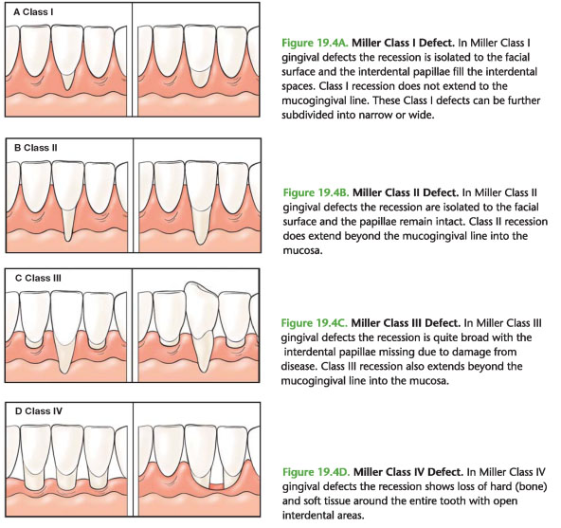
*This classification can give us an indication for the prognosis of root coverage procedure.
*Class I+II we can do soft tissue grafting, and since we have goof bed of blood supply for the graft we will have a very good prognosis.
*Class III+IV we can’t do tissue grafting. VERY poor prognosis.
*P.S: grafting does NOT reduce mobility.
-How can we check for attachment loss proximally?
By probing and radiographs.
2) Periodontal Probing:
First of all, we should know the difference between probing depth and pocket depth.
Probing depth: It is a clinical measure, the probe tip almost always penetrate into the junctional epithelium.
*When there is an inflammation, there will be less resistance to probing “increase in pocket depth”.
*Pocket depth shrinkage happens after the inflammation is removed.
Pocket depth: It is a histological term, it’s the area from the free gingival margin to the most coronal junctional epithelial cell.
- When using the probe we should the mid proximal area (the area under the contact point), because periodontal diseases starts there not at the line angles.
- Some limitations of probing:
- Overhangs restorations.
- Calculus accumulation.
- Your angulation (the probe tip should be parallel to the root).
We should notice pus and blood that comes out during examination.

3) Mobility Test
-Grade 0
-Grade 1
-Grade 2
-Grade 3
The Dr didn’t mention anything about them, but we should know them.
4) Plaque and calculus check
*How can we detect calculus?
Simply by visual inspection or tactile sensation using instruments like probes.
-There is several types of periodontal probes, one of them is Nabers probe that is used to check furcation involvement.
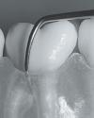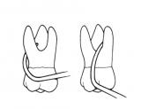

*Never forget that we should examine 6 sites for each tooth, 3 buccally (mid-buccal, disto-buccal, mesio-buccal) and 3 lingually, and that is so important, because gingival disease is site specific.
*Periodontal charting will be explained in the clinics
Good Luck
Majed A. Sharayha

