-Pedo Lec.4
Dr. Suha
Date: 13/3/2014
Dony by: Rakan Khtoum
Behavior management in children - Pharmacological behavior management techniques

Behavior Management
-The majority of pediatric dental patients can be managed in the conventional dental environment.
-This is accomplished by relying on sound behavior management techniques.
-For some patients, additional steps must be taken to control anxiety.
- Sedation
- General anesthesia

Children’s perception of pain
-A child's perception of pain varies widely, particularly with age.
-The response is further determined by the child's coping ability influenced by family values, level of general anxiety, and intelligence.
-Infants up to about 2 years of age are unable to distinguish between pressure and pain.
-After the age of approximately 2 and up to the age of 10, children begin to have some understanding of 'hurt' and begin to distinguish it from pressure or 'a heavy push'.
-It is not always possible to identify which children will respond by being co-operative when challenged with LA and dental treatment.
-There is a strong relationship between the perception of pain experienced and the degree of anxiety perceived by the patient.
-Painful procedures cause fear and anxiety; fear and anxiety intensify pain.
-This circle of cause and effect is central to the management of all patients.
-Good behavior management reduces anxiety, which in turn reduces the perceived intensity of pain, which further reduces the experience of anxiety.

Pharmacological behavior management techniques
- Sedation.
- General anesthesia.

General considerations
-The age of the child.
-The degree of surgical trauma involved.
-The perceived anxiety and how the patient has responded previously.
-The complexity of the operative procedures.
-The medical status of the child.

The age of the child
-The younger the child the greater the likelihood of a need for GA.
-It is unlikely that a 15-year old will need GA for simple orthodontic extractions, although this might be required for more complex surgery, such as exposing and bonding an impacted canine.

The degree of surgical trauma involved
-A single extraction is most likely to be carried out under LA, removal of the four first permanent molars is most likely to be carried out under GA.

Perceived anxiety and how the patient has responded previously
-Excessive anxiety, especially after an attempt at treatment under LA and sedation, would lead to simple treatment such as conservative dentistry being carried out under GA.

The medical status of the child
The degree of intellectual and/or physical impairment in handicapped children would also be a factor to be considered.

Sedation
-A technique in which the use of a drug or drugs produces a state of depression of the central nervous system enabling treatment to be carried out, but during which verbal contact with the patient is maintained throughout the period of sedation.
-The drugs and techniques used to provide conscious sedation for dental treatment should carry a margin of safety wide enough to render unintended loss of consciousness unlikely.
-The level of sedation must be such that the patient remains conscious, retains protective reflexes, and is able to understand and respond to verbal commands.
-Patient assessment includes medical, dental, and anxiety history.
-The use of sedative drugs carries the risk of inadvertent loss of consciousness.
-The clinical facilities need to include suitable resuscitation equipment and emergency drugs.
-Informed consent is mandatory.
-Preoperative and postoperative instructions should be given prior to the sedation visit.
-Appropriate facilities, child-friendly environment and sedation trained staff are essential.
-The operator-sedationist, irrespective of gender, must be chaperoned at all times.
-The child must be accompanied by an adult escort.
-To practice sedation, the clinician must have training in sedative techniques and be assisted by a suitably trained dental nurse.

Aims of sedation
-To enable the provision of quality dental care.
-To manage disruptive behavior.
-To promote a positive psychological response to dental treatment.
-To return the patient quickly to a physiologic state in which safe discharge is possible.

Advantages
-Avoidance of general anesthesia.
-Improvement in operating conditions.
-Rehabilitation of dentally anxious children and adolescents.

Disadvantages
-Unpredictable outcome in some techniques.
-Need for supervised recovery.
-Close supervision at home for the remainder of the day of the operation.
ASA Classifications
ASA I - Healthy patient, no medical problems (ASA = American Society of Anesthesiologists)
ASA II - Mild systemic disease, e.g. mild diabetes/ not disabling.
ASA III - Severe systemic disease, e.g. severe pulmonary insufficiency/ disabling.
ASA IV - Severe systemic disease that is a constant threat to life, e.g. signs of cardiac insufficiency.
ASA V – Moribund patient, little chance of survival without operative intervention.

Complications
-The main complications are:
hypoxia, nausea, vomiting, inadvertent loss of consciousness (GA/over sedation).
-Morbidity and mortality increase with:
young age, worsening ASA classification.

Monitoring The Sedated Child
-Sedative drugs are also CNS and respiratory depressants and as such, cause a variety of effects from mild sedation, deep sedation, and GA and, in excessive concentrations, even death.

Clinical status of a sedated patient
- The patient’s eyes are open.
- The patient is able to respond verbally to questions.
- The patient is able to independently maintain an open mouth.
- Monitoring The Sedated Child
- The patient is able to independently maintain a patent airway.
- The ability to swallow.
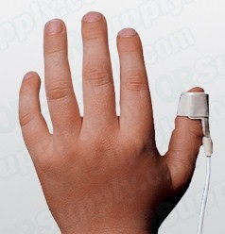
- The child is a normal, pink color.
Pulse Oximetry
-A non-invasive method of measuring arterial oxygen saturation using a sensor probe placed on the patient's finger or ear lobe.
-The probe has a red light source to detect the relative difference in the absorption of light between saturated and desaturated hemoglobin during arterial pulsation.
-A child's normal oxygen saturation (SaO2) is 97% to 100%.
-Adequate oxygenation of the tissues occurs above 95% while oxygen saturations lower than this are considered hypoxemic.

Routes of administration
-The routes of administration of sedative drugs used in clinical pediatric dentistry are:
- Oral,
- Intravenous,
- Inhalational,
- Transmucosal (e.g. nasal, rectal, sublingual).

Oral sedation
-Advantages
- Convenience.
- Economy
- Lack of toxicity.
-Disadvantages
- Variability of effect.
- Onset time.
- Oral sedation

- Diazepam
- Midazolam
- Chloral hydrate

Clinical Technique
-On arrival of the patient check whether, preoperative instructions have been followed.
-Weigh the patient and estimate the dose of diazepam.
-Have the dosage checked by a second person.
-Administer diazepam ~1 h before the treatment.
-Allow the patient to sit in a 'quiet' room.
-Once ready, start and complete the treatment with (or without) LA.
-Once the treatment is complete, allow the patient to recover in the quiet room until ready to return home.
-Reiterate the postoperative instructions to escort.
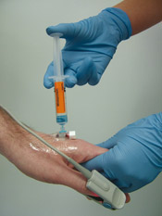
Intravenous sedation
-Limited use in children, although there is a slow but steady trend to extending its use especially in adolescents.
- Midazolam
- Propofol
-Advantages
- Quick onset of action.
- Titration.
- Reversal possible: Flumazenil
-Disadvantages
- The needle.
- Clinical training.

Restraint/Protective Stabilization?
-The restriction of patient’s freedom of movement, with or without the patient’s permission, to decrease risk of injury while allowing safe completion of treatment.
Papoose Board
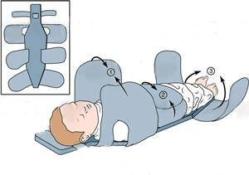

Inhalation sedation / N2O sedation

-Nitrous Oxide is known to the public as ‘laughing gas’.
-N2O is a slightly sweet smelling, colorless inert gas.
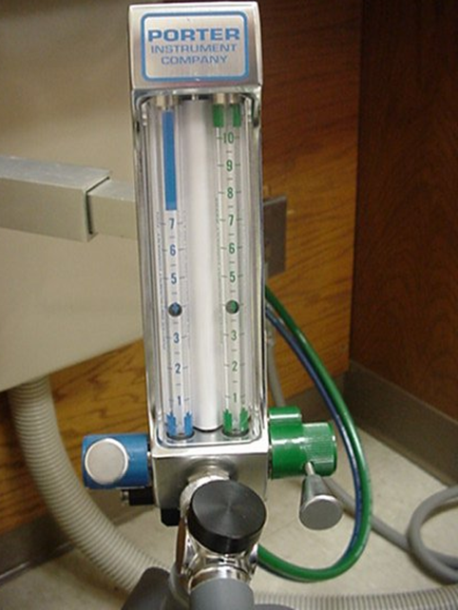
-It is compressed in cylinders as a liquid that vaporizes on release.
-N2O sedation is dentistry’s most basic and widely used form of sedation.
-Nitrous oxide produces analgesic and anxiolytic effects.
-Serious complications seem rare with N2O sedation.
-In over 45 years, there has not been any mortality
or serious morbidity recorded. (Roberts 1990)
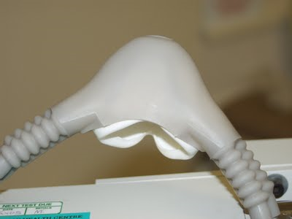
-Inhalation of an oxygen-nitrous oxide gas mixture in
relatively low concentrations, usually 20-50% nitrous oxide.
-The operator is able to titrate the gas against each individual patient.
-In dentistry, nitrous oxide is typically used as an anxiolytic.
-Most often it is administered through a nasal mask.

Objectives of Nitrous Oxide sedation
-Reduce or eliminate anxiety
-Reduce untoward movement and reaction to dental treatment
-Enhance communication and patient cooperation
-Raise the pain reaction threshold
-Increase tolerance for longer appointments
-Aid in the treatment of the mentally/ physically disabled or medically handicapped persons
-Reduce gagging

Clinical technique
-The patient should be started out breathing 100% oxygen and then slowly allowed to breathe increasing amounts of N₂O until the desired effect is achieved.

-It is important that the patient be reminded
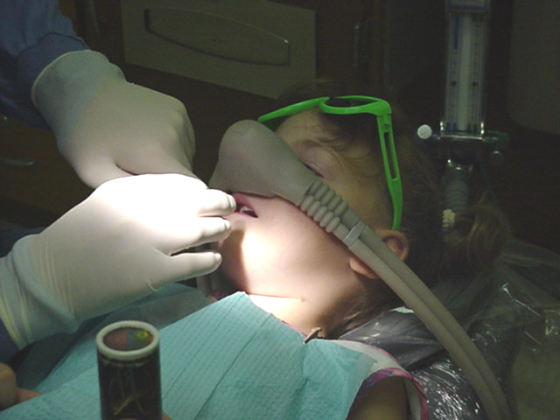
to breathe through the nose in order for the gas to work.
-As the N2O begins to exert its pharmacological effects, the patient is subjected to a steady flow of reassuring and semi-hypnotic suggestion. This maintains rapport with the patient.


-The patient should be questioned as to how they are feeling to ensure an optimal level of nitrous is being administered.
-Therapeutic levels will vary from patient to patient.
-If the nitrous level being administered is too low, the patient will not be receiving an effective anxiolytic dose.
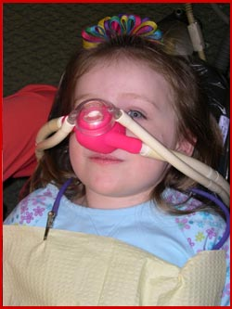
-If the nitrous level is too high, unwanted side effects may occur.

Inhalation sedation / N2O sedation
-To bring about recovery, administer 100% oxygen for 2 minutes.
-The patient should breathe ambient air for a further 5 minutes before leaving the dental chair.
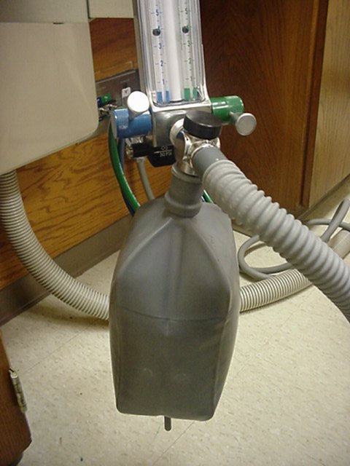

-Safety cut-out devices installed within equipment. It is not possible to administer 100% N2O.
-Advantages
- Rapid onset and recovery time
- Titration.
- Lack of serious side effects.
-Disadvantages of Nitrous Oxide sedation
- Lack of potency
- Dependent largely on psychological reassurance
- Interference of the nasal hood with injection in the anterior maxillary region
- Patient must be able to breathe through the nose
- Nitrous oxide pollution and potential occupational exposure health hazards

General anesthesia
-A controlled state of unconsciousness accompanied by a loss of protective reflexes, including the ability to maintain an airway independently and respond purposefully to physical stimulation and verbal command.
Circumstances and conditions suitable for GA
-Severe pulpitis requiring immediate relief.
-Acute soft tissue swelling requiring removal of the infected tooth/teeth.
-Surgical drainage of an acute infected swelling.
-Single or multiple extractions in a young child unsuitable for conscious sedation.
-Symptomatic teeth in more than one quadrant.
-Moderately traumatic or complex extractions e.g. extraction of broken-down permanent molars.
-Teeth requiring surgical removal or exposure.
-Biopsy of a hard or soft tissue lesion.
-Debridement and suturing of orofacial wounds.
-Examination under GA, for a special needs child where clinical evidence exists that there is a dental problem which warrants treatment under GA.

-Risk of general anesthesia:
- Mortality: ~ 3 per million.
- Morbidity:
- Symptoms associated with the procedure.
- Distress at induction and during recovery.
- Prolonged crying.
- Nausea.
- Postoperative bleeding.
-The potential for disastrous complications is greater than any other technique of pain control.
-Requires the presence of an anesthesiologist in a hospital setting.
-There will always be a need for general anesthesia in dentistry for children.

Dony by: Rakan Khtoum

