Behavior management techniques
-Pedo Lec.3
Dr. Suha
Date: 6/3/2014
Dony by: Rakan Khtoum

Most of this lecture is a repetition for the last lecture we took, and some kind of revision.
Behavior management in children
Definition
Behavior management: The means by which the dental health team effectively and efficiently performs treatment for a child.
The aim is to instill a positive dental attitude.
-To do this the dentist must establish a relationship based on trust with the child and accompanying adult to -ensure active involvement with preventive regimes and treatment.
-The appropriate management technique should be chosen based on the individual child’s requirements.
-Every practitioner integrates his or her personality with basic psychological principles in managing children in the dental environment.
-What works for one practitioner may not necessarily work for another.

Behavior management techniques
-There are a number of non pharmacological techniques that aim to help manage patient behavior.
-The techniques are described individually, but they are often used in combination.

Behavior management techniques
-Preparatory information.
-Non verbal communication.
-Voice control.
-Tell-show-do (TSD)
-Enhancing control
-Behavior shaping and positive reinforcement.
-Modeling.
-Distraction
-Systemic desensitization
-Negative reinforcement (Hand over mouth)

Preparatory information
-Usually in the form of a letter welcoming the patient and family to the practice.
-Such letters will inform the family about what will happen at the visit, give advice about preparing the child and also reduce parental anxiety.
-Wright et al. found that children whose families had received a letter were more cooperative and the mothers found it to be helpful.

Non-verbal communication
-Non-verbal communication is occurring continuously and may reinforce or contradict verbal signals.
-Examples: having a child friendly environment and a happy smiling team.
-Gentle pats, or squeezes on the shoulder minimize stress.
-Sitting and speaking at eye level allows for friendlier and less authoritative communication.
-The 3 “essential communications” imparted to child patients through primarily non-verbal means are:
- 1. “I see you as an individual and will respond to your needs as such”;
- 2. “I am thoroughly knowledgeable and highly skilled”;
- 3. “I am able to help you and will do nothing to hurt you needlessly”. ‘Chambers, 1977’
Voice control
-Young children often respond to the tone of voice rather than the actual words.
-This technique uses a controlled alteration of voice volume, tone or pace to influence and direct a patient’s behavior.
-It aims to improve attention and compliance as well as to establish authority.
-Sudden and firm commands are used to get the child’s attention or to stop the child from whatever is being done.
-May not be acceptable to all parents or clinicians.
-Not appropriate for children too young to understand or with a mental handicap.

Tell-show-do (TSD)
-The tell phase involves an age appropriate explanation of the procedure.
-The show phase is used to demonstrate the procedure.
-The do phase is initiated with minimum delay.
-Widely used in children’s dentistry to familiarize a patient with a new procedure.
-The technique is well accepted by parents.
-Avoid sudden movements.
-Do not ask permission.
Word substitutes for explaining procedures to children
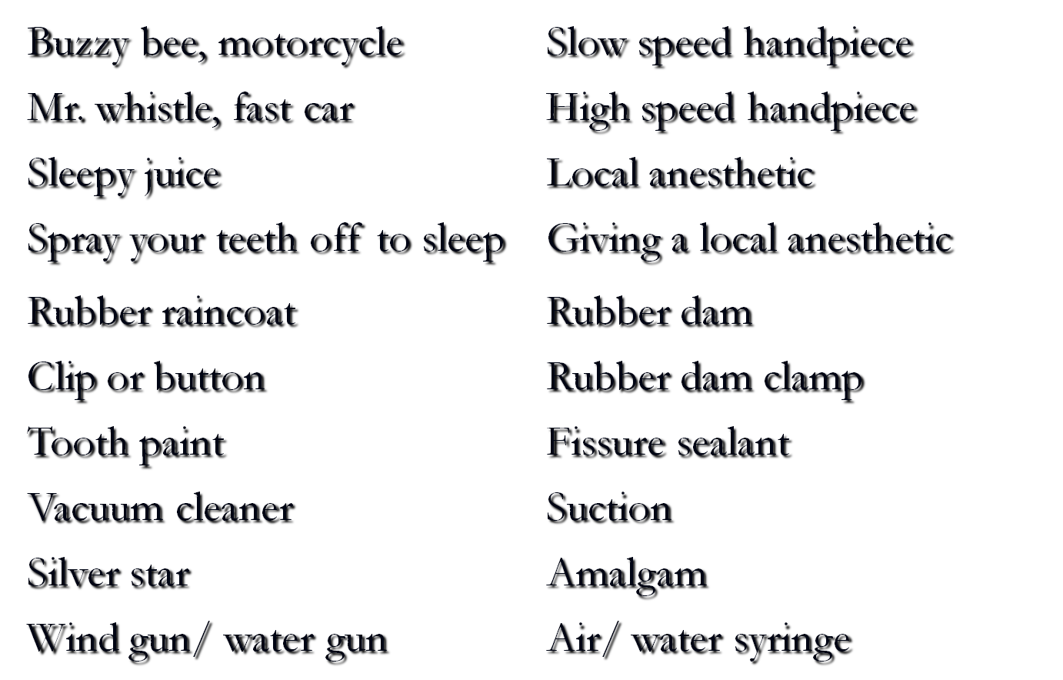
Enhancing control
-Here the patient is given a degree of control over their dentists’ behavior through the use of a stop signal, usually raising an arm.
-Such signals have been shown to reduce pain during routine dental treatment and during injection.
The stop signal should be rehearsed and the dentist should respond quickly when it is used.

Behavior shaping and positive reinforcement
-That procedure which very slowly develops behavior by reinforcing successive approximations to a desired goal.
-Many dental procedures require quite complex behaviors and actions from our patients which need to be explained and learned.
-For children this requires small clear steps.
-This is most easily achieved by selective reinforcement.
-Reinforcement is the strengthening of a pattern of behavior, increasing the probability of that behavior being displayed again in the future.
-Anything that the child finds pleasant can act as a positive reinforcer; stickers or badges are often used at the end of a dental appointment.
-The most powerful reinforcers are social stimuli such as, facial expressions, positive voice modulations, verbal praise, appraisal by hugging.
-Reinforcers work best when applied directly after the appropriate behavior.
-Behavior shaping and positive reinforcement
-Be as specific as possible since specific reinforcement is more effective than a generalized approach.
-In the dental clinic, this means continuous praise from beginning to end, not just a ‘well done’ as they leave you.

Modeling
-The technique is based on the principle that people learn about their environment by observing other’s behavior.
-A model is used, either live or by video to exhibit appropriate behavior in the dental environment.
-For best effects, models should be the same age as the target child, should exhibit appropriate behavior and be praised.
-They should also be seen entering and leaving the clinic.

Distraction
-This approach aims to shift the patient’s attention from the dental setting to some other situation, or from a potentially unpleasant procedure to some other action.
-Cartoons have been shown to reduce disruptive behavior in children when combined with reinforcement, that is when children knew they would be switched off if they did not behave. (Ingersoll et al, 1984)
-Later studies suggest that audio tapes may be even more effective.
-Short term distractors such as pulling the lip as a local anesthetic is given may be helpful.
-The dentist who talks while administering local anesthetic is also using distraction with words.

Systemic desensitization
-This technique helps individuals with specific fears or phobias overcome them by repeated contacts.
-A hierarchy of fear-producing stimuli is constructed, and the patient is exposed to them in an ordered manner starting with the stimulus posing the lowest threat.

Phobia
-A persistent, abnormal, and irrational fear of a specific thing or situation that compels one to avoid it, despite the awareness and reassurance that it is not dangerous.
-A true dental phobic would not be able to even consider the prospect of attending a dental practice.

Systemic desensitization
-Systemic desensitization has two elements, firstly gradual exposure to the fear inducing stimulus and secondly the induction of a state incompatible with anxiety.
-It is based on the assumption that relaxation and anxiety cannot exist at the same time in an individual.
-First the patient is taught how to relax, and in this state exposed to each of the stimuli, only progressing to the next when they feel able.
-The relaxation phase is critical and may take several visits to achieve.
-For true phobias several relaxation sessions with a psychologist or a dentist who has received training in relaxation techniques may be required.
-Dentists may undertake this role but a psychologist is usually preferred.
-The technique is useful for a child who can clearly identify their fear and who can verbally communicate.

Systemic desensitization
- Look at an assembled dental syringe.
- Hold an assembled dental syringe in the palm of the patient’s hand.
- Hold an assembled dental syringe by the patient’s face.
- Hold an assembled dental syringe inside the patient’s mouth.
- Hold an assembled dental syringe (needle guard removed) on the palm of the hand.
- Hold an assembled dental syringe (needle guard removed) by the side of the face.
- Hold an assembled dental syringe (needle guard removed) inside the mouth.
- Replace the guard and hold the end of the syringe against the mucosa overlying the injection site.
- Press the syringe (guard in place) over the injection site.
- Remove the guard and hold the syringe inside the mouth.
- Place the needle in contact with the mucosa over the injection site.
- Place the needle in contact with the mucosa and insert some pressure.
- Hold the needle in contact with the mucosa and insert enough pressure for the needle to penetrate the mucosa.
- As in 13, but deliver a minute amount of local analgesic solution.
- As in 13, but deliver a normal amount of local analgesic solution.

Negative reinforcement
-It is the strengthening of a pattern of behavior by the removal of a stimulus which the individual perceives as unpleasant (a negative reinforcer) as soon as the required behavior is exhibited.
-The stimulus is applied to all actions except the required one, thus reinforcing it by removal of a negative stimulus.
-It should not be confused with punishment, which is the application of an unpleasant stimulus to inappropriate behavior.
Negative reinforcement
(Hand over mouth exercise)
-HOME involves restraining the child in the dental chair, placing a hand over the mouth (to allow the child to hear), the nose must not be covered.
-The dentist then talks quietly to the child explaining that the hand will be removed as soon as crying stops.
-As soon as this happens, the hand is removed and the child praised.
-If protests start again, the hand is replaced.
-The technique aims to gain the child’s attention and enable communication, reinforce good behavior and establish that avoidance is futile.
-Those that advocate the technique recommend it for children 4-9 years of age when communication is lost or during temper tantrums.
-Parental consent is important and the technique should never be used on children too young to understand or with mental or emotional handicap.
-The technique is the most controversial of all behavior management techniques used by dentists.
-There have been no studies of the effectiveness of HOME.

Negative reinforcement
(Selective exclusion of the parent)
-Less controversial but uses similar principles.
-Indications are the same as for HOME
-Parental consent is required.
-When inappropriate behavior is exhibited, the parent is asked to leave.
-Ideally, the parent should be able to hear, but be out of sight of the child.
-When appropriate behavior is exhibited, the parent is asked to return, thus reinforcing that behavior.
RELATIONSHIPS
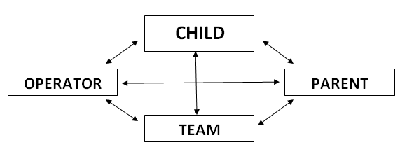
Protective stabilization
-The restriction of patient’s freedom of movement, with or without the patient’s permission, to decrease risk of injury while allowing safe completion of treatment.
-The restriction may involve another human(s), a patient stabilization device, or a combination thereof.
-The use of protective stabilization has the potential to produce serious consequences, such as:
- physical or psychological harm
- loss of dignity
- violation of a patient’s rights.

Dentist Behavior
-The communicative behavior of dentists is a major factor in patient satisfaction. (Gale et al, 1984)
-Dentist behaviors reported to correlate with low parent satisfaction include:
- rushing through appointments, not taking time to explain procedures,
- barring parents from the examination room,
- generally being impatient (Reichard et al, 2001)
-Relationship/communication problems have been demonstrated to play a prominent role in initiating malpractice actions.
-Even where no error occurred, perceived lack of caring and/or collaboration were associated with litigation. (Lester 1993)

Done By: Rakan Khtoum

