Behavior management in children 1
-Pedo Lec.2
Dr. Suha
Date: 27/2/2014
Dony by: Rakan Khtoum

Definition
Behavior management: The means by which the dental health team effectively and efficiently performs treatment for a child.
- The aim is to instill a positive dental attitude.

Behavior management
-Behavior management methods are about communication and education.
-The relationship between the child, the child’s family and the dental team is a dynamic process.
-It starts before the patient arrives in the surgery and involves dialogue, voice tone, facial expressions, body language and touch.
-The appropriate management technique should be chosen based on the individual child’s requirements.
-Every practitioner integrates his or her personality with basic psychological principles in managing children in the dental environment.
-What works for one practitioner may not necessarily work for another.

Children and anxiety
-Pre-existing anxiety is the best predictor of poor intra-operative pain control.
-Raised anxiety lowers the pain threshold.
-Dentally anxious children are more sensitive to dental pain.
Definition of anxiety
-Anxiety: A vague, unpleasant feeling, accompanied by a premonition that something undesirable is about to happen.
-Anxiety vs. Fear
-Fear is a dread of something specific in the external environment and anxiety is a more general, non-specific feeling of apprehension.

Anxiety
-In a study by Agras et al, visiting the dentist ranked fourth behind snakes, heights and storms as an anxiety producing situation.
-The most anxiety provoking procedure at the dentist has been reported to be the local anesthetic. (Humphris et al, 1995)

Anxiety
Anxiety manifests itself in:
- Physiological and somatic sensations.
Perspiration, palpitation, breathlessness.
- Cognitive features.
Interference of concentration, imagining the worst that can happen.
- Behavior.
Avoidance; postponing a dental appointment.

How do you measure anxiety?
-Physiological measures: polygraphic recording of heart rate, hand and face temperature.
-Self-report measures: interviews and questionnaires.
- Venham picture test for small children.
- Corah’s dental anxiety scale.
-Behavioral observational scales:
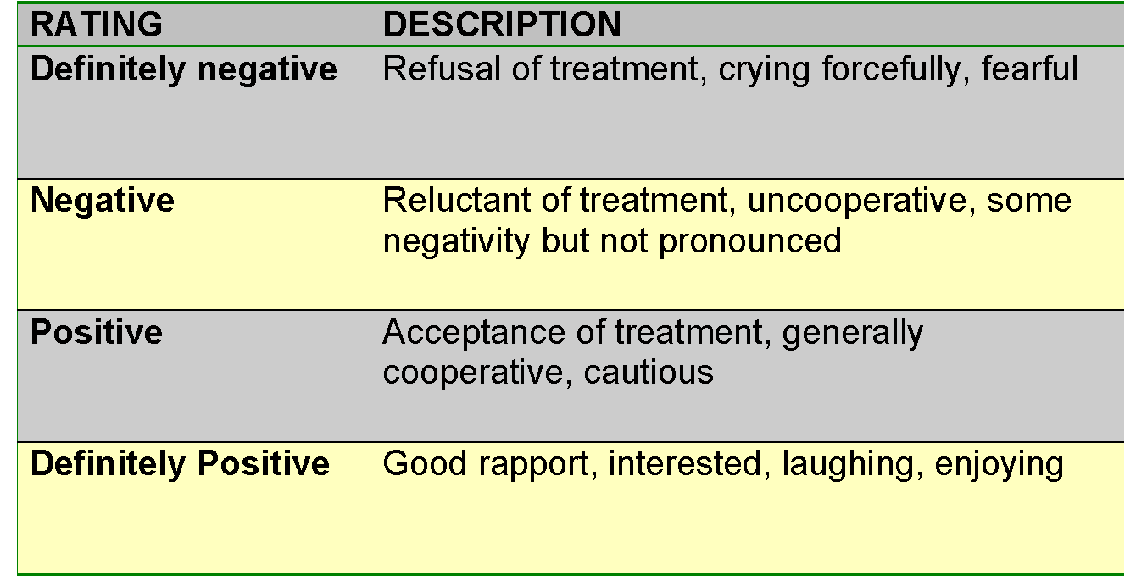
- Frankl behavioral scale.

Frankl Behavior Rating Scale

Classifying behavior
Wright’s clinical classification:
- Cooperative.
- Lacking cooperative ability.
- Potentially cooperative.
Cooperative: get along fine in the dental environment without significant disruption.
Lacking cooperative ability: Because of their young age ‘less than 2 years of age’ or mental level, these children are unable to cooperate and unable to communicate at the proper level.
Potentially cooperative: have cooperative abilities but for some reason, elect not to cooperate.
Your most challenging patients.

Potentially cooperative
-Uncontrolled.
-Defiant.
-Timid.
-Tense-cooperative.
-Whining.

Potentially cooperative behavior
-Uncontrolled.
- 3-6 years of age.
- Tantrum.
- Can result in a dangerous situation.
- Deferral of treatment is to be employed.

-Defiant.
- All ages.
- ‘I don’t want to’ in young children.
- Passive resistance in older children.

-Timid.
- Shielding behavior or hesitating.
- Hide face with hands or hide behind their mothers.
- May deteriorate into uncontrolled.

-Tense-cooperative.
- Older children, more than 7 years of age.
- Trying to be helpful, but are very anxious at the same time. ‘White knucklers.’

-Whining.
- Usually continuous.
- Absence of tears.

Factors influencing child behavior
-Anxiety is a recognized personality trait, but there are some factors which have been found to increase the likelihood of behavior problems at dental appointments.
- Medical History.
- Parental anxiety.
- Awareness of a dental problem.

Medical history
-Children who have had negative experiences associated with medical treatment may be more anxious about dental treatment. (Wright and Alpern, 1973)
-Fear sustained from previous bad dental visits has been related to poor behavior at subsequent visits. (McTigue, 1984)

Parental influence
-Children learn from their parents the basic aspects of everyday life, this process is termed primary socialization and is an ongoing and gradual process.
-Primary socialization can have a profound and lasting effect.
-Fear of dental treatment can often be traced back to family influence.
-Parents can shape a child’s expectations and attitudes about oral health.

Parental anxiety
-The importance of maternal anxiety has been recognized for over 100 years.
-The relationship between maternal anxiety and child behavior is well documented.
-This is particularly important for children less than four years old. (Wright and Alpern, 1973)
-When a parent is unable to contain their own dental anxieties it may increase the child’s own anxiety, in such cases finding an alternate adult who is less fearful may be helpful. (Freeman, 1999)
-Parents are also able to accurately predict the likely behavior of their children. (Johnson and Baldwin, 1969)

Awareness of a dental problem
-Children who know they have a dental problem are more likely to exhibit negative behavior at the first dental appointment. (Wright and Alpern, 1973)

Communication
-Good communication is essential with all patients.
-With children, the communication pathway is more complex than the simple one to one communication that exists with most adult patients.
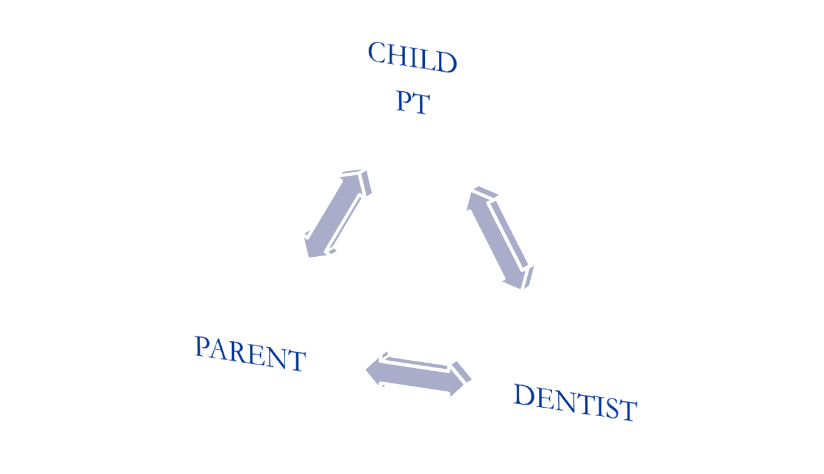

-The child, dentist, parent and dental nurse are all potentially involved
-The child can only concentrate on one individual.
-Each member of the dental team must understand their role and so must the accompanying parent.
-Communication may be impaired when the sender’s expression and body language are not consistent with the intended message.
-When body language conveys uncertainty, anxiety, or urgency, the dentist cannot effectively communicate confidence in his/her clinical skills.
-It is possible to communicate with the child patient briefly at the beginning of a dental appointment to establish rapport and trust.
-However, once a procedure begins, the dentist’s ability to control and shape behavior becomes paramount, and information sharing becomes secondary.
-The 2-way interchange of information gives way to 1-way manipulation of behavior through commands. This type of interaction is called “requests and promises”. ‘Pinkham,1993’

The role of the parent
-Most research suggests that children’s behavior is unaffected by parental presence or absence. (Fenlon et al, 1993)
-An exception exists with children less than 4 years of age who have been shown to behave better with their mothers present. (Frankl, 1973)
-Many parents prefer to be present during treatment, especially if their child is young or at an initial visit.
-The major concern for dentists is the potential of the parent to disrupt treatment by inappropriate communication or by exhibiting anxiety themselves .
-The parent often repeats orders creating an annoyance for both dentist and child patient.
-The parent intercepts orders, becoming a barrier to the development of rapport.
-The dentist may be unable to use voice control.
-The child divides attention between parent and dentist.
-The dentist divides attention between parent and child.
-Dentists are more relaxed and comfortable when the parent remains in the reception area.
-For young children parental presence is important, while for older children parental presence appears not to have such a clear effect on child behavior but may be important to the parent.
- What is essential is that individual practitioners explain their practice policies on parental presence to parents. (Guthrie, 1997)

General considerations of child patient management
-Always call the patient by their first name or nickname.
-Direct the conversation towards the child whenever possible.
-Approach the child in an easy going manner.
-Talk at the child’s level.
-Avoid quick, sudden movements when performing dental procedures.
-Avoid fear promoting words such as, stick, hurt drill, etc.
-Short, concise commands are better in telling patients what to do than questions or suggestions.
-Admire and praise good behavior whenever you can, this enhances repetition.
-The operator must keep his/her own self-control at all times.

General considerations of child patient management
-Scheduling
-Appointment length.
-Dental attire.

General considerations of child patient management
Scheduling
- Many children become restless and tired when faced with long delays in the reception area.
- Morning appointments have been suggested for children.
General considerations of child patient management
- Children are more alert and the dental team is fresher in the morning.
- When age groups are kept together (preschoolers in the morning and older children in the afternoon) the peer group has a positive influence, with children serving as models for each other.

Appointment length
- Children have a short attention span.
- A long visit is traditionally defined as any period in excess of half an hour to 45 minutes.
- The current trend towards quadrant or half-mouth dentistry have altered this view.
- Lenchner studied the behavior of 3 and 5 ½ year olds and found no significant difference in children’s behavior during long dental appointments compared to shorter ones.
- Getz and Weinstein studied videotapes of children 3-5 years of age and found that the longer the restorative phase, the greater the likelihood of stress-fear reaction.
- Current evidence on appointment duration is divided.

Dental attire
- Children who have had previous negative medical experiences may be afraid of strangers in white uniforms.
- Some children who have been exposed to surgical procedures may be frightened by a face mask.
- Many pediatric dentists have taken to wearing colorful clothing.
- Less formal attire will have a beneficial effect on some children.
- It may also aid the staff by contributing towards a more natural and casual attitude.
- Some dentists feel that street clothing might affect their professional image.
- A dentist’s attire remains a personal decision.

Behavior management techniques
-There are a number of non pharmacological techniques that aim to help manage patient behavior.
-The techniques are described individually, but they are often used in combination.

Behavior management techniques
-Preparatory information.
-Non verbal communication.
-Voice control.
-Tell-show-do (TSD)
-Enhancing control
-Behavior shaping and positive reinforcement.
-Modeling.
-Distraction
-Systemic desensitization
-Negative reinforcement (Hand over mouth)

Preparatory information
-Usually in the form of a letter welcoming the patient and family to the practice.
-Such letters will inform the family about what will happen at the visit, give advice about preparing the child and also reduce parental anxiety.
-Wright et al. found that children whose families had received a letter were more cooperative and the mothers found it to be helpful.

Non-verbal communication
-Non-verbal communication is occurring continuously and may reinforce or contradict verbal signals.
-Examples: having a child friendly environment and a happy smiling team.
-Gentle pats, or squeezes on the shoulder minimize stress.
-Sitting and speaking at eye level allows for friendlier and less authoritative communication.
-The 3 “essential communications” imparted to child patients through primarily non-verbal means are:
- 1. “I see you as an individual and will respond to your needs as such”;
- 2. “I am thoroughly knowledgeable and highly skilled”;
- 3. “I am able to help you and will do nothing to hurt you needlessly”. ‘Chambers, 1977’
Voice control
-Young children often respond to the tone of voice rather than the actual words.
-This technique uses a controlled alteration of voice volume, tone or pace to influence and direct a patient’s behavior.
-It aims to improve attention and compliance as well as to establish authority.
-Sudden and firm commands are used to get the child’s attention or to stop the child from whatever is being done.
-May not be acceptable to all parents or clinicians.
-Not appropriate for children too young to understand or with a mental handicap.

Tell-show-do (TSD)
-The tell phase involves an age appropriate explanation of the procedure.
-The show phase is used to demonstrate the procedure.
-The do phase is initiated with minimum delay.
-Widely used in children’s dentistry to familiarize a patient with a new procedure.
-The technique is well accepted by parents.
-Avoid sudden movements.
-Do not ask permission.
Word substitutes for explaining procedures to children
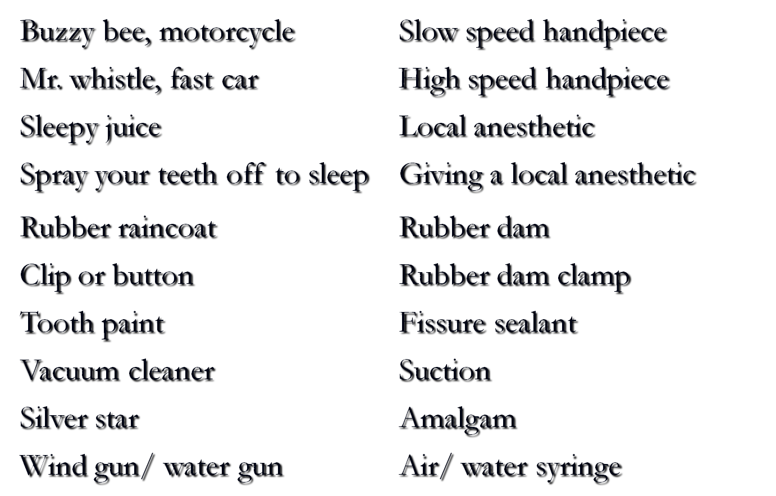
Enhancing control
-Here the patient is given a degree of control over their dentists’ behavior through the use of a stop signal, usually raising an arm.
-Such signals have been shown to reduce pain during routine dental treatment and during injection.
The stop signal should be rehearsed and the dentist should respond quickly when it is used.

Behavior shaping and positive reinforcement
-That procedure which very slowly develops behavior by reinforcing successive approximations to a desired goal.
-Many dental procedures require quite complex behaviors and actions from our patients which need to be explained and learned.
-For children this requires small clear steps.
-This is most easily achieved by selective reinforcement.
-Reinforcement is the strengthening of a pattern of behavior, increasing the probability of that behavior being displayed again in the future.
-Anything that the child finds pleasant can act as a positive reinforcer; stickers or badges are often used at the end of a dental appointment.
-The most powerful reinforcers are social stimuli such as, facial expressions, positive voice modulations, verbal praise, appraisal by hugging.
-Reinforcers work best when applied directly after the appropriate behavior.
-Behavior shaping and positive reinforcement
-Be as specific as possible since specific reinforcement is more effective than a generalized approach.
-In the dental clinic, this means continuous praise from beginning to end, not just a ‘well done’ as they leave you.

Modeling
-The technique is based on the principle that people learn about their environment by observing other’s behavior.
-A model is used, either live or by video to exhibit appropriate behavior in the dental environment.
-For best effects, models should be the same age as the target child, should exhibit appropriate behavior and be praised.
-They should also be seen entering and leaving the clinic.

Distraction
-This approach aims to shift the patient’s attention from the dental setting to some other situation, or from a potentially unpleasant procedure to some other action.
-Cartoons have been shown to reduce disruptive behavior in children when combined with reinforcement, that is when children knew they would be switched off if they did not behave. (Ingersoll et al, 1984)
-Later studies suggest that audio tapes may be even more effective.
-Short term distractors such as pulling the lip as a local anesthetic is given may be helpful.
-The dentist who talks while administering local anesthetic is also using distraction with words.

Systemic desensitization
-This technique helps individuals with specific fears or phobias overcome them by repeated contacts.
-A hierarchy of fear-producing stimuli is constructed, and the patient is exposed to them in an ordered manner starting with the stimulus posing the lowest threat.

Phobia
-A persistent, abnormal, and irrational fear of a specific thing or situation that compels one to avoid it, despite the awareness and reassurance that it is not dangerous.
-A true dental phobic would not be able to even consider the prospect of attending a dental practice.

Systemic desensitization
-Systemic desensitization has two elements, firstly gradual exposure to the fear inducing stimulus and secondly the induction of a state incompatible with anxiety.
-It is based on the assumption that relaxation and anxiety cannot exist at the same time in an individual.
-First the patient is taught how to relax, and in this state exposed to each of the stimuli, only progressing to the next when they feel able.
-The relaxation phase is critical and may take several visits to achieve.
-For true phobias several relaxation sessions with a psychologist or a dentist who has received training in relaxation techniques may be required.
-Dentists may undertake this role but a psychologist is usually preferred.
-The technique is useful for a child who can clearly identify their fear and who can verbally communicate.

Systemic desensitization
- Look at an assembled dental syringe.
- Hold an assembled dental syringe in the palm of the patient’s hand.
- Hold an assembled dental syringe by the patient’s face.
- Hold an assembled dental syringe inside the patient’s mouth.
- Hold an assembled dental syringe (needle guard removed) on the palm of the hand.
- Hold an assembled dental syringe (needle guard removed) by the side of the face.
- Hold an assembled dental syringe (needle guard removed) inside the mouth.
- Replace the guard and hold the end of the syringe against the mucosa overlying the injection site.
- Press the syringe (guard in place) over the injection site.
- Remove the guard and hold the syringe inside the mouth.
- Place the needle in contact with the mucosa over the injection site.
- Place the needle in contact with the mucosa and insert some pressure.
- Hold the needle in contact with the mucosa and insert enough pressure for the needle to penetrate the mucosa.
- As in 13, but deliver a minute amount of local analgesic solution.
- As in 13, but deliver a normal amount of local analgesic solution.

Negative reinforcement
-It is the strengthening of a pattern of behavior by the removal of a stimulus which the individual perceives as unpleasant (a negative reinforcer) as soon as the required behavior is exhibited.
-The stimulus is applied to all actions except the required one, thus reinforcing it by removal of a negative stimulus.
-It should not be confused with punishment, which is the application of an unpleasant stimulus to inappropriate behavior.
Negative reinforcement
(Hand over mouth exercise)
-HOME involves restraining the child in the dental chair, placing a hand over the mouth (to allow the child to hear), the nose must not be covered.
-The dentist then talks quietly to the child explaining that the hand will be removed as soon as crying stops.
-As soon as this happens, the hand is removed and the child praised.
-If protests start again, the hand is replaced.
-The technique aims to gain the child’s attention and enable communication, reinforce good behavior and establish that avoidance is futile.
-Those that advocate the technique recommend it for children 4-9 years of age when communication is lost or during temper tantrums.
-Parental consent is important and the technique should never be used on children too young to understand or with mental or emotional handicap.
-The technique is the most controversial of all behavior management techniques used by dentists.
-There have been no studies of the effectiveness of HOME.

Negative reinforcement
(Selective exclusion of the parent)
-Less controversial but uses similar principles.
-Indications are the same as for HOME
-Parental consent is required.
-When inappropriate behavior is exhibited, the parent is asked to leave.
-Ideally, the parent should be able to hear, but be out of sight of the child.
-When appropriate behavior is exhibited, the parent is asked to return, thus reinforcing that behavior.
RELATIONSHIPS
CHILD

Done By: Rakan Khtoum
TEAM
PARENT
OPERATOR

