Pediatric Dentistry Introduction
-Pedo Lec.1
Dr. Suha
Date: 20/2/2014
Dony by: Rakan Khtoum
&
Examination and treatment planning

Reference Book
Paediatric Dentistry
- Richard R. Welbury, 4th edition 2012 (3rd edition 2006 is fine)
Lecture Outline
Definition of Pediatric Dentistry.
Aims of Pediatric Dentistry.
Scope of Pediatric Dentistry.
Functions of primary teeth.
Examination and treatment planning
What is Pediatric Dentistry?
Defining factor is AGE
Is an age-defined specialty that provides both primary and comprehensive preventive and therapeutic oral health care for infants and children through adolescence, including those with special health care needs.*
*this definition is from American academy of pediatric dentistry
What are the key elements of this definition?
-"age-defined": most specialties are procedure defined (endodontics, periodontics, etc.). Pediatric dentists provide care for their specific age group of patients.
There is no limitation to what type of treatment they provide.
-"primary and comprehensive...care": Pediatric dentists are primary providers. There is no need for a referral of patients.
Parents can choose to have their children evaluated and treated by a pediatric dentist just like they can choose to have their child treated by a pediatrician.
-"infants and children through adolescence": Pediatric dentists see patients at any age from birth up to their late teens
-"special health care needs": Pediatric dentists have the training and experience to evaluate and treat patients, that are medically compromised.
Aims of Pediatric Dentistry
The child reaches adulthood in a state of good dental health.
The child develops positive attitudes to dental care & good oral hygiene.
-Interesting statistic
According to the 2004 figures from the Department of Statistics; 37.1% of the Jordanian population is under 15 years of age (a young community).
Scope of pediatric dentistry
Health of the child as a whole.
Oral Health: Prevention.
Restoration of the mouth to good health
Observation and control of the developing dentition (ortho point of view).
Behavior management.
Dental emergencies.

Health of the child as a whole
-Interest in the child’s physical condition.
- Watching for early signs of disease.
- Studying growth and development of the individual as a whole.
- If necessary, refer the patient for advice and treatment.
- Oral health plays an important role in the overall health of children.
-Observe the child’s mental and psychological development.

Oral Health: Prevention
-Prenatal counseling.
- Advice on good oral health practices and proper nutrition can be started early.

-First dental visit around the child’s first birthday.
- Reinforcement of advice and examination of the child.
-Knowledge of nutrition as well as systemic and topical fluorides.
-Proper advice on oral home care.

Restoration of the mouth to good health
-Convince the parent and child of the importance of dental treatment.
-Work of high technical standards.
-Good work and quality should ideally be enjoyable to the patient.
-Early diagnosis leading to the simplest treatment is required.

Restorative Dentistry for children
-Early diagnosis using good exam techniques.
-Encourage regular attendance.
-Use local anesthetic whenever necessary.
-Employ modern cutting equipment.

Observation and control of the developing dentition
-Assess the dentition from an orthodontic point of view.
-Be alert to the timing and sequence of tooth eruption.
-Patients diagnosed early can be referred at the correct time.
-Aim to preserve deciduous teeth whenever possible.
-Consider the use of space maintainers when indicated.
-Be alert to oral habits such as digit sucking.

Behavior management
-The child has to be managed differently than the adult.
-The very young, pre-teens, and teenagers all need different approaches in dealing with their behavior.

Dental emergencies
-The main consideration should be the good of the child as a whole.
-In emergencies, think of the child instead of perfection (so deal with the emergency).

Dental Home
a new concept
-A dental home is: the ongoing relationship between the dentist and the patient, inclusive of all aspects of oral health care delivered in a comprehensive, continuously accessible, coordinated, and family centered-way.
-Establishment of a dental home begins no later than 12 months of age and includes referral to dental specialists when appropriate.
-Savage et al examined a cohort of 9200 patients 2004) :
- seeing children earlier for oral health examinations and preventive services saves money.
- children who had an early preventive dental visit were more likely to use subsequent preventive services and experience lower dentally related costs.
-By establishing a Dental Home and taking preventive steps recommended by the pediatric dentist, parents can avoid their children contracting early childhood caries.
-Early Childhood Caries is extensive, devastating tooth decay that results in pain, failure to thrive, and in many cases, extensive and costly restorative work.

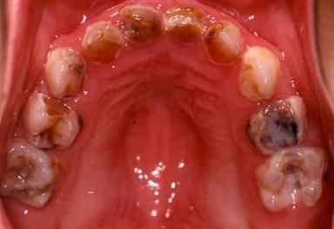

Functions of primary teeth
Digestion and assimilation of food.
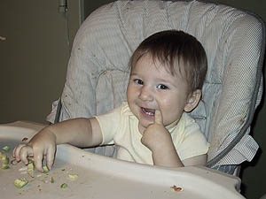

Maintenance of space in the dental arches for the permanent teeth
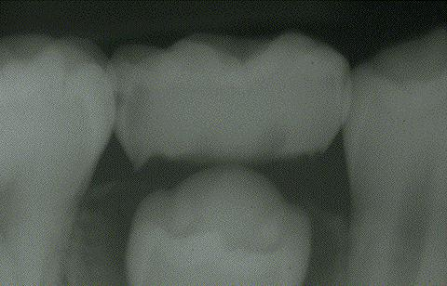

Stimulation of growth of the jaws.
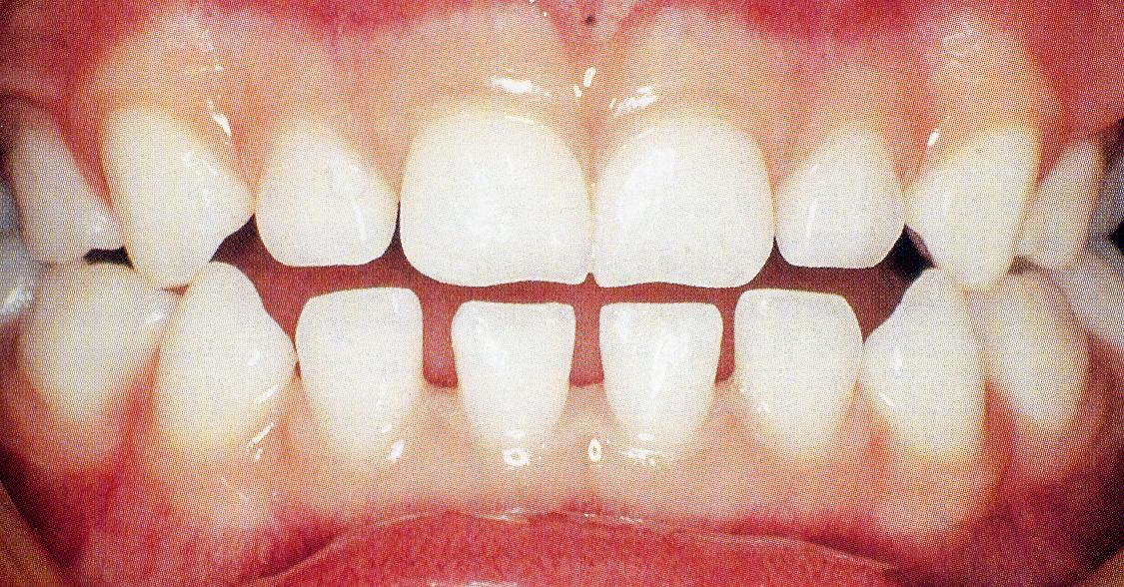

Development of speech.


Maintenance and improvement of appearance.
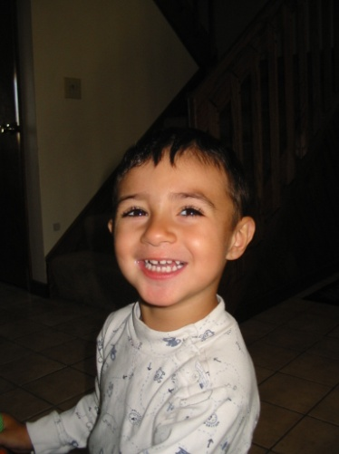

Examination, Assessment and Treatment Planning
History
History taking is a three way stream (child – parents – you)
-Essential for accurate and appropriate treatment planning.
-Beginning of a good relationship with the child.. Take your time.
-Standard forms are helpful reminders.
-Make sure child is accompanied by a legal guardian.. for Consent!

Social History
-Name, age, address, parental occupation and number of siblings.
-Establish communication and rapport with the child patient.
-Try and make an assessment of the social background from which the child comes.
-Helps in formulating a realistic preventive plan.
-Gives an idea on how easy it is going to be for a parent to bring their child to the dental surgery.
Can detect signs of child neglect and abuse (also physical examination)
Medical History
-Should be reviewed systematically with relevant data being taken into the treatment plan.
-Consider medical conditions common in childhood.
-Necessary for safe delivery of routine dental care.
-Medically compromised children may have an aversion to strangers in white.
Medical History (go over all systems with the presence of parents) :
-Growth & development -CNS -CVS -RS -GIT -GUT -Endocrine -Allergies -Hospitalization -Medications

Dental History
-Inquire about the reason for attendance(chief complain).
-Ask the child, not just the parent.
-Full history of the chief complaint.
-To evaluate the child’s and parent’s attitude to dental treatment.
-Past dental experiences will give an indication on whether the child is going to cope well with dental treatment or not.
-Do they attend the dentist regularly?
-Have they had any previous dental treatment?
-Fillings: With or without LA?
-Extractions: LA or GA?, were there any complications?

Clinical Examination
-Consider the child as a whole.
-Overall impression of the child’s health the moment he or she enters the clinic.
-Learn to distract the child while continuing to carry out a careful examination.

Extra-oral Exam
-Gait (المشية).
-General size- Normal for age?
-Speech: Normal, slurred, stuttering, lisp.
-Hands: nail biting, finger clubbing?
-Head & neck: swellings, soft tissue lesions?
-TMJ
-Submandibular area.

Intra-oral exam
-Soft tissue- Any pathology?
-Periodontal tissue.
-Oral hygiene- poor, fair, good.
-Plaque score: good acclimatization procedure.
-Occlusion.
-Teeth.

Intra oral examination: occlusion
-Overjet.
-Overbite.
-Molar relationship (if the 6s not erupted we look at the distal aspect of the Es, and if the 6s erupted we go to angle's classification).
-Crossbites.
-Habits.
-Incisors erupted (in the age we expect them to erupt).
-Canines palpable (by 9-10 years of age).

Intra oral examination: teeth
-Count the teeth! (because the Es look like 6s so to overcome this : COUNT!)
-Set a routine for examination.
-Hypoplasia or discoloration.. Record.
-Clean & dry each tooth individually for proper assessment.
-Good source of light.
-Careful use of a probe.
-Record.
-Teeth present.
-Unerupted teeth.
-Missing teeth.
-Caries.
-Existing restorations/ sealants.
-Teeth to be extracted.
-Anomalies.

Radiographic examination.
-To aid the diagnosis of dental caries.
-To detect abnormalities in dental development.
-To detect bony and dental pathology.
-Radiographs requested must be appropriate and justified.

Caries diagnosis
-Bitewing radiographs are essential in diagnosing approximal caries.
- Wide contact area in primary dentition makes clinical diagnosis difficult.
- This is especially true in small lesions.
- Kidd and Pitts (1990) The use of Bitewing radiographs is essential if much approximal caries is not to be missed. (50% were missed !!)
-Caries progresses rapidly in primary teeth & may involve the pulp if left undiagnosed.
-Also for diagnosis of hidden dental caries under sound looking occlusal enamel.

Abnormalities in dental development
-Panoramic Radiographs.
- Unerupted teeth, ectopic teeth, congenitally missing teeth, supernumerary teeth.
- Parallax technique for exact location of impacted teeth. i.e. max. canines.

Detection of bony or dental pathology
Periapical radiographs.
- When increased detail of a particular tooth is required.
- Pulpal involvement suspected following trauma.
- Assess root development/ resorption.

Special investigations
-Vitality testing: Ethyl chloride, hot GuttaPercha, electric pulp testing.
-In permanent teeth following trauma.
-Not very reliable in children, false positive.
-Good isolation.

Treatment Planning
-Management of pain (the painful chief complain).
-Preventive care.
-Restorative care.
-Surgical Treatment.
-Orthodontic treatment.
-Review and recall.

Management of pain
-A priority.
- Have the long term treatment plan in mind before embarking on a single item of treatment.
- In the case of traumatic injuries, it is necessary to carry out immediate treatment.
- A subsequent appointment is made to formulate a long-term treatment plan.

Preventive Care
-The most important aspect of treatment planning for the young patient.
-Advice should be realistic and tailored to each individual case.
-Dietary advice, fluoride supplementation & oral hygiene measures.
-Preventive advice should be reinforced regularly.
Restorative Care
-Obtain the cooperation of the child.
-Good clinical judgment: Is the tooth restorable? Is it about to exfoliate?
-Start with easy operative, if possible, usually maxillary arch (because the LA with the upper arch is easier).
-Larger restorations later on.
-Temporizing.

Surgical Treatment
-Have a long term treatment plan before embarking on an extraction.
-Consider the need for space maintenance.

Orthodontic Treatment
-Refer at the correct time.
-Space maintenance when indicated.

Review and recall
-Review is an attendance at a further appointment within a course of treatment.
-Recall is defined as the planned, unprecipitated return of a patient, who when last seen was in good oral health.
-Recall at least once a year.
-6 months is a convenient interval which provides for continuity of care.

Variations in recall frequency
-Milestones in dental development.
-Eruptive sequence of teeth.
-Signs of active oral disease.
-Specific oral conditions i.e. periodontal disease.
-Medically Compromised children.

Aims of Pediatric Dentistry
-The child reaches adulthood in a state of good dental health.
-The child develops positive attitudes to dental care.

Dony by:
Rakan Khtoum

