Classification of Malocclusion
please refer to the doctor’s slides since he explained many things on pics !
in this lecture we gonna talk about MALOCCLUSION ( that’s what we do as orthodontics and what we treat ) and we gonna talk about different classification for this problem ..

Definitions:

A Classification: A systematic arrangement or distribution into a class or
classes
You are grouping things together, e.g.we have class 1 ,class 2 and class 3

An index: A number of formula expressing a certain property, form, or ratio
relating to the subject in question.
An index will give a value to the problem, e.g we don't say in class 1 cavity if its deep then we give it 50% or 80 % .. this is not present in cons just in ortho we give a value to the problem

So in order to have an index we have requirements ..

Requirements of Indices:
- Reliablity: a dental index should have a high lever of intra- and inter-
examiner reproducibility.
There’s an intra and inter examiner reliability.
Which means when I use it or you use it, it should give the same result , the same number and the same value

- Validity : an index measure what is purports to measures.
If you try to measure height using a scale that’s the wrong tool , so you have to use the correct tool to measure what you gonna measure .

- Validity with time: an index should consider the normal development of the
dentition.
So for example we know that the occlusion develops ( primary dentition , mixed dentition and permanent dentition )and this index should be valid with time it should take that in consideration. It should not be just a cross sectional type of index that works only at a certain period of time, so that through these development its actually works.

Reasons of developing indices:

1) To classify malocclusion. (Angle classification and British Standards Incisor
classification (BSI)) and that’s what we gonna talk about today .)
2) To measure epidemiological prevalence of malocclusion.
3) To assess treatment need or priority.
4) To asses treatment standards and treatment success.
5)To determine treatment difficulty or complexity
6) To record aesthetic impairment

Uses of indices :

1) To help in the diagnosis and treatment planning of orthodontic patients
2) as an aid for communication between orthodontists

Common Orthodontic Classifications:

- skeletal Classifications
- the incisor Classification
- Angle’s Classification

1) Skeletal Factors:
- Anteroposterior which is the Skeletal Classification.
- Class I
- Class II
- Class III
- Vertical – Lower face Height and FMPA
- Transverse – Rule of thumb

Anything in orthodontics, in dentistry in general you have to try stay away from thinking in 2 dimension cuz everything , people are 3D .. so always think in 3 D

- TRANSVERSE - RULE OF THUMB
it's difficult to assess person in transverse plane , people faces are differ they look differ , some have narrow faces and some wide faces , so you can't really tell there is transverse problem from looking to persons extra orally , the ONLY way that you can tell is by looking intra-orally and the way of dentition occludes together . if you take the cast for the upper arch , if the pts can put their thumb inside it comfortably in palate that means that the width is more or less good , the lower should fit to the upper .. its really rough type of description ( its a guide but not reliable ).

Anterioposterior :

Class I (normal skeleton pattern) :
The maxilla should be 2-3 mm infront of the mandible
Look at the deepest concavity in upper lip and the deepest concavity in the mandibular fold
Those two the relationship between them 2-3 mm maxilla in front of the mandible
The other way to exam it is the facial profile. Class I is to have a straight profile
A straight line connects: forehead between eyebrows, in front of the upper lips and the most prominent point of the chin.
These are two ways (2-3 mm apart and facial profile)

Class II
Maxilla is more than 2-3 mm in front of the mandible, the relationship between deepest point in upper lip and deepest point in the mandibular fold is more than 2-3 mm
The facial profile is convex . If we look at the same three points (between eyebrows, in front of the lips and most prominent point of the chin) we will see a convex line

Class III

It’s the opposite. The maxilla is less than 2-3 mm in front to the mandible , And the patient will have a concave facial profile.
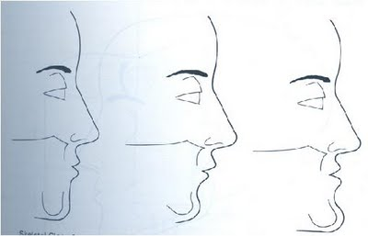
- Class 1 >> straight facial profile
- Class 2 >> convex facial profile
- Class 3 >> concave facial profile

- ( Vertical ) LOWER FACE HEIGHT
Facial can have normal , increased or reduced lower face height .
And the points we are looking at between eye brows, nasolabial angle ( the angle that the nose form with the upper lip and under the chin, those 2 should be equal.
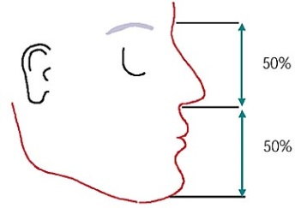
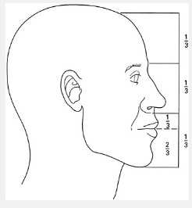

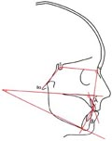

another way to measure the lower facial height is using Frankfort Mandibular Plane Angle (FMPA) , extaraorally we look at the upper border of the Targus of the ear and the orbital foramen , these 2 lines must cross at occiput , that means the lower Facial Height is normal.

So we have 2 ways ( halfs or thirds and FMPA)
pic >> in this pt you can see that the FMPA meets behind his head ,,this means the LFH is reduced .
pic >> in this pt the FMPA means forward or anywhere on the cranium ,, that means LFH is increased .

Prevalence of malocclusion in 16 year old Jordanian school children
Doctor did this study long time ago 2001, in this study they found that
46% are Class I, 37% Class II and 17% Class III.
Most people are within the normal. Class I and Class II are more common in our
population

2) The British Standards Incisor Classification BS-4492 (1983)
The most important classification that we use in describing malocclusion .
This is inside the mouth ( intra-orally ). It’s the relationship between the incisal edges of lower incisor and cingulum plateau of upper incisors. (Or middle third of palatal surface).
We have class 1, class 2 (division 1 , division 2 ) and class 3.

Class I:
The lower incisal edges occlude on the cingulum plateau of the upper incisors.
Sometimes, there is no cingulum plateau in the uppers, so we look at the middle third of the palatal surface of the uppers)

When you want to exam your patient you should look at:
Where the lower incisors edges, where they occlude. If they occlude on the cingulum plateau this is Class I. or we get a mirror and look up down .

Class II:
The lower incisal edges occlude posterior to the cingulum plateau or middle third of the
upper incisors.
Division 1: the upper incisors are proclined, or normally inclined.
Division 2: the upper incisors are retroclined.

Class III:
The lower incisal edges occlude anterior to the cingulum plateau or middle third of the
upper incisors.

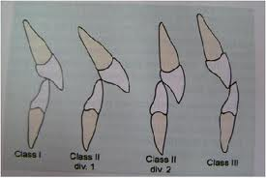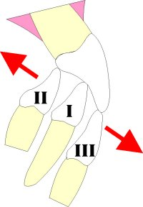
Pic :
The incisal edge posterior to cingulum plateau and retroclined , the adjacent incisor proclined >> class 2 devision 2 ,devision 1
We are looking to 4 incisors , if the teeth differ we describe each indivisual tooth eg. Upper rt 1 .. class 2 devision 1
Upper rt 2 .. class 2 devision 2
If we have 4 incisors , 3 of the incisors are class 2 devision 1 and one is something else then its class 2 devision 1 .

Pic :
It’s obvious that lower incisal edges are anterior to the cingulum plateau of uppers. This is Class III
Pic:
In case we have anterior open bite , use perio prope and see where the occlusion occur. In the pic its class 1

Pic: class 1
Pic : class 2 devision 2

Incisor Classification:
In Jordan:
40.3 % Class I
26.3 % Class II division I
8.4 % Class II division II ( the least)
25.0 % Class III
NOTE ! any malocclusion is combination of skeletal problems , soft tissue problems and dental problems , they interact together to produce the malocclusion.

3) Angle’s Classification (1899)
Angle was regarded as the father of orthodontic,he is the first one that began to make orthodontics as science more than an art , his idea that the first molars are the keys to occlusion , he thought if you got the sixes in their right positions everything else will fit correctly
- Based on the relationship of the upper first permanent molars (the Keys to occlusion and the dental bases(

- Tip of mesio-buccal cusp of the upper molar should occlude with the
buccal groove of the lower first molar
(Class I)

Only internationally recognized classification. When we tried to compare our studies with other nations, the only study that we found all around the world was Angle’s study

Class I molar relationship according to Angle

- The tip of MB cusp of the upper occludes on the B groove of the lower >> class 1.
- If it’s anterior (MB cusp) >> Class II
- If its Posterior >> Class III

In clinic, bring a probe put it at the level of MB cusp of upper six and see its’ relation to the buccal groove of the lower. This is very accurate way to make the decision which class is the patient.
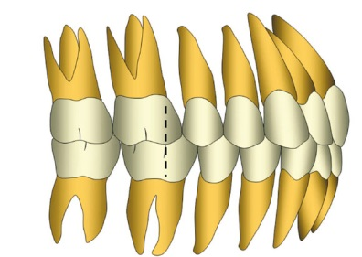
Molar Relationship (Angle)
62.5 % Class I
21.5 % Class II
16.0 % Class III
Note :
Angle's molar relationship is described in Units .
and unit in orthodontics means : premolar width which is ≈ 7 mm
We use the (unit) in orthodontic to quantify spaces
So if the MB cusp of upper molar is a fully unit forward >> full class 2
And also we have half unit ( edge to edge ) and sometimes quarter unit .

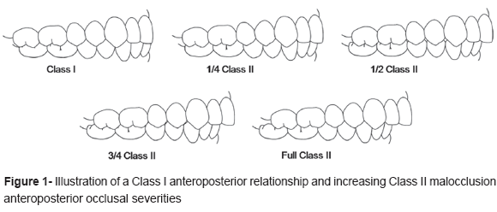

Shortcomings of Angle’s Classification:

- Early extraction of E’s causes drifting of 6’s forward

- Small sized 6’s

- Early loss of 6 due to caries.

- Only anteroposterior plane . (No account of transverse or vertical)

The Six Keys to Normal Occlusion (Andrews 1972)

- Molar relationship
- Crown angulation (MD tip)
- Crown inclination (BL tip)
- Absence of rotations.
- Tight proximal contacts. (no spacing)
- Flat occlusal plane (curve of spee)

We took it in the first lecture ..

In 2001 we looked for andrews six key and went to 16 school in amman and we looked around 320 pt , no one had andrews six keys so its rare .

Common Orthodontic indices

IOTN and PAR are indices look at the needs of orthodontic treatment. In UK orthodontic treatment is free , which means that they cannot give treatment to every single person who wants it , they have to give it according to need cuz there is limiting orthodontics .

1) Index of Orthodontic Treatment Need (IOTN)
a) Dental health component (DHC)
What the need for treatment is and give the treatment to those who deserve it .

b) Aesthetic component (AC)
This is a way to assess the needs according to the aesthetics
2 ) Peer Assessment Rating (PAR) index
This is a way of assessing the success of the treatment

IOTN – DHC
Grades 1-5
Grades 1 and 2 > little or no need
Grade 3 > borderline need
Grades 4 and 5 > great or very great need.

Treatment on the National Health Service (NHS) only offered to Grades 4 and 5
Exception : Grade 3 with significant aesthetic impairment AC 6 or worse

Grade 4 :

Memorize in the word MODCO

- Missing teeth
- Overjet > 6 mm- 9 mm
< 3.5 mm (reverse overjet(
- Displacement of contact point > 4 mm (crowding)
- Crossbites with > 2 mm displacements
- Overbite, increased complete traumatic
All these are dental health problems

Grade 5 :
Worse than Grade 4
- Impaction of teeth (except 8’s(
- Cleft lip and palate
- Submerging deciduous teeth.

Orthodontic
treatment need in Jordanian school children
We published a paper in 2001, and the need of treatment in Jordan about 20 ,about 1/3 of population!
28% of school children need orthodontics treatment

IOTN – DHC , Shortcomings:
- It does not look at the demand for treatment. Sometimes, dental health need is low but the patient is very concerned about the treatment but this index does not take this in consideration.

- Psychosocial effect. eg . treatment for girls more important that boys !

- Combinations of features.

IOTN – AC
Evans and Shaw took 1000 pics of pts , they select 10 from best to worse .
- 10 intra-oral anterior photographs
- Ask the patient to find a representative photograph which appeals as much
in dental attractiveness as in his occlusion
- Selection by equivalence on a continuum of attractiveness rather than
specific morphological similarity. You do not look at a specific feature, just
look at how bad the teeth look and compare them to your teeth

- in UK The cut point for treatment is 6 to 10 . in other places its from 8 to 10 need orthodontic treatment

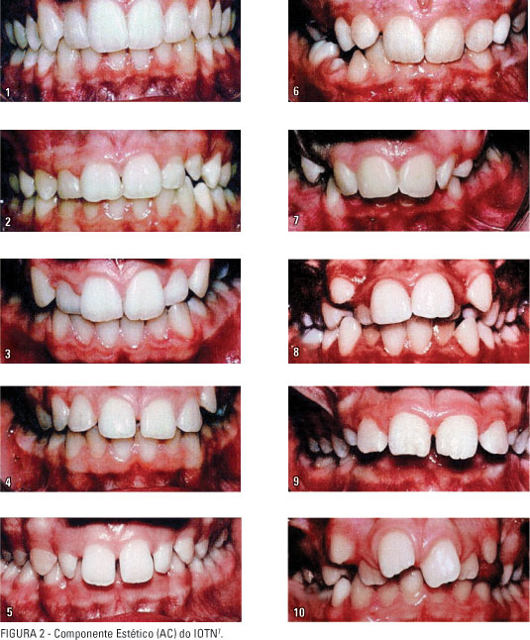

IOTN – AC, Shortcomings :
- Reliability. Usually when we let the patient to choose in two different occasions, he won’t choose the same number.
- There is no pictures for Class III and Anterior open bite.
- Doesn’t take patient and parent assessments into consideration.

The PAR index (Richmond et al. 1992)

- Measures treatment outcome or success
- Allocates a score for occlusal features that deviate from the normal
- Pre and post-treatment scores are compared to assess treatment success.
If the occlusion is worse the score will be heigh

The occlusal features measured :
- Displacement of contact points (crowding/spacing)
- Overjet x6
- Overbite x2
- Midlines x4
- Molar occlusion (AP and vertical(
- Crossbites

We have three categories for success :
- Greatly improved
- Improved
- Worse or no different

We calculate the score before and after; we give certain score for the crowding, overjet
midline …etc to get the final score, if the reduction in score was more than 70% then
it’s improved. If less then it’s worse or no different
- While if the score reduced more than 21 points, then this is the greatly
improved.

Shortcoming of the PAR index :
- No consideration of facial esthetic. Study only on models
- High weightings for overjet. if you have overjet then its good but if you don't have overjet this is not good . one reduction of overjet you reduced the point 6 points
- All malocclusions are grouped together. e.g. If there’s no overjet the score will
- be low and improvement will be less.
- No consideration of treatment complexity or difficulty.

Sorry for any mistake ..

Happy eid My colleagues

