Functional appliances
Mainly, 3 types of appliances are used in orthodontics
- Removable appliances
- Functional appliances
- Fixed appliances
In this lecture we are going to discuss functional appliances
History
*A decade ago, Pierre Robin designed this appliance to posture the mandible forward in babies born in severely retrognathic mandible and compromised airways.
*Andresen discovered the functional appliance by chance, his daughter had braces, and after the braces he made a modified retainer that looks like the functional appliance, and noticed that his daughter who had class 2 malocclusion is getting better, Andresen appliance
Definition
*Functional appliance, it’s a removable or fixed appliance utilize, eliminate, or guide the force of muscle function, tooth eruption and growth to correct a malocclusion
*its an orthopedic appliance that used to prevent, intercept or correct improper relationship between maxilla and mandible as well various functional deviations by influence growth, development and function
*every functional appliance is orthopedic appliance but not vice versa
*rapid maxillary expansion appliance is considered an orthopedic appliance as well
How does it work?
It could have a skeletal effect, dentoalveolar effect and soft tissue effect

**skeletal effects:
Functional appliances mainly used in class 2 patients, in class 3 it has only dental effect
So skeletal effects mainly occurs in class 2 patients
Many theories regarding skeletal effects in the mandible
*additional growth (the jaw grows more than it's supposed to)
*accelerated growth in the mandible but the overall growth is the same
*change in the direction of growth of the mandible (anterior rotation instead of posterior rotation)
*change in the position of the glenoid fossa, theories suggest that glenoid fossa and the condyle moves to a more forward position
Skeletal effect in the maxilla:
*it’s a growth restraining effect of the maxilla (it prevents forward growth in the maxilla)
**Dentoalveolar effects (which is the main effect of functional appliances):
#class 2 patients:
*it retroclines the upper incisors
*it proclines the upper incisors
*it might reduce the overbite according the associated bite plane
*lower buccal teeth moves mesially
*upper buccal teeth moves distally
**soft tissue effects:
*In class 2 patients the lower lip is trapped against the upper incisors, so the functional appliances could have an effect, the functional appliance removes this effect, allows more favorable environment for the mandible to grow forward "the lower lip restricts the growth of the mandible by being trapped against the upper incisors"
*removal of adapted tongue activity "seen in patients with open bite, the tongue has a contact with the lower lip, the tongue is in a forward position, so it corrects the position of the tongue
*removal of soft tissue pressure on the cheeks and the lips
Classification
*Fixed VS Removable
*according to its components (the most accurate method)
*tooth borne VS tissue borne
*according to the malocclusion (class 2, class 3, facial asymmetry …)
#tooth borne appliance: active or passive
Active: with active components (i.e.: elastics, screws, springs …..)
Passive: depends only on soft tissue stretch and muscle activity
#tissue borne appliance: the only example is Functional regulator "Frankel appliance"
#components:
- Functional component: for example, the component that makes the patient postures his jaw in a certain way, to achieve the main effect of the appliance, example: lingual flange
- Tooth controlling components: arch expansion, screws, springs, buccal shield, occlusal stops, bite blocks, lingual shields
*So those components guides teeth by moving or restrict their movement in a certain direction
- Stabilizing component: i.e. retentive components, adams, labial bow, ball ended clasp
When do we use functional appliances???
* Class 2: div 1&2
*Class 3: the whole effect of functional appliance is dental
* Skeletal asymmetry
* Functional appliance is used mainly in class 2 div 1 patients
Criteria for the use of functional appliance:
- A growing child: if we used functional appliance in adult patients we only get dentoalveolar effect
- Patient with mandibular retrusion: because the main effect of functional appliance is on the mandible
- Favorable growth of the face: i.e. the patient doesn’t have severe open bite or severe skeletal deep bite
- Motivated patient
- Well aligned arches: because this appliance doesn’t align teeth, the main effect of this appliance is gross movement of the jaw
- Proclined upper incisors or at least normal inclination
- Retroclined lower incisors or normal
- Upper molars not distally angulated : this appliance moves upper molars more distally so they shouldn't be distally angulated(to prevent occlusal interferences)
- in class 2 div 2 the upper incisors are retroclined, and according to the previous criteria upper incisors should be proclined or normally inclined, so to solve this situation we should provide this patient with removable appliance to procline upper incisors, then we provide him with functional appliance
- In class 3 patients only minimal posturing of the mandible is possible, so mainly the effect is dental
- Facial asymmetry
*****Examples of commonly used Functional appliances
*****Activators:
- Andresen activator:
- monobloc, it’s a one piece appliance, its removable, it’s a tooth borne passive appliance "it doesn’t have springs,…… active components"
- Used for class 2 cases, so it’s a class 2 functional appliance
- It has eruption guidance(facets made by bur) to encourage upper teeth to move distally, buccally and occlusally
- Distally and occlusally to correct the class2
- Buccally: expand the upper arch, to prevent the crossbite made by the mandible as it postures forward
- We need to move the lower teeth to move mesially and upwards
- Mesially to correct class 2
- Upwards to occlude with the upper teeth

- Medium opening activator:
- A modification of Andresen
- Removable
- Monobloc
- Tooth borne passive
- Class 2
- Deep bite cases
- Can be used in mixed dentition (at the time of eruption of 6s and lower incisors)
- A disadvantage: we can't expand the upper arch
- The retention of this appliance is by adams clasp
- The posterior area is free of acrylic so that the posterior teeth are free to erupt correcting the overbite
- We can't expand the upper arch due to the presence of adams clasp on post teeth
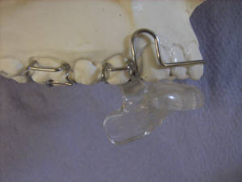
- Bionator
- A modification from Andresen
- Retention from blocks
- Less bulky(it doesn’t cover the palate)
- More comfortable fore speech
- Has the ability to expand the upper arch (by separating the cheek from the upper teeth)
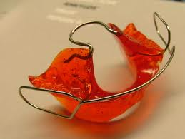
Bionator

- Harvold appliance:
- a modification from activator
- a shelf that covers the upper teeth but not the lower teeth, they are free to erupt
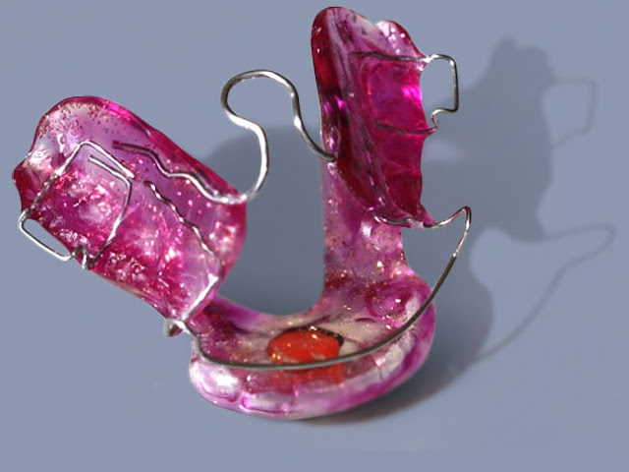
Harvold appliance
*****van beek appliance
- used in patients with gummy smile
- it has facebow head gear
- it induces intrusion of the upper buccal segment
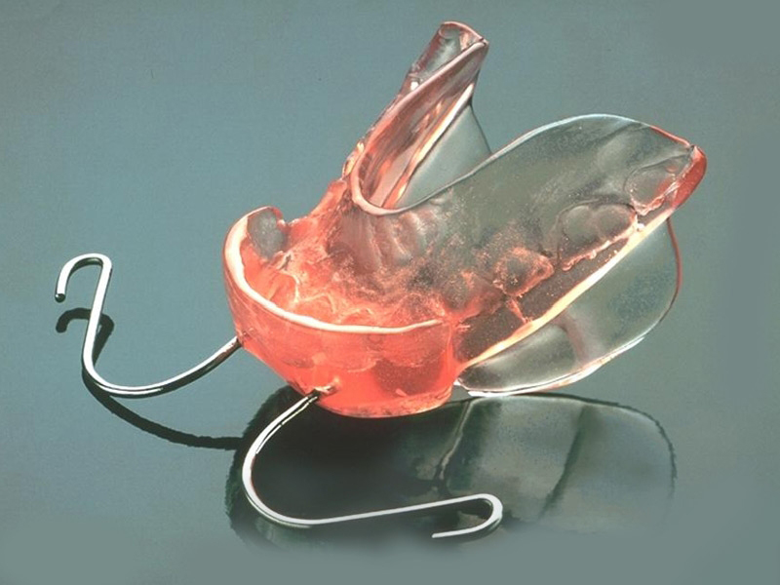
****Twin-block appliance
- most commonly use removable functional appliance in JUH
- tooth borne active, it has active components
- removable
- two designs, one for class2 and another one for class 3
- easily tolerated
- it’s a two piece appliance
- we can expand upper arch by screws
- can be used with head gear
- retention by adams clasp
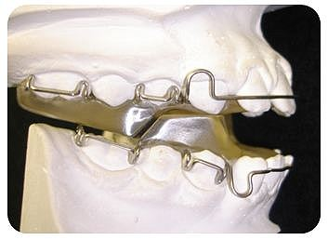
- it has tooth supported rams when the patient bites, he has to posture forward then the lower jaw locks with the upper
- in class2 cases the lower rams are forward
- in class3 cases the lower rams are backward
******Frankel appliance (Functional regulator)
- very bulky
- tissue borne
- class2 & class 3
- removable
- expensive
- easily break
- just like medium opening activator it corrects the overbite
- it postures the mandible forward
- it has buccal shield that holds the cheek away from teeth
- it has labial ballots, removes the lip trapping , in class 2 Frankel we put labial ballots downward on the lower arch , class 3 vice versa
- labial bow in class 2 upward on the upper arch, class 3 vice versa
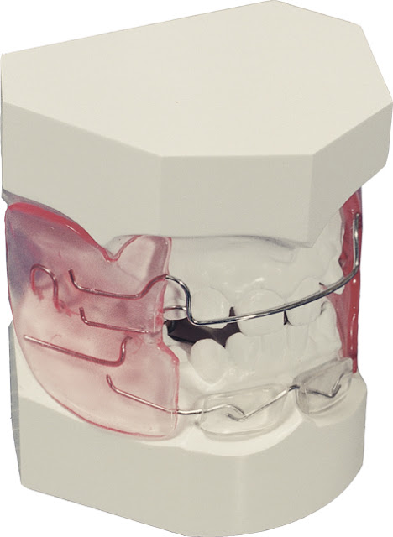
class 2 Frankel appliance

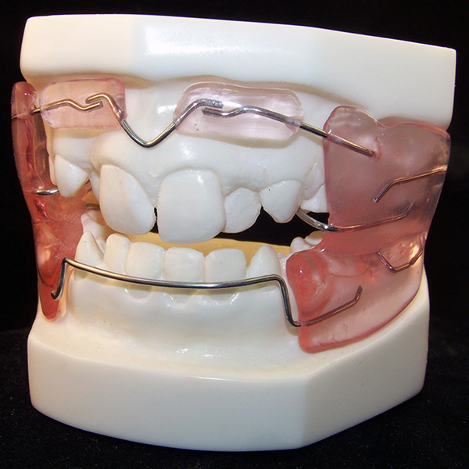
Class 3 Frankel appliance
- labial ballots may encourage bone growth by putting a pressure on the periosteum
- main effect is dental
- proclination for the upper teeth
- retroclination for the lower teeth
- it might encourage the mandible to grow backwards
*****Herbst appliance
- fixed functional appliance
- there is a section attached to upper buccal segment teeth and a section attached to the lower buccal segment teeth, these sections are joined by a rigid arm that postures the mandible forewards
- it has both skeletal and dental effect but mainly dental
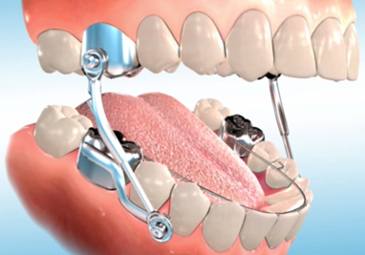

The end
- sorry for any mistakes
- best wishes and love
- Ahmad Tayel Khajiil

