Ortho sheet #1
Removable appliances
Definition: is an appliance that can be removed by the patient or by the specialist; it’s not fixed on teeth, it can be removed from the mouth but that doesn’t mean that the patient can take it out whenever he wants, there are instructions that must be followed, the patient must wear the RA 24 hours per day (full time) except after meals the patient is allowed to take it out, clean it and clean his teeth. So the general rule is full time wear
6 hours is the time needed for teeth to start moving
When do we use RAs?
1- If the treatment of the case requires simple tipping movement. We have different types of movements; tipping, bodily, torque, rotation, extrusion and intrusion. Simple tipping movement can be achieved with RAs so if this type of movement can fix the patient malocclusion then we use RAs
2- If you want to transmit forces not to a single tooth but blocks of teeth. Remember that RAs are no so specific so they either put a force to produce tipping or push a whole segment of teeth, they can’t perform specific movements.
3- as an adjunct for fixed appliances, for example, a classical case of class II division II, if we think of using fixed appliance on the lower and upper teeth, the bite is too deep to keep the brackets on the lower teeth not being debonded so if I want to protect the lower incisors + reducing the overbite which is the first stage of treatment then usually I go for Upper removable appliance with flat anterior bite plane In order to disocclude the teeth, after reducing the overbite I can then use FA
4- can be adjusted in order to have some bites; I can have an anterior bite plane in order to disocclude the buccal segment or I can have a posterior bite plane in order to diocclude the anterior segment. Sometimes you want to move a tooth across the bite and if there is a deep bite sometimes the tooth is locked so using bite planes is a good idea to disocclude teeth and to move teeth across without being affected by forces of occlusion, so you can modify it with anterior bite plane or posterior bite plane, we call it buccal capping of teeth.
5- Can be used as space maintainers. Sometimes patients lose their Es early so you can use the RA as a space maintainer. There are two types of space maintainers; fixed and removable, in pediatric dentistry they use fixed space maintainers, in Ortho we can use RAs as space maintainers in mixed dentition or if you have an extraction for a primary canine and you want to give the patient another 6 months to allow the canine to erupt.
6- Retainers. RAs can be used not to produce active tooth movement but to retain the teeth in their position. Used after FA to prevent relapse
7- Can be used to test patient compliance. It is easier to comply with RAs than FAs in terms of hygiene, diet, instructions and stuff. If the patient doesn’t comply with the RA then we may have to change your treatment plan or discharge the patient.
Advantages
- Can be removed for tooth brushing. After meals you can remove it and clean your teeth easily unlike FAs which is good for oral hygiene. (During meals you keep the RA inside your mouth).
- Palatal coverage increases anchorage.
- Easy to adjust. You can adjust it with Adam’s and loop forming pliers
- Less risk of iatrogenic damage (eg. Root resorption) than with FA
- In growing children you can use it to reduce the overbite, if the patient is for example 12 years old we can use RA to reduce the overbite but if he was 20 I can’t use RA because this will not reduce the overbite, it will disocclude the occlusion temporarily. Deep overbite is a nightmare and needs lots of techniques, if you can reduce it during growing than this is a bonus.
- Acrylic can be thickened to form flat anterior bite plane or buccal capping, why? Because I want to minimize occlusal forces during tooth movement to make tooth movement more efficient.
- Useful as passive retainer or space maintainer.
- Can transmit forces to blocks of teeth.
Disadvantages
- Appliance can be left out
- Only tilting (tipping) movement is possible
- Good technician required
- Affect speech because it covers the palate
- Intermaxillary traction is not possible. What is intermaxillary traction? In Ortho we use one arch to transmit forces to the other arch by elastics. If you have RAs in the upper arch and you use elastics, it will be dislodged so this method won’t work.
- Lower appliance are difficult to tolerate because of the tongue and ginigiva, the ginigiva lingually is very sensitive but there are some lower RAs like twin block which has lower and upper pieces
- Inefficient for multiple individual tooth movement. it can move block of teeth.
For RAs construction we use alginate to make an impression then pour it with stone and start your metal work then add the acryl, it is easy to construct.
Components of the RA
Active component
Retentive component
Anchorage
Base plate
Sometimes some components can actually work for both we will talk about it now
If your case is indicated for extraction plus RA, which one do you do first? You fit your RA, test patient compliance if it is good then you extract. You never go for extraction and then discover that your patient will not wear the appliance. You fit the appliance inactive for 4 weeks, test patient compliance if it is good, good oral hygiene, the patient is coming to the appointments at time and taking care of the appliance then do the extraction.

Types of active components
1-springs
2- Screws
3-elastics
Springs
Most commonly used active component, Inexpensive and easy to construct in the lab (it is not ready made you have to construct it)
The relationship between the force produced by this spring and other factors is summarized in this formula $F=\frac{dr^{4}}{i^3}$
“d” stands for deflection which is the amount of activation. If you increase the amount of deflection twice the force increases twice
“r” stands for the radius (thickness of the wire), the more thickness you have the force will increase to the power of 4. Most active components are made of 0.5 mm wires.
“I” stands for the length. The longer your wire the more gentle the force will be (less magnitude of force). In Ortho we don’t prefer heavy forces, we prefer gentle forces, the more gentle the force is the less the consequences that may develop such as root resorption, pain and problems. So if you increase the length twice the force will be reduced by 8 times
The length of the wire can be controlled by the size of arch or depth of sulcus. Sulcus depth is not the same for all patients, the deeper the sulcus is means you have more room to fit longer active component which means more gentle force, if you don’t have this distance or depth, you can increase the length by adding coils or loops.
This wire will produce certain amount of force, if we use the same wire length but with a coil or loop in the middle it will then produce less force because the coil/loop increases the length.
There is something called stability ratio for the springs which is the stiffness in the direction of unwanted displacement/ stiffness in the intended direction of tooth movement. palatal finger spring has high stability ratio, it has to resist the unwanted movements and reduce the wanted movements to have high stability ratio.
Screws
Bulky and expensive relatively
The type or direction of tooth movement depends on where you place the screw; if you place it right in the middle it means you are trying to produce symmetrical movements of both blocks (buccal movement). If you place the screw just in front of the left molars then you are trying to distalize the left posterior segment (buccal segment) (push the molars posteriorly as a block)
Screws are two types; the one that has two sides and the one that is single sided you just open it with a screw driver and it will push back the tooth you can get it out by quarter turn, so we have spring loaded system and two halves on a threaded central cylinder which is turned by means of key which separates the two halves by a predetermined distance.
Elastics
Comes in different thicknesses and sizes ranging from 1/8 inch to 3/4 inch. The amount of force applied usually 2oz, 3.5 oz or 4.5 oz (oz = 28 grams) depending on the thickness and activation

We have talked about the three general types of active component, now we will discuss specific types of active components according to the type of the produced movement.
If your case is indicated to move the incisors labially, which active component would you use?
1-Z spring
2-Double cantilever
3-Recurved palatal spring
4- Expansion screws
All these are options and depends on the case

Z spring
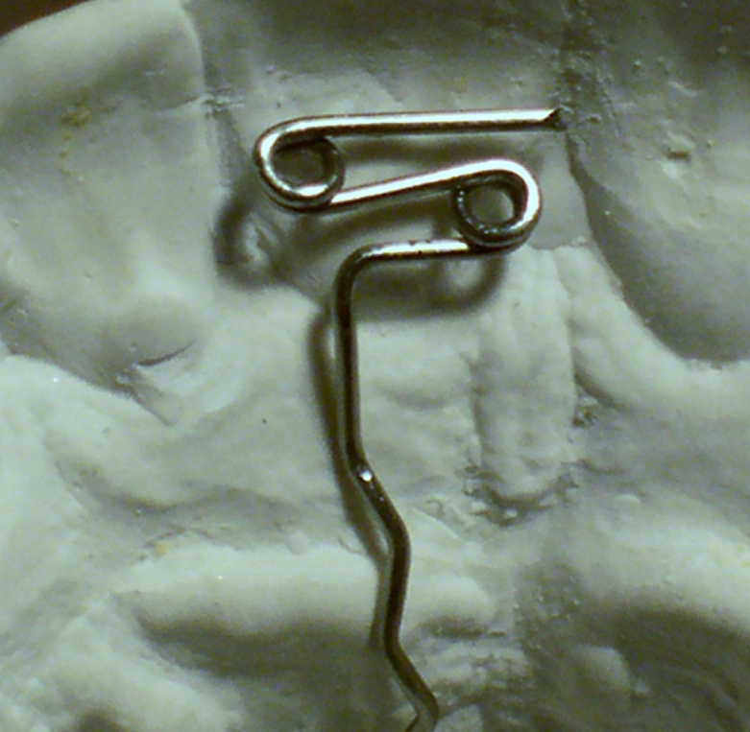
Retentive arm
Active arm
is mainly used (its indication) when you have a problem in a single anterior tooth that you want to push labially, it has two coils, its mesio-distal width is exactly the same as the tooth you want to move and is made of 0.5 mm ss wire. The direction of movement can be altered because I have two coils so I can activate it to produce a little bit of specific movement BUT it is still tilting (tipping movement).
if you want the appliance to stay in the patient mouth after activation, you need a very good retentive component as close as possible to the active component to be efficient (anterior retention).
It is activated by holding the active arm with adam’s pliers, about 1-2 mm away from the baseplate, just push the active arm 45˚ away from the acryl (45˚ in the direction of the desired movement) and every 4 weeks the patient has to come for further activation.
The other option is double cantilever
It is the same as the z spring but used when you have MORE than one incisor, it is exactly the same but the thickness of the wire is 0.7-0.8, the wire thickness is increased because we have longer span here so longer wire and as we know longer wires produce less force so we increase the thickness to increase the force.
If you have both incisors palatally displaced and you want to move them forward, you don’t use z spring on each one because this will produce asymmetrical movement of teeth and will make it more difficult for the technician to fit two active components beside each other so one double cantilever is used for both incisors. It is activated exactly the same as z spring
Recurved palatal spring it doesn’t have coils but instead to make it longer it has loops and it can be used for the 4 incisors, it is activated in the same way, pull the active arm 45˚ 1-2 mm away from the base.
Expansion screws, again the screws, which are used here for a specific type of movement which is to move incisors labially and the last option is screw appliance which is not used in any case because you have to have at least three teeth, why? Because the force is intermittent and heavy, the patient has to open the screw twice a week so forces are heavy and has to be distributed over large area that’s why it is used for at least 3 teeth. It is activated by means of turning the screw one quarter turn, you use a key which is actually a wire you put inside the hole and move it in the direction of the arrow (there is an arrow in the screw which tells you in which direction you should go). Quarter turn opens the two sections of the appliance by 0.25 mm. for active movement the patient should turn the screw twice a week, so in one week we will have 0.5 mm of activation, after 4 weeks we will have 2mm of activation.
**Z spring is used on one tooth, double cantilever on two teeth and screws on at least three teeth
** Modification of Adam’s clasp is double Adam’s which is used on two teeth

Let’s talk now about another type of movement that can be produced by the active components which is the palatal movement (retraction) of incisors. So we talked about moving incisors labially which is in class III, now we’ll talk about moving them palatally which is in class II
This can be done by using
- Labial bow
- Robert’s retractor
- Strap spring
- Elastics
Labial bow
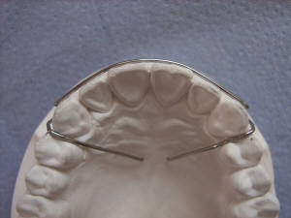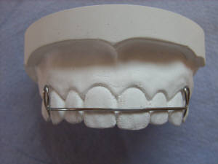
We know it is a classical retentive component but I can modify it to produce an active component. The labial bow goes from canine to canine (the classical one) and it has a nice loop to give a range of activation
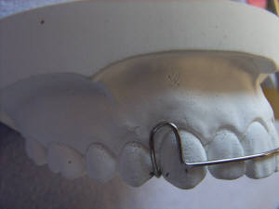
Loop
It is made of 0.5mm ss wire and as we said the conventional design is too stiff I can use it as retentive component but as an active component it will produce too much force so how can I modify it to reduce the force? Make it longer so instead of going from 3 to 3 it will go from 4 to 4 (first premolars).
Labial bow can be soldered to the bridge of the Adam’s with a loop all the way to the other side, we call it wrap around, and this is very long so it will produce a more gentle force on the incisors
Another modification is instead of having a loop; we call it labial bow with reversed loop, this reverse will give extra wire length and that will give more flexibility.
To activate the conventional labial bow you close the loop but to activate the labial bow with reversed loop you widen it, you open the loop is much easier to activate, it is more practical
Another modification is when you have two separated wires, you can modify this if you have a diastema that you are planning to close.
Robert’s retractor
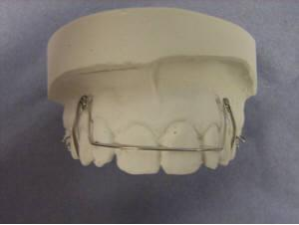
Patient’s nightmare! It is two buccal canine retractors connected anteriorly, it is used to retract the incisors and is made of 0.5 mm ss wire with tubing because it is very long so if you make it only 0.5mm and the patient is eating the wire will distort, I need it to be stable to resist unwanted tooth movement, I need to make it stiffer, how? By adding sleeves and this is tubing, if you don’t have tubing you can actually use 0.6-0.7 depending on the extension. Robert’s retractor requires adequate depth of the vestibule so when you take the impression you must have a very good impression for the depth of the Sulcus, otherwise this will cause patient ulcers during function, and this is very much technical sensitive because it goes all the way to the Sulcus.
It needs separate appliance for retention. Sometimes when you finish the active tooth movement you can use the same appliance as a retainer except if your active component is Robert’s retractor because it’s already not comfortable to the patient so you have to construct another appliance for the stage of retention.
Strap spring is a labial bow, thick stiff labial bow and you just add to it a cast wire, very thin wire on the loop you attach it very well and you leave it from the other side to be free sliding has to cirss cross each other so you have it fixed on the loop and from the other side it goes loose. It is used to retract the incisors, it is called self straightening arch and made of 0.5 mm ss wire winded on a heavier labial bow, so the active component is actually 0.5 mm but is winded on a very heavy wire, the small wire that is winded produces the needed force. The good thing about this appliance is that it can be used to produce canine retraction and overjet reduction using the same appliance (because the active component I add it by winding wires) and I can use it for retention by just removing the small wire so you don’t have to make another appliance for retention, it is a handy appliance for retroclining the incisors. It is activated by tightening the base labial bow
Elastics, you can have a hook coming out from your RA from both sides and you ask the patient to hook the elastic from one side to the other, this is how elastics are used to retrocline incisors and the elastics that we use are 5/8th inch and produces 3.5 oz. elastics can’t be used with very proclined incisors because the elastics would slide all the way up to the gingiva hurting the gingiva.
Done by Salma Khayyat

