Orthodontic materials & their properties

Lecture Outline:
*Material Classification
**Impression Materials & Dental Plasters
***Brackets & Bonding Adhesives
****Bands & Band Cements
*****Auxiliaries

Orthodontic materials can be classified according to stages of orthodontic management:
- Patient comes to clinic if he/she is indicated for orthodontic treatment Examination & record acquisition (Photos; radiographs; impressions and models)
- Diagnosis
- Treatment planning & consent form
- Fit an appliance:
*URAs (Removable appliances)
Those involve S/S wires mainly and acryl
*Functional appliances
*Fixed appliances
Involve bands, archwires, auxiliaries, Mini screws, power chains, ….

After obtaining an alginate impression, one must head to the lab and mix stone or plaster on a vibrator and pour the impression layer by layer to avoid bubble formation. After the initial pour dries, create a base for your model. If the patient is indicated for removable appliances, the technician starts bending wires in accordance with the orthodontist’s treatment plan.
Study Models are needed for several purposes:
- As a record
- As a working model (Mainly for the technician to work on)
- Model for mid-treatment re-assessment
- Model for end and near-end of treatment peer re-assessment
*Points 3 & 4 are mainly needed in cases of complicated orthodontic cases such as when an orthognathic surgery is to be performed.
Impression Materials
Alginate is the material of choice for almost all orthodontic cases. Non- aqueous elastomers such as silicones are rarely indicated and are only chosen in cases of clear aligner construction (Figure 1).
Alginate is an elastic, irreversible hydrocolloid. A hydrocolloid is a material that is mixed with water. Alginate gives just enough details for most orthodontic procedures. It is supplied as a powder that is to be mixed with a well-defined proportion of water and one must follow the manufacturer’s instructions in this respect.
Generally speaking, 2 spoons suffice for an upper arch and 1.5 spoons for a lower. However, the proportions are prone to modifications according to the specific case worked on (Child; patient with narrow/wide arch).
Advantages of alginate as an impression material:
- Easy to mix (No need for a nurse; you just mix and load)
- Doesn’t require fancy equipment
- Elastic and therefore comes out easily from undercuts
- Economical and relatively cheap
- Impression obtained can be removed easily
- Patient friendly (pleasant taste and odor)

Disadvantages:
- Poor tear resistance especially in thin sections (particularly important in patients with spacing where the poured impression would have stone between teeth due to tearing)
- Dimensional stability is poor (you should wash, disinfect and poor immediately or cover with a moist cloth or just refrigerate impression until the technician collects it later on)
- Distortion may occur if tray shifts after seating as the material gradually sets and shifting during this process would lead to an impression that doesn’t represent the patient’s anatomy.
- Cannot be refined as it is irreversible (If you are not satisfied with it, repeat).

The impression should be poured with dental plaster (a form of gypsum material whose types include: *POP **Stone ***Die stone). Plaster is stable and cheap and fairly fulfills the needs of orthodontic study and space analysis. Stone could also be used and is both harder and stronger than plaster and may be the material of choice if a studying model is to be constructed and be subjected to heat and used to bend wires.

Acrylic Base Plates

Acrylic is of two types:
- Cold Cure
- Heat Cure

*Cold cure acrylic is:
1. Less time consuming
2. Cheap
3. Easy to use (Can be used to adjust platform in clinic after being processed by the technician)
4. Brittle
5. Used when an appliance is to be used for a time period of 6-9 months and not more than that.

*Heat cure acrylic is:
1. Time consuming
2. Harder
3. Used when appliance is expected to last for a long time (> 1 yr).
4. Used when heavy forces are expected (For example, if a URA is to be used to reduce overbite using flat anterior bite plate (Figure 2) which is placed intraorally almost all the time and the patient constantly bites on it)

Brackets (Figure 3)

A bracket is the part of a fixed orthodontic appliance that is attached to a tooth.
Consists of three main parts:
- Base
- Wings
- Slot

Brackets could be classified according to the material they’re made of to:
- Gold (Old & hardly used anymore)
- Metal (S/S; Ti; Co/Cr)
- Plastic
- Ceramic
According to size of slot (Part of bracket where the wire engages), brackets are classified to:
- 0.018^{n} X 0.025^{n} (Old but may be still used by old fashioned orthodontists)
- 0.022^{n} X 0.028^{n}
Originally, slots were standardized irrespective of teeth and were unspecific; if an orthodontist desired to specify, he/she would bend the wire accordingly. Nowadays, slots are customized for each individual tooth a process referred to as bracket prescription (generating specific torque, rotation, tipping, in & out motions). Effectively, a bracket for an upper left 3 for example wouldn’t fit on any other tooth; in other words, specific bracket cut is designed to deliver a specific movement by means of engaging the wire inside.
Such brackets are referred to as pre-adjusted edgewise appliances/brackets and include Begg, tip-edge, and self-ligating brackets which are all specific in terms of direction and angle of cut.
The bracket’s base provides retention to the tooth through mechanical bonding as it is mainly made out of metal and therefore cannot bond chemically.
To make the base more efficient in this respect, some made it:
- Perforated obsolete (old)
- Mesh *Firm
*Coarse
Of which the former provides a stronger bond to tooth structure.
- Microlock spherical photoetching (small microscopic bubbles inside it)
- Dynalok undercut channels (Oldest modification to the base in order to improve retention)
The material of choice to construct brackets is mainly S/S. The type of S/S used is AISI 304 steel AKA 18/8 steel as it consists of:
- 18% Cr
- 8% Ni
- 71% Fe
- <0.2% C

Advantages of S/S:
- Cheap and available
- Provides less friction (as a wire engages the slot, it is expected to deliver a certain force with a certain direction and angle; but as the frictional forces increase, the magnitude of the delivered force is reduced and hence tooth movement efficiency is also reduced).
- Less retention of food (Theoretically at least)
Disadvantages of S/S:
- Poor esthetics (true for all metallic brackets)
- Contains Ni which has been associated with allergic reactions. Alternatives to which include Ti and Co/Cr. Ti is Ni free, has excellent corrosion resistance but offers higher friction and therefore reduced efficiency. Co/Cr also has no Ni, offers less friction but is not as cheap as S/S.

Plastic Brackets (Figure 4)
Due to metals’ poor esthetics, plastic (polycarbonate)brackets were introduced by Newman in 1969.
Disadvantages:
- Stain easily (contributing to reduced esthetics). Brackets are expected to be worn for 1.5-2 yrs and them being stained easily is obviously not a merit.
- Distort easily
- Prone to fracture (cannot sustain forces)
- Poor surface finish creating more friction
- High bond failure rate (weak bond to teeth)
Fiber-Glass Reinforced Plastic Brackets (Figure 5)
Consists of 60% polycarbonate with fiber-glass that is 2-3 mm in length X 0.8 mm in diameter. Unlike ceramics, the material has no tendency for fracture and creates no enamel damage when is debonded.
Fiber-glass addition improved stiffness, durability and bond strength.
Disadvantages of plastic brackets:
- Worn-off (especially if it came in contact with teeth as in if the brackets were placed on lower anteriors in case of a deep bite, the upper incisors will bite on the brackets causing them to wear).
- Cannot be recycled (Not much of a concern since we rarely recycle anything)
Ceramic Brackets (Figure 6)
They first became commercially available in the late 1980s and became very popular due to their superior esthetics.
2 types:
- Alumina-based ceramics
*Monocrystalline
*Polycrystalline
2. Zirconia-based ceramics

Advantages of ceramic brackets (In comparison to plastic brackets):
- Durable
- Resist staining (Superior esthetics)
- Can be customized as ceramics are made and then hardened so you can specify however this has a cost consequence.
- Dimensionally stable
Disadvantages:
- High friction and reduced tooth movement efficiency (Problem solved by making the bracket’s slot out of metal).
- Brittle especially at the wings (part that engages elastics) which are prone to fracture.
- If inhaled they are not radio-opaque and therefore cannot be readily located.
- Causes enamel to wear off in deep bites ( A special setting was indicated for this scenario: use metal brackets on all teeth except for upper sextants(from 3 to 3) to combine esthetics and protection of upper anterior enamel from wear).
- Exhibit high bond strength to teeth and so when they are to be removed they either tend to fracture leaving residues on the tooth surface and much instrumentation is used in order to remove the remainder or the surface enamel will break off. This was solved by introducing channeled bases to allow easy removal and decreased bond to teeth.
- Expensive (37 JDs for a S/S Vs. 130 JDs for a ceramic).
- Needs elaborate and specific instruments.

Adhesives
Composite, GI, and hybrid adhesives can be used to bond brackets to teeth.
Composite consists of :
- Filler
- Resin
- Saline coupling agent
Composites are supplied in a variety of preparations and can come as:
- Chemical cure
Comes in the form of tubes with an active material. Homogeneity is a problem and is often difficult to attain a homogenous setting. The setting time is short and the working time is accordingly reduced. Using no mix preparations, the active material is placed on the bracket, composite on the tooth and a bit of the active material on top of the tooth. Perform the sandwich technique by pressing the bracket and the tooth against each other to eventually obtain a very thin homogenous amount of the adhesive.
Tooth Preparation to Receive Brackets
The tooth surface should be made clean and debris-free; abrasion , brushing and similar procedures could be carried out for this purpose.
The tooth can then be etched using 37% phosphoric acid for 30 seconds then it should be rinsed thoroughly and dried. A primer is then applied and the entire complex will be subjected to air to increase wetting.
NB: A standard to any orthodontic treatment is maintaining good OH.
An alternative to the etch and rinse procedure is the use of self-etching adhesives to aid in tooth bonding. The preparation is often supplied in a packaging resembling a lollipop. The “Lollipop” consists of two sealed, separated chambers (a top and a bottom one) along with a tip/adapter. To apply some on the tooth surface, you squeeze the first top chamber to release contents and mix them with the contents of the second bottom chamber to produce a mix that is to be applied on the dried tooth. You go back and forth with the adapter around the tooth for 3 seconds. Self-etching adhesives both etch and prime simultaneously.
The main disadvantage of self etching adhesives is that they are expensive. They have been proven effective and time saving when a single tooth has debonded while the other teeth are unaffected; use the adhesive in this case to rebond the bracket to the lone debonded tooth.
Self etching adhesives consist of Acidulated Phosphoric Ester and practically eliminate the need for washing. Research suggests that since they take less time, the rate of bond failure when they are used is the same if not actually lower than when the conventional “etch and rinse” adhesives are used.
NB: A failure rate of 5-10% is considered acceptable while a higher percentage is not.
APC (Adhesive Pre-Coated) Brackets (Figure 7)
Those are brackets already sealed and loaded with composite.
Advantages:
- Theoretically, their handling requires no assistance.
- Easy to use especially for 1 bracket bonding (Just place it on a tooth that is already prepared)
- Ensure homogenous distribution of composite on the tooth and bracket (no deficiency or excess)
GI Cements
GI cements are not really used anymore however, they were once one of the available options.
Generally, the material of choice to bond brackets is composite (chemical/light/dual cure).
Advantages of GI:
- Doesn’t require etching
- Fluoride release
Disadvantages:
- Provide a non acceptable bond failure rate (>5-10%)
- Reduced strength
RMGI Cements
Resin-Modified Glass Ionomer cements theoretically combine the advantages of conventional GI and composite. They set by means of an acid/base reaction by free radical additives and they provide twice the strength of conventional GI and better esthetics; however, there is no strong solid scientific evidence of whether RMGI has a similar failure rate. RMGI still releases fluoride as the conventional GI. RMGIs are inferior to composites and so we still use composites for orthodontic purposes.
Bands (Figure 8)
Historically, orthodontists used to band all teeth during treatment. Nowadays, band use has declined due to rapid development of bonding materials and esthetic demands; however, they are still being used in specific cases and their use is mainly restricted to molars.
Indications for band use:
- If a tooth is to be subjected to heavy forces as in using a facebow and a head gear which apply heavy intermittent forces on teeth. (Figure 9)
- If TPAs (Trans-Palatal Arches) and lingual arches are to be used to reinforce anchorage (Figure 10)
- If the tooth’s crown is broken or is short and in cases of heavy fillings
- If rotational forces are to be applied to teeth (lingually and bucally). In which case attachment is needed from both sides and bands come with 2 spikes (lingually and buccally) to provide this kind of attachment.

Band Cements
- Zinc Phosphate
Zinc Phosphate has great handling properties and good longevity but ensues risk of pulpal irritation due to its acidity.
It is also a non adhesive cement (doesn’t adhere to tooth structure) and merely works by means of increasing friction between the band and the tooth.
- Zinc Polycarboxylate
Introduced by Smith in 1968. It is a very messy material in comparison to GI (see point below) and therefore it is very difficult to handle. An assistant is almost always needed as a consequence and you need to work quickly because the provided working time is not that long. It can adhere to enamel and dentine and so removing the material after it bonds sometimes becomes very hard that cutting the band becomes a choice to facilitate its removal. The bond it creates maybe just too strong.
It combines the advantages of Zinc Oxide Eugenol and Zinc Phosphate cements.
Disadvantages include:
- Highly technique sensitive and dependant on handling procedures (should be loaded and mixed properly)
- Requires assistance and if it got on gloves and instruments such as spatulas, the clinician has to change everything.
- Has a short working time.

- GI Cement
Introduced by Wilson & Kert in the 1970s.
Advantages:
- Fluoride release and therefore reduces incidence of decalcification (white spots as those marking the beginning of a carious process). However, their use only reduces incidence not total elimination of it and so if the patient doesn’t maintain OH, he/she is going to get decalcifications irrespective of the use of GI cements.
- Bond strength with teeth is just enough for orthodontic purposes as most appliances are expected to last 1.5-3 years at maximum (not too strong and not too weak)

Types:
- Conventional acid/base & dual cure GI cement
- Acid/base & light cure GI cement
- Tri-cure (Hybrid) GI cement (Light + chemical + acid/base rxn)
Orthodontists mainly use conventional GI cements as they produce satisfactory results in terms of band cementation.
All other types (Points 2 & 3 above) are fancy and come in various colors mainly blue that upon setting change color to a more esthetic tooth colored shade. This property is actually favorable especially if we want to build bites on molar teeth where upon band removal, you just leave the cement attached to the tooth.
Disadvantages:
- Expensive

- Initial slow setting needing 5-10 min to set (Keep suction and cotton rolls during that time). Consequently, they are placed first during assembly of appliance while keeping cheek retractors in place to allow adequate setting and band cementation.

- Vulnerable to wear that when we place them we ask the patient to bite gently and we must also tell the patient that he/she need not to be scared if flecks of white material start coming out as those are not tooth fragments but are rather tooth-colored, brittle GI material and their presence is kind of expected. Tell patients that it is just their bite going down.
Advantages:
- Easy to use and requires less or no assistance
- Strength and stiffness
- Fluoride release
- Biocompatibility
- Good resistance to acid dissolution (Anticariogenic)
However, if cariogenic features persist, caries becomes almost inevitable.
Auxiliaries
- Modules (Small donuts)…. (Figure 11)
Parts placed on wings to secure the wire in the bracket’s slot. Modules come in a variety of shapes and one manufacturer once made them fluoride releasing which was initially a good thing but afterwards they started absorbing fluids before they could be replaced (the inter-appointment period is 4-6 weeks which is more than enough to allow plaque retention).
- Short Ligatures…. (Figure 12)
In some cases, the elastics are not strong enough to secure the wire in place and the wire is needed to be engaged fully in its respective slot. In such cases use short ligatures by placing them around wings of brackets. They are also used in the first stage of fixed appliance construction (Leveling and Aligning) in which a wire is put and is expected to align all teeth. Sometimes one tooth remains rotated and if a module is to be used it’ll simply stretch out. In such a case, use a short ligature to force the wire in by placing it around wires and fixing it then cutting the excess.
- Power Chains…. (Figure 13)
Mainly composed of multiple modules attached to each other to produce a certain amount of force to group teeth together as in to close spaces.
- Elastics…. (Figure 14)
Parts bigger than modules that are used to transfer forces between arches. They include: box elastics, class II elastics and class III elastics. They often come in packages and in different colors and are sometimes even supplied in animal designs based on the child’s stage of treatment and amount of force applied; in other words, every animal designation has its own force, thickness and length. We have elephants, foxes, monkeys, koalas….
- Mini screws …. (Figure 15)
Screws used to provide absolute anchorage
- Long ligatures… (Figure 16)
They are annealed S/S wires that are similar to short ligatures but are used to engage a group of teeth. Sometimes we stick a module inside it to use the assembly as a means to provide spaces between teeth.
- Space closing Ni/Ti springs…. (Figure 17)
Ni/Ti alloy has memory and so when stretched it goes back to its original form closing spaces as a consequence. The springs are attached to teeth by means of holes on either side.
- Open coil…. (Figure 18)
Represents the exact opposite of the Ni/Ti springs. They are compressed and placed between teeth and afterwards stretch out on their own creating spaces. An example on their utilization is deciding to replace a congenitally missing upper lateral incisor that has no space in the arch.
Done By:
Mais B. Abu Ghosh

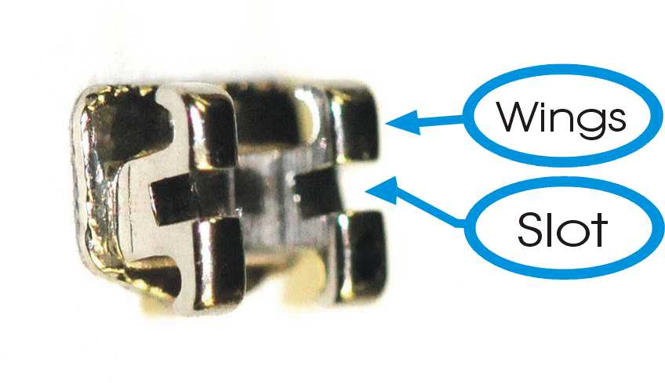
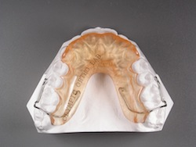
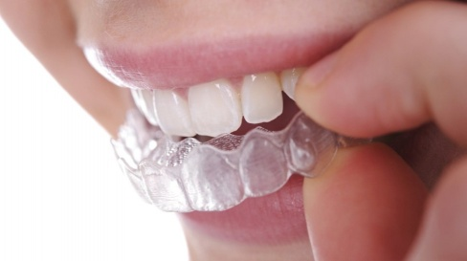
Figure 3
Figure 2
Figure 1

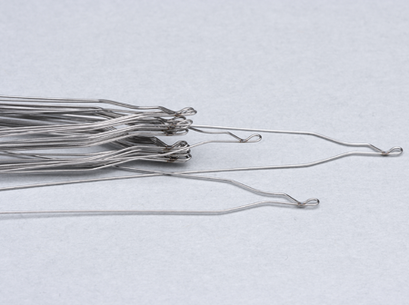
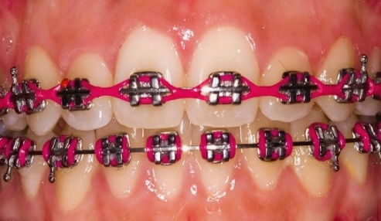
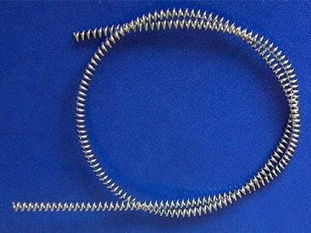
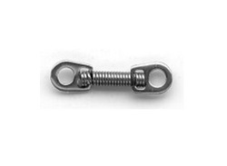
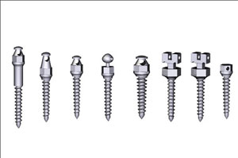
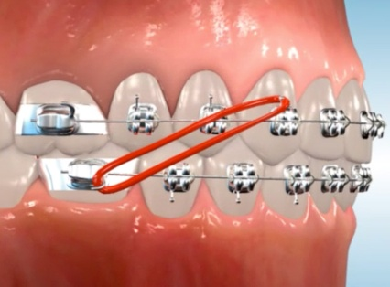
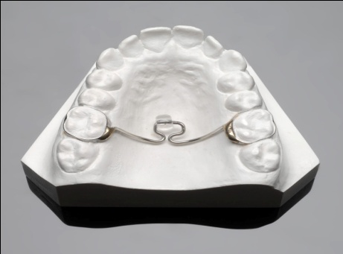
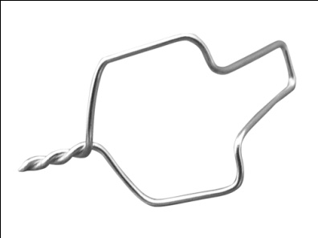
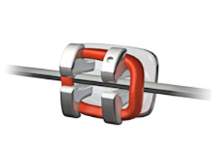
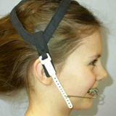
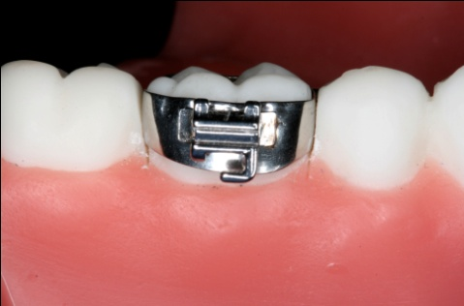
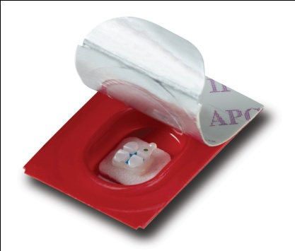
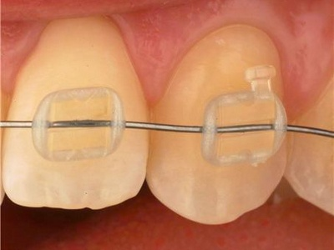
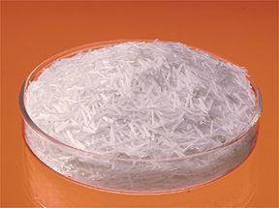
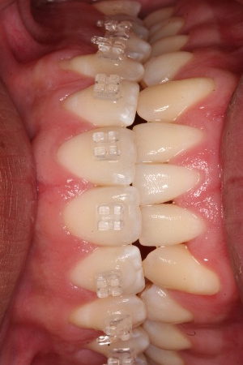
Figure 18
Figure 17
Figure 16
Figure 15
Figure 14
Figure 13
Figure 12
Figure 11
Figure 10
Figure 9
Figure 8
Figure 7
Figure 6
Figure 4
Figure 5

