Oral surgery
Lecture: 3
Dr: Sukina

- Today's lecture is about instruments used in oral surgery and next lecture will be about the indications for extractions.
- The main rule in surgery is visibility, the field should be visible and clear so do not do anything that you cannot see; you should always respect the tissues.
- Always check your chair and light and make good retraction on both sides.

- BLADES 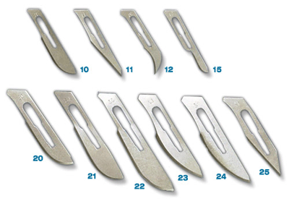
- When we talk about surgery we talk about blades.
- You should differentiate between the blade "scalpel" and the handle "Quiz question".
- In extraction we don’t need scalpel handle
- We need the blade when we make a flap "to incise the tissues".
- The scalpel handle has a ruler that can be used in Ortho-gnathic surgery (when either one of the jaws is protruded or retracted), it needs special calculations so it may help but we actually measure everything before the operation is done, more info in fifth year.
- There are different types of blades which we should memorize:
- Number 15: most commonly used intra-orally
- Number 10: has the same shape of blade 15 but is larger and it is used extra-orally (e.g. we can use it on the face).
- Number 11: for stab incisions, we use it when we have an abscess and puss, (if there is puss we should get it out, we never treat puss by antibiotics; we should incise it and drain it out).
- Number 12: it is designed for incisions in the palate "for access"
- Each individual blade should be used for its designated purpose.

- Mucoperiosteal elevator "fryer": 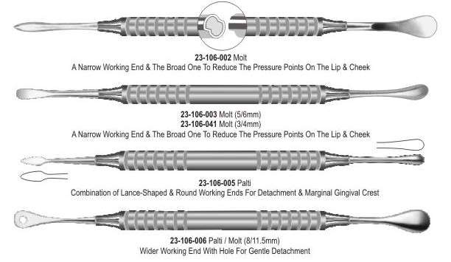
- It's a very valuable instrument
- Some people memorize its shape as a spoon as it looks like a spoon .
- The fryer has two ends; one of the ends is wide and the other is narrow.
- The wide end has 2 surfaces: a concave surface and a convex surface, the convex part should always face the Periosteum not the bone.
When we make an incisional flap we will see the mucosa then the Periosteum then the bone, we should protect this soft tissue "Periosteum" because it is the source of blood supply.
- The beginners who are not trained should be careful not to tear the Periosteum.
- But if you are skilled and you know what you are doing you will not tear the Periosteum and by training you will be better and better.
- The concave part should face the bone because I will drill the bone, I will drill the bone to excavate something inside it for example impacted tooth or remaining root or a cystic lesion.
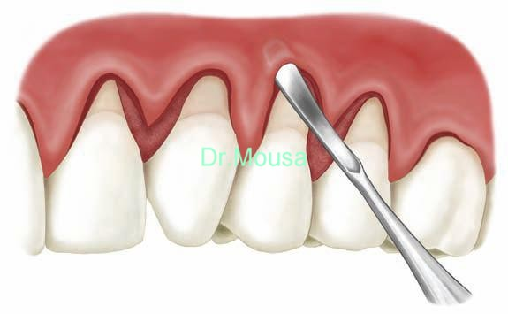
- The other end is triangular in shape, smooth and small and is used to raise the interdental papillae.
- There are different types of flaps.
- You should differentiate it from a Cryer.
- We have different designs for fryers as we see in the slides:
- One of them has a handle and a spoon part which is smaller, they have this design because flaps are of different sizes and locations (whether ant. Or post., in the maxilla or in the mandible, etc) and manufacturers introduced different designs for instruments to be more efficient.
- Sometimes the blade part is wide and in others the convexity is forward, this design is made for better accessibility.
- Remember: incision is done by a blade and elevation of flap is done by a fryer.
- Sometimes I elevate the sinus for implants to pack bone because the membrane of the sinus is delicate so that the convex part is toward the membrane to make detachment and elevation for the membrane to get some space to pack bone to put in it an implant later on.
- A fryer can be used for retraction of delicate tissues because it is a gentle retractor.
- Also we can use it to pack the bone, we have different shapes
- Retractors :
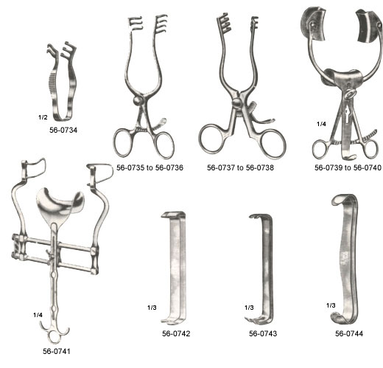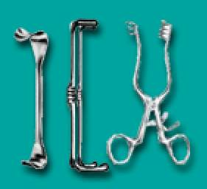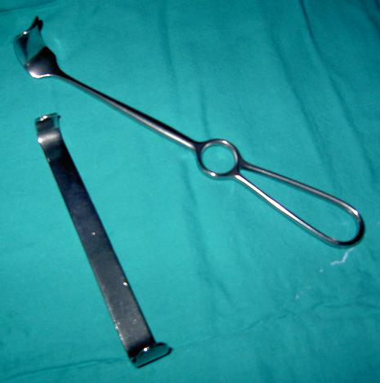
- There are different designs and shapes for retractors but the most important thing is to distinguish a retractor despite its design.
- Some of them have modifications and extensions (this depends on the design), we use them for extraction of upper impacted wisdoms; from anatomy we know it is important because its surrounded by the sinus and it may fall in the pharynx or larynx and if it falls backwards it will go to PP fossa (Pterygo-palatine fossa) so here the design can help with retraction and the extension within the design can block that area of the mouth thereby protecting it and preventing teeth and instruments from falling down the patient’s throat. (You should know that we use it for retraction and any extension is for certain purpose.)
- There are other instruments used for retraction and protection of certain areas.
- We have different types of retractors: right angle retractor, tongue retractor "concave and convex and it is heavy because tongue muscles are strong so we try to control them", cheek retractor, flap retractor and malleable retractor.
- Remember: we can use the fryer for retraction and flap elevation
- Malleable retractor: bigger than the fryer, we can remodel it by bending and we use it because sometimes we have delicate tissues and we need to be gentle as to avoid injuring them, for example when there is an orbital floor fracture and the globe of eye goes down (Enophthalmos) we make a delicate sub-cillary incision to elevate the globe; and an extra malleable retractor should be used with extra care to reduce the fracture.
- When the eye globe goes forward it is called exophthalmos.
- Tissue forceps
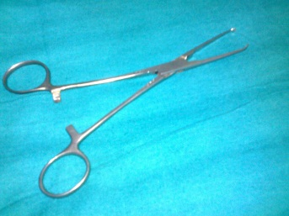
- It is toothed and has a sharp edge to grab the tissue of interest, the one the Dr. showed us is called an Addison’s forceps (it’s a special design).
- When making a suture holding the tissues with these forceps is done (as those forceps can be used to grab tissues firmly).
- The teeth are crisscrossed to hold the tissues (this is mainly related to design).
- Note: we do not use it for hemostasis of bleeding.
- You should differentiate between tissue forceps which we use in oral surgery and the forceps that we use it in cons to hold cotton rolls "tweezers".

- Clip forceps :
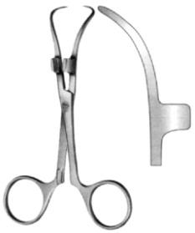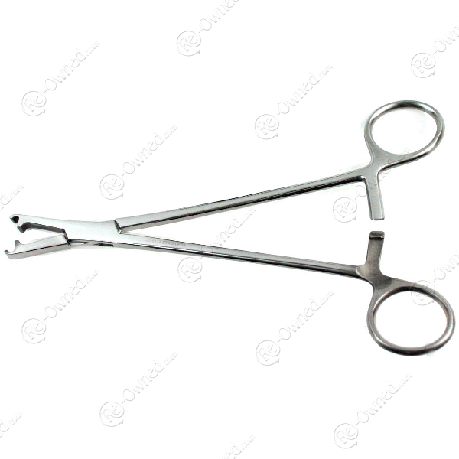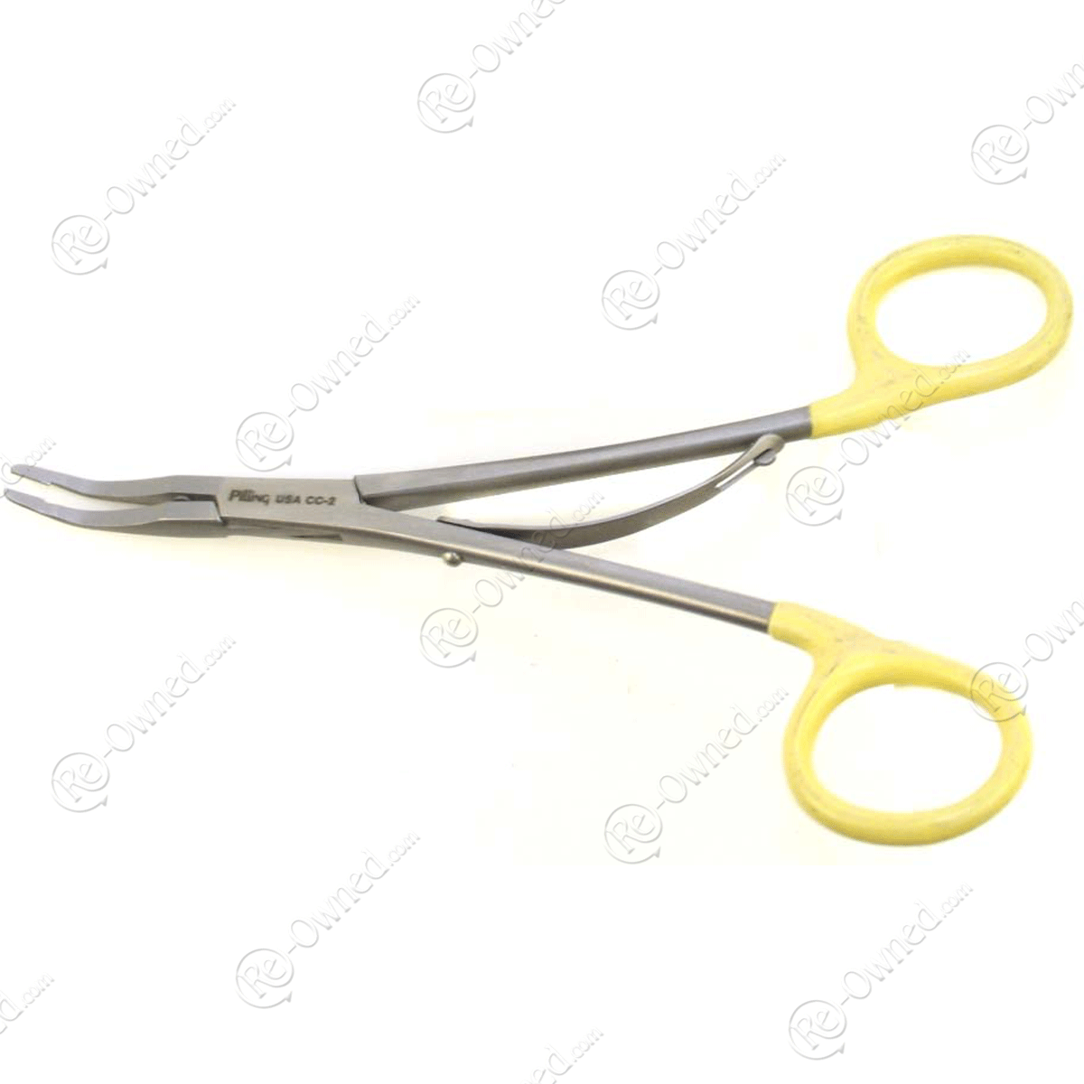
- Used to clip something and hold it, for e.g. when we towel the patient for surgical scrubbing before surgery.
- It is serrated and can be opened and closed like a pair of scissors.
- We may use it to hold gauze.

- Tissue forceps
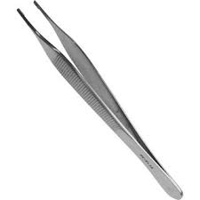
- It is smooth, non-toothed, has different uses.
- Its problem → if you catch the flap by it, it slips.
- We may use it to raise something or remove something but not for flab fixation, we may use it to hold teeth after extraction.
- Ideally when you extract a tooth you should follow certain steps: luxation, rotation, then pull it, the idea is that you should pick up the tooth by an instrument (forceps, mosquito or clip forceps) from its place so that it won’t slip and fall into the patient’s mouth (the pharynx or larynx, if it goes to the pharynx it is not a problem but if it goes to the lungs the patient will suffer from asphyxia and documentation of the event needs to be done which will include taking chest X-rays to locate the tooth and then extract it from the lungs either surgically or by an endoscope.

- Rongeur :
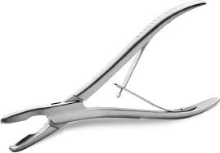
- bone cutter to remove big bites of bone so I can smoothen the bone and remove interdental bone "sometimes we extract 5 teeth together and inter-septal bone is left behind, later the patient will come and say that you didn’t extract the teeth because he feels the hard bony objects so you use the Rongeur or bone file or bur (which are different methods to remove bone), this is very important.
- Look at the design of Rongeur, the cutting edge, handle, joint, beaks (blades; both can be made for cutting).

- Hammer and chisel :
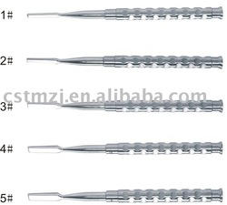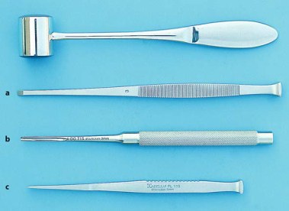
- Instruments for bone removal; we call them Osteotomes.
- At the end of an Osteotome there is a bevel, we put this bevel on the surface we want to cut.
- Example: extraction of an impacted wisdom tooth; usually we use a hand piece but if it is not working we can use the chisel and the hammer.
- It shouldn’t be used on a patient who is under LA because the patient is conscious and we work at the base of the skull so mainly we use them when the patient is under GA.
- In orthodontic surgery we use it for splitting and removing bones, to avoid fracture and cut bones in a special way.
- There are different sizes, different designs and cross sections but the idea is where to use them.
- Bone file :
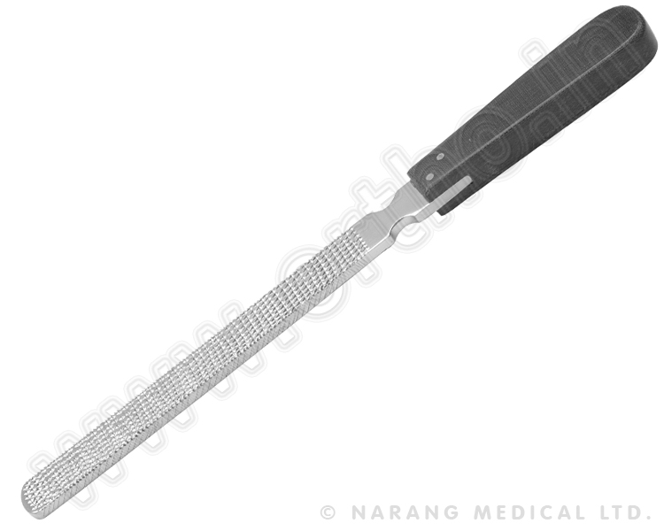
- Looks like a fryer so be careful and differentiate between them.
- It is serrated and is used to smoothen bones, it is used for small bony edges and is used in a similar manner to nail files.
- Rotary straight hand piece :
- We should use a long bur to help us in access, low speed.
- There is always irrigation to avoid heating the bone, because heated bone will become necrotic and the patient will suffer from other complications such as a dry socket and osteomyelitis.
- Irrigation by normal saline is better than water, internal irrigation when irrigation comes from the hand piece itself or external by your assistant (using the 3 in 1 syringe).
- The temperature should never exceed 47 c
- Surgical curette:
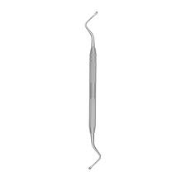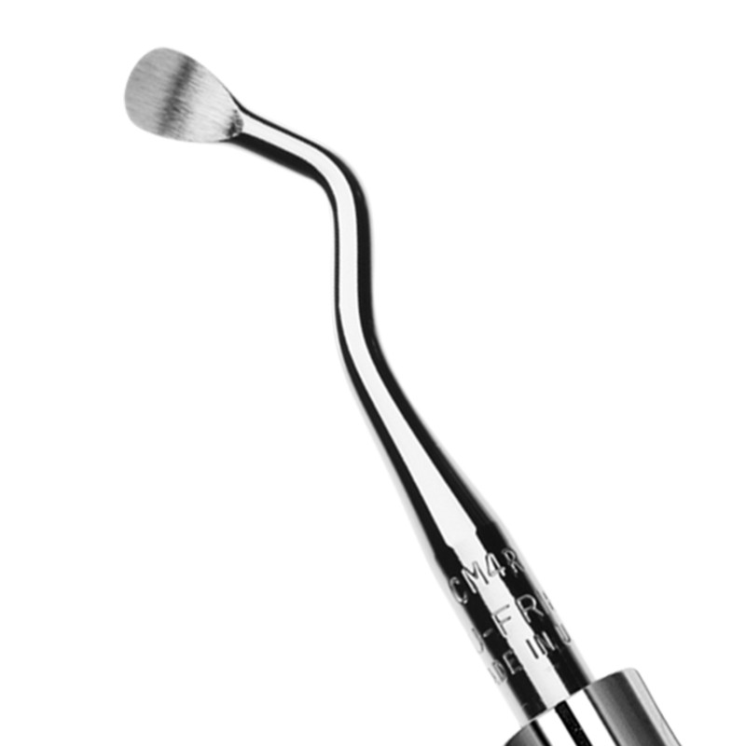
- It is bigger than the one which we use in cons (we use it in cons to remove caries) in surgery we use it to remove granulation tissues, soft tissues and cystic lesions.
- For example when we extract a tooth and we find a granuloma, we should use a curette to clean the socket, the same goes for an apicoectomy when we do a RCT and it fails we cut the apical one third of the tooth and the surrounding tissues using a hand piece then we use a curette to clean that area.
- Hemostat
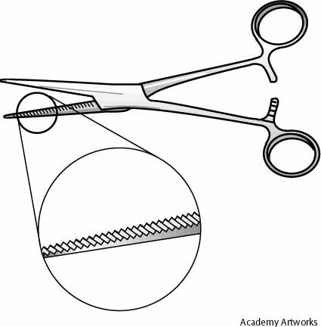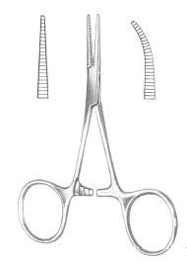
- The difference between a needle holder and a hemostat: From the outside they are the same so you should look at the working end, if it had a crisscross serration it is a needle holder but if the pattern of serration is parallel it is a hemostat! (Exam question), a needle holder is heavy because it needs precise manipulation and force application while suturing while a hemostat is light because it is used to block an artery or vein and be left there (without anyone actually holding it).
- It is called a hemostat because we can use it to establish hemostasis, different sizes and models are used according to which artery or vein is injured; we will study how to manage bleeding later.
- Beaks of a needle holder are small; in a hemostat they are long because of their function; a needle holder is used to grab a needle but a hemostat is used to ligate/compress a blood vessel so we need it to be long.
- We cannot use smooth "blunt" beaks because they will not catch anything.
- Needles: we will have a lecture about needles and suturing and types of needles; their cross section, length, cutting ends, etc.
- We use a curved needle, whether half circle or 3/4 circle or 3/8 circle.
- We don’t use a straight needle in oral surgery but in general surgery we use a straight needle.
- How to load the blade on the handle?
Open the blade, grab it from its end then snap it "flushed ends". Sometimes doctors use a needle holder to load the blade on the handle but here there is a possibility to injure yourself such as use mirror for retraction "you may hurt yourself because the mirror might slip". We may use a needle holder to remove the blade as it is safe to do so.
- Mouth prop :
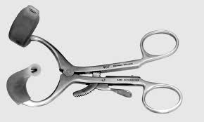
- Its two ends are covered by plastic to protect the lips.
- We use it to increase the mouth opening and keep the mouth open.
- Cryer :
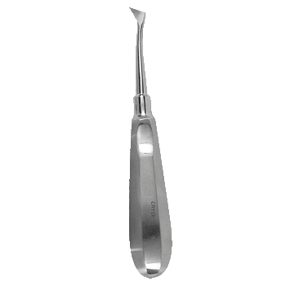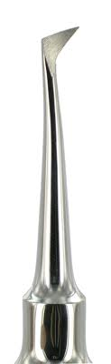
- Used to extract remaining roots.
- Has a handle and its blade is triangular in shape
- Straight elevator :
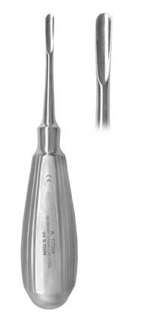
- Has a handle, joint and a blade.
- The convex part should face the bone and the concave part should face the tooth.
- It is an extremely essential and valuable instrument which used to luxate the teeth, retract the tissues, detach the teeth and extract them.

- Apexo elevator:
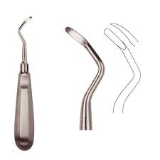
- We use it when the root is fractured and we need to enter the socket to elevate the apex of the root.
- Warwick James
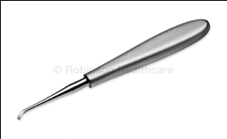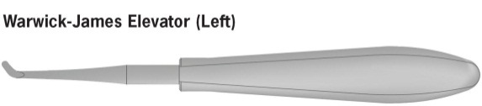
We will continue next lecture about elevators and forceps …

الدكتورة أكدت على أهمية التمييز بين الأدوات و إنو رح تكون أسئلة بالامتحان عن الأدوات .
Just for revision:
Mandibular nerve:
- largest of the three branches or divisions of the trigeminal nerve
- It is made up of two roots:
- a large sensory root proceeding from the inferior angle of the trigeminal ganglion.
- a small motor root (the motor part of the trigeminal), which passes beneath the ganglion, and unites with the sensory root, just after its exit through the foramen ovale
- Branches:
The mandibular nerve gives off the following branches:
- From the main trunk of the nerve (before the division)
  - muscular branches, which are efferent nerves for the medial pterygoid, tensor tympani, and tensor veli palatini muscles (motor)
  - meningeal branch (a sensory nerve)

- From the anterior division
  - masseteric nerve (motor)
  - deep temporal nerves, anterior and posterior (motor)
  - buccal nerve (a sensory nerve)
  - lateral pterygoid nerve (motor)
- From the posterior division
  - auriculotemporal nerve (a sensory nerve)
  - lingual nerve (a sensory nerve)
  - inferior alveolar nerve (a sensory nerve)
  - motor branch to mylohyoid and anterior belly of digastric muscles (mylohyoid nerve)
- To remember the sensory branches of V3
- B - Buccal n.
- A - Auriculotemporal n.
- I - Inferior Alveolar n.
- L - Lingual n.
Maxillary nerve
- Its branches may be divided into four groups, depending upon where they branch off: in the cranium, in the pterygopalatine fossa, in the infraorbital canal, or on the face.
- In the cranium

Middle meningeal nerve in the meninges
- From the pterygopalatine fossa

Infraorbital nerve through Infraorbital canal
- Zygomatic nerve (zygomaticotemporal nerve, zygomaticofacial nerve) through Inferior orbital fissure
- Nasal Branches (nasopalatine) through Sphenopalatine foramen
- Superior alveolar nerves (Posterior superior alveolar nerve, Middle superior alveolar nerve, Anterior superior alveolar nerve)
- Palatine Nerves (Greater palatine nerve, Lesser palatine nerve), including the Nasopalatine nerve
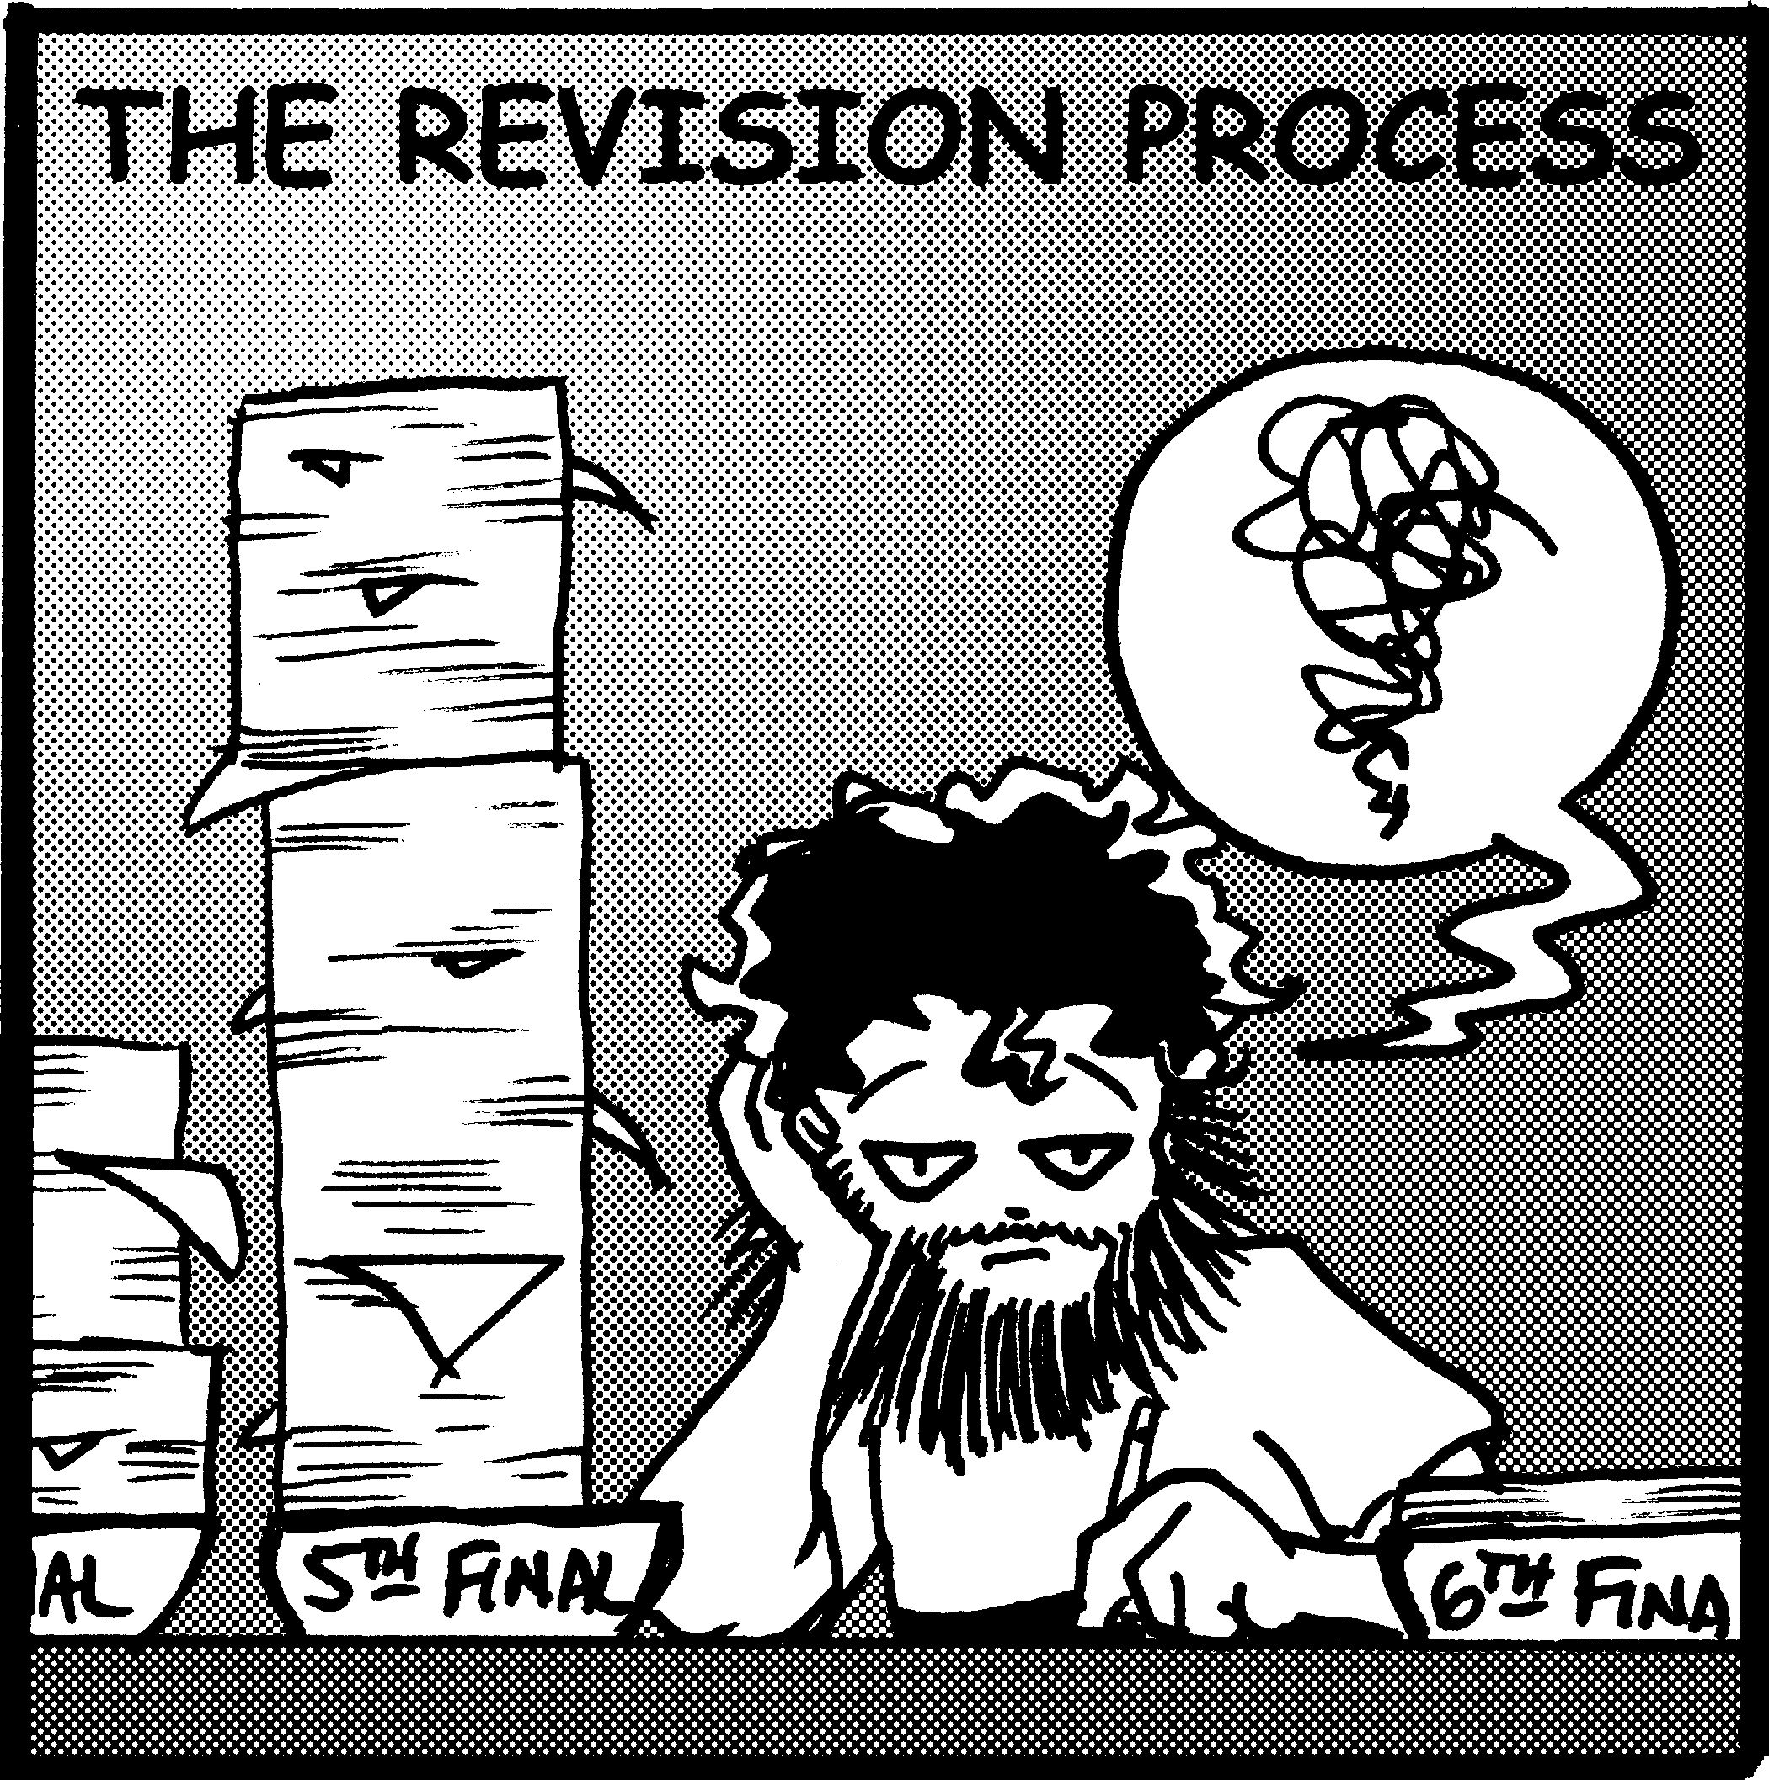
- Pharyngeal nerve
- In the infraorbital canal
- Anterior superior alveolar nerve
- Infraorbital nerve
- On the face
- Inferior palpebral nerve
- Superior labial nerve
Thanks for WAJD AL MAAYTA
Any correction more than welcome

Hamza,

