Oral Medicine
Lecture 11
Date: Tuesday 10/12/2013
Dr.Najla
Oral pigmentation
- We will be taking 2 lectures about oral pigmentation.
- Regarding oral pigmentation you are required to differentiate between intrinsic pigmentation and extrinsic pigmentation.
- When we talk about oral pigmentation we usually mean intrinsic pigmentation, meaning that we have a pigment in the oral mucosa.
- This pigment can be natural (Endogenous), such as Melanin pigment.
- Most of the pigmented lesions that we are going to discuss in this lecture and the next lecture are caused by excessive melanin production.
- Thus, the first and the most common type of oral pigmentation is excessive melanin production.
- We also have exogenous pigments, such as those that are caused by medications, metals, tattoos…etc.
- Thus, it is essential to differentiate between endogenous and exogenous pigments.
- Although we are also going to talk about some color changes occurring in oral pigmentation, we will be more concerned about endogenous and exogenous pigments. (The rest of color changes will be discussed in 5th year).
- When you see a color change in the oral mucosa, you have to describe the color, (ie: blue, black, brown…etc.), you should also describe the pattern (Macular pattern or Patchy pattern).
Macular pattern: it is only few millimeters in diameter.
Patchy Pattern: it is more than 5 millimeters in diameter.
- It is very important to describe the pattern, because it helps us in the differential diagnosis of the lesion. (You have to focus on that).

- Causes of Oral Pigmentation:-
- The causes of oral pigmentation can be broadly divided (Classified) into two main types:-
- Congential, and it includes:-
- Racial Pigmentation (Melanoplakia)
- Naevi
- Peutz-Jegher’s syndrome
- Acquired, and it includes:-
- Endocrinopathies indicates a problem in the Pituitary or Adrenal glands.
- Metablioc (EX: Hemochromatosis)
- Neoplastic (include tumors that are manifested by color change (ie: Melanoma)
- Metals
- Drugs (such as oral contraceptives, antimalarials and some antibiotics)
- AIDS
- This classification was according to {Etiology}
- Remember: We can also classify them according to the color and according to the pattern (Macular, Patchy).
Now we will discuss the congenital types of oral pigmentation:-
- Racial Pigmentation:-
- It results from excessive or increased secretion of melanocytes.
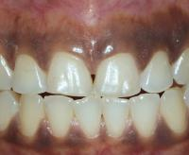
- The number of melanocytes is Fixed, however we have increased activity of melanocytes.
- The pattern of racial pigmentation is Patchy.
- It is usually found in blacks, Asians, but also can be found in Mediterranean littoral (المناطق المطلة على البحر المتوسط) and Pale skinned people (to a lesser extent).
- It mostly arises in the gingiva.
- It is Asymptomatic.
- Differential diagnosis of racial pigmentation:-
- Addison’s Disease
- Albright’s Syndrome
- Heavy metal pigmentation
- Use of Antimalarial Drugs
- Smoker’s Melanosis
{All the mentioned diseases have patchy pattern in oral pigmentation, thus we have to exclude them before we decide that our patient has racial pigmentation)
Usually racial pigmentation does not require any treatment, however some patients may not like the stain and demand its removal.
- Naevi:-
- They are another type of congenital oral pigmentation.
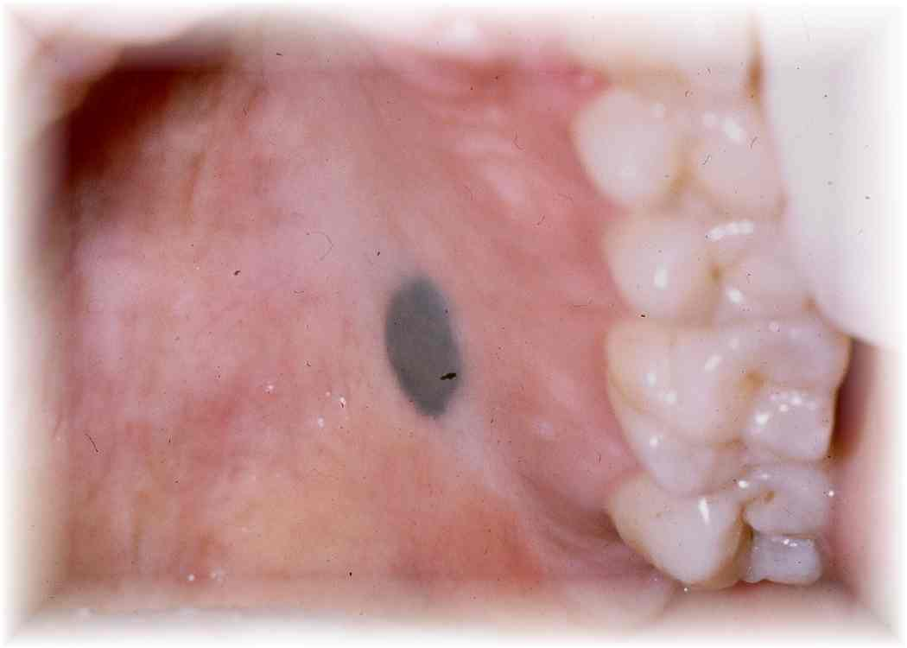
- They are usually elevated and are less than 1 cm in diameter.
- The most commonly affected site is the palate.
- It is not premalignant and asymptomatic.
- The reason behind its appearance is the increased secretion of melanin and we have proliferation of melanocytes also.
Remember: in Racial pigmentation we have fixed number of melanocytes, while in naevi the number of melanocytes is increasing.
Although there is no any risk from naevus, some authorities prefer to excise it for biopsy purposes, especially if it was in the palate or the gingiva (to exclude melanoma {will be discussed in the end})

- Peutz-Jegher’s syndrome:-
- It is a syndrome of benign intestinal polyps.
- In contrast to gardner’s syndrome, where we have polyps in the colon that are potentially malignant.
- The people that have peutz-jegher’s syndrome have also Macular pattern of pigmentation around the orifices (Nose, Mouth…etc).
- These intestinal polyps found in this syndrome may cause obstructions and make the patients more prone to cancers.
- Thus, patients having this syndrome should be monitored and followed up closely.

Now we will move on to discuss the acquired causes of oral pigmentation:-
- Endocrinopathies:-
- As we know, we have the endocrine system (The Adrenal cortex secretes cortisol. Also, the epithelial cells of the oral mucosa secrete cortisol, and they have receptors for cortisol.
- They include:-
- Addison’s disease
- Nelson’s syndrome
- Ectopic ACTH Production As we know Adrenocorticotropic hormone (ACTH) and Melanocyte stimulating hormone (MSH) are normally produced from the anterior pituitary, however we have some types of cancers that release ACTH, hence the name “Ectopic ACTH production” .
- PregnancyAlthough it is under the category of endocrinopathies, it is not a pathology, it is considered as a physiological process ( as a normal change in the endocrine system), not a pathology.

Now we will discuss each one in Details:-
- Addison’s disease:-
- As we know, the anterior pituitary secretes ACTH, which stimulates the adrenal cortex to produce cortisol.
- Sometimes we may have “Adrenocortical Hypofunction” due to (autoimmune destruction of the gland, malignancy, infection such as tuberculosis or histoplasmosis…etc). As a result the adrenal cortex will stop producing cortisol.
- The negative feedback mechanism on the anterior pituitary will stop, leading to more and more secretion of ACTH along with MSH, this will eventually lead to pigmentation.
- This resulting pigmentation will characteristically appear in the oral mucosa.
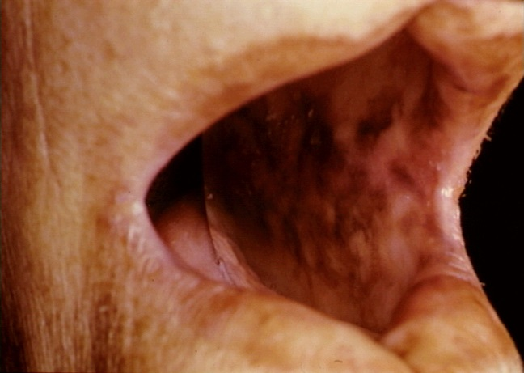
- Thus, the pigmentation seen in Addison’s disease is secondary to increased ACTH. (So the main problem here is the excess production of ACTH from the anterior pituitary not from the Adrenal cortex).
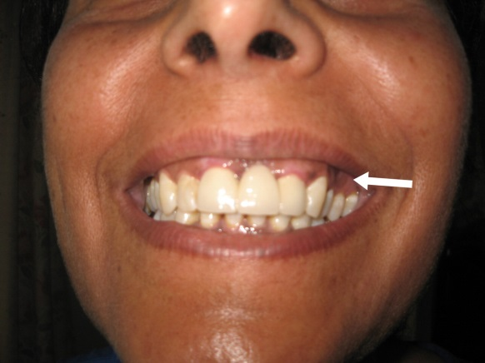
- Clinically, we have brown or black color anywhere in the oral mucosa (Tongue, floor of the mouth, gingiva, but most commonly it appears on the Buccal Mucosa this makes it easier to be detected.
- More than 75% of Addison’s disease patients have oral pigmentation, and maybe it is the presenting symptom of the disease.
- Sometimes the patient is still not diagnosed with Addison’s disease and you notice diffuse patchy melanotic pigmentation in the oral mucosa, and accordingly you decide that this patient requires further investigations.
- Before sending the patient to have further investigations, we have to ask the patient some questions in order to know if he has problems in the adrenal cortex.
- Usually these patients have:-
- Decreased levels of cortisol
- Decreased levels of Aldosterone As you know aldosterone helps in maintaining blood pressure.
- Fatigue due to hypotension.
- Hypoglycemia
- Thus, the patient will be complaining of fatigue, dizziness, and hypoglycemia.
- It is our responsibility “As dentists” to at least achieve the primary diagnosis (Preliminary diagnosis) of Addison’s disease.
- Simply, we have to order a serological test, which is serum’s cortisol level. Usually this test is done in the early morning (8:00am) in which the cortisol levels are in their highest levels.
- There is a certain level of cortisol (reference ranges for normal values), if the cortisol was lower than the normal values, then we will require further investigations.
- One of the further investigations is the “Synacthen Test”.
- In Synacthen test, synthetic ACTH is injected and we will monitor the levels of cortisol.
- Normally, the levels of cortisol should be high after the injection of the synthetic ACTH, which indicates normal adrenal cortex.
- However, if cortisol levels value is not raised, this will give us an indication that the patient has Addison’s disease.
- Thus, hypo functioning adrenal cortex will show no response to synacthen test (Synthetic ACTH).

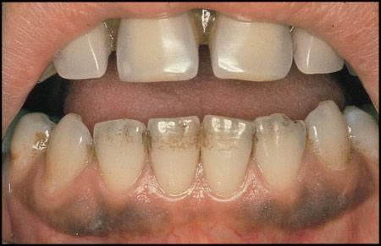
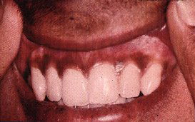
- Notice that the pigmentation appearing in Addison’s disease is very similar to the pigmentation occurring in smoker’s melanosis and racial pigmentation {Patchy Melanotic pigmentation}.
Racial Pigmentation
Smoker’s Melanosis
Addison’s Disease

- Nelson’s Syndrome:-
- We already know, Cushing’s disease in which we have increased secretion of ACTH from the anterior pituitary. As a treatment for this disease we perform Bilateral Adrenalectomy. As a result of the performed treatment (After resection of the adrenal cortex) the negative feedback mechanism to the anterior pituitary will be stopped, leading to increased and excessive secretion of ACTH and MSH and eventually with pigmentation (this is known as Nelson’s syndrome).
- Thus, Nelson’s syndrome is considered as a complication to bilateral adrenalectomy that is performed when treating Cushing’s disease.
- The difference between Nelson’s syndrome and Addison’s disease is in the percentage of developing oral pigmentation, in Neslon’s syndrome it is only 10%, compared to 75% in Addison’s disease. (Note that both diseases {Nelson’s syndrome and Addison’s disease} are the same in location, color and pattern).
- Ectopic ACTH production:-
- It is rare.
- It is due to tumors that are responsible for excessive amount of ACTH production such as “Bronchial Adenocarcinoma”.
- Oral hypermelanotic pigmentation is similar in pattern to addison’s disease {Patchy Pattern}, with additional involvement of the Soft Palate. {{This is the only difference that is a characteristic for bronchial adenocarcinoma, which produced the excessive ACTH}}
- Pregnancy:-
- We have oral pigmentation in pregnancy, but it is very rare.
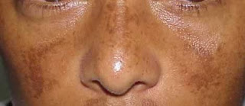
- Some pregnant ladies have what is so called “Chloasma”, which is a feature of late pregnancy.
- Chloasma Means pigmentation on the Face (الكلف).
- It can affect the oral mucosa, but this is extremely rare.
Q: If you find melanotic pigmentation in the oral mucosa of a pregnant lady, what do you think about its cause? {{is it a smoker or due to chloasma}}?
A: Smoker; because chloasma is very rare
- Smoker’s Melanosis:-
- Generally it is reversible, once the patient stops smoking the patches will start to disappear gradually, but it requires time (Months to years).
- Albright’s Syndrome:-
- It is another endocrine disease, it is considered as endocrine because the patients have:-
- sexual precosity (تطور قبل أوانه)
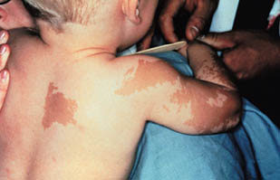
- Polystotic fibrous dysplasia (the bone is replaced by fibrous tissue)
- Cutaneaous hyperpigmentation ((Mainly))
- Although they can have oral pigmentation, its incidence is very rare and mainly its cutaneous pigmentation.
- It has a patchy pigmentation pattern.
- Notice Café-au-lait spots (the brown lesions)
{{As you have noticed, Most of the patterns were Patchy, and some cases were macular (ie: Peutz-Jegher’s syndrome)}}
- Metabolic:-
- The metabolic causes of oral pigmentation includes “Haemochromatosis”.
- Haemochromatosis:-
- There is excessive iron overload that will be deposited in the body tissues, such as the skin causing pigmentations.
- It is a genetic disease.
- The mechanism of iron overload is still unclear.
- It affects males more than females
It is less in females because the female menstruation will lessen the iron load.
- After the 5th decade (after menstruation of females) both males and females will be equally affected.
- When suspected haemochromatosis, the following investigations are required:-
  - Serum Iron It will be elevated
  - Total Iron Binding Capacity (TIBC)It will be reduced
  - FerritinIt will be elevated
- Biopsy from the liver (hepatocytes) will be required to see if there is overload.
{{All what we have discussed above (including endocrinopathies and metabolic causes) are considered as Generalized causes of Oral pigmentation.}}
- In addition to the generalized causes, we also have local causes of oral pigmentation and they include:-
- Ecchymosis Which is bleeding in the Submucsoa and it’s patchy in pattern (more than 5mm).
Ecchymosis is considered as a subgroup from purpuras (which is a bleeding in the submucosa), but it is so called “Ecchymosis” due to its patchy pattern.
- Ephelis It is similar to freckles.
- Melanoma which is a localized cause of oral pigmentation, it is Malignant.
The main difference between them is the texture
- Naevus
- Melanotic macule
How to confirm the diagnosis?
{By Histopathology, in the macules we don’t have increased number of melanocytes (it is fixed) we only have excessive pigment production. While in the naevus, we will have increased number of melanocytes.

- Tattoos includes (Amalgam tattoo, ink (it is similar to body to body tattoos, but in the mouth), graphite.)
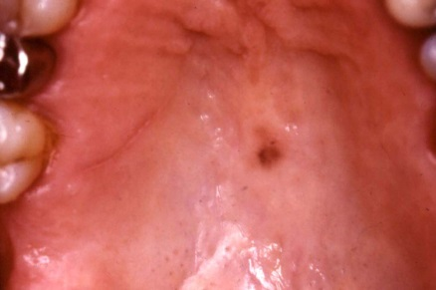
Now we will talk in details:-
- Melanotic Macules:-
- They are mostly seen in the Lips (upper or lower lips).
- They are less than 1 cm in diameter.
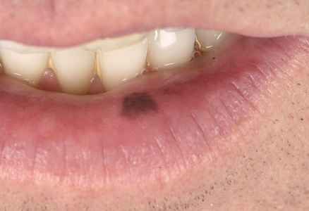
- They arise at any age.
- NOT premalignant
- Notice the melanotic macule in the palate (upper pic) and at the junction between the mucosa and the skin (second pic).
Q: What should we do when we find something like that when the patient comes complaining from this patch or macules?
A: Simply we take the dimensions of the lesion, record it in the patient’s file, then give him a review appointment in 3 months or 6 months and let the patient monitor the lesion. Unless, there is a change in size {indication of Melanoma}; because melanoma is a very sinister type of tumors since it grows rapidly, metastasizes quickly and it has a very poor prognosis.
Thus, we have to be sure that the lesion is not Melanoma.
- Tattoos:-
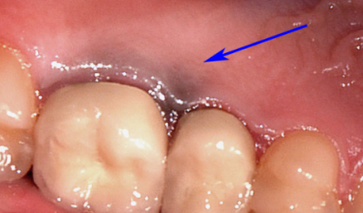
- The most common type of tattoos is Amalgam Tattoo.
- It is caused by either intentional (those who intend to make tattoos) or Accidental implantation of exogenous pigments. So it is not due to melanin.
- In some cases we may notice pigments around the gingival margins, which is due to accidental metal implantation of the prosthetic crown or bridge in the soft tissues (they appear as dark brown, black or grey)
- It is irregular in shape.
- For Amalgam tattoo, the main cause is due to “Silver Particles” that breakdown in the soft tissues causing the color.
- See the Picture in (Slide 24), Notice the extracted first molar, in this area it appears that during the filling procedure the dentist has wounded the soft tissues so the amalgam particles were embedded in the tissues and by time the silver particles gave this particular color of the palate.
- Notice that the wound occurred in the buccal mucosa (the other pic in the slide)
- How to achieve diagnosis of amalgam tattoo??
As we have mentioned, we have to exclude “Melanoma”, generally melanoma occurs in the palate or gingiva.
So simply you have to confirm that this is an amalgam tattoo not melanoma; because amalgam tattoo does not require any treatment.
To confirm that we should take a radiograph, and the radiograph should show us the radiopaque particles of silver.
If nothing appeared on the radiograph (No silver particles radio opacity) we should take a biopsy to confirm the presence of silver particles (they appear as black spots).

- Bacillary Angiomatosis (infection):-
- It is an infection that is considered as a local cause of oral pigmentation.
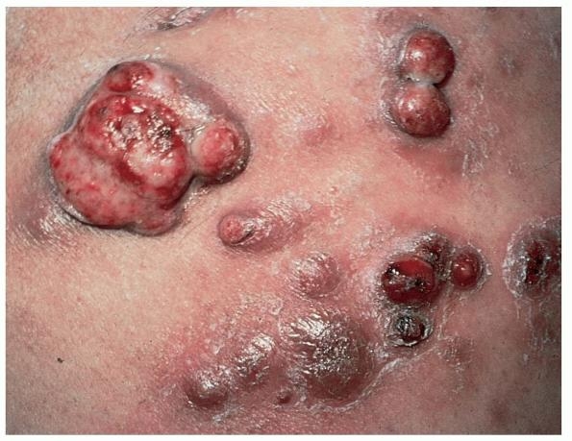
- It occurs in HIV patients only.
- It is caused by: Bartonella Quintana or Bartonella Henselae.
- It gives rise to pigmented nodules, not only in the oral mucosa, but also in the skin, bone and liver.
- The treatment of choice is an Antibiotic “Erythromycin”, so when we have bacterial infection we give an antibiotic.
- This lesion usually indicated HIV patient, but HIV test is required to confirm the diagnosis (ELISA test for HIV)
{{Note: Presence of thrush is also a diagnostic feature of HIV patients.}}

- Malignant Melanoma:-
- It can affect the skin anywhere.
- Fortunately, it is rare in the Head & Neck region and even rarer in the oral mucosa. However, it is hard to be diagnosed in the early stages if it occurs in the oral mucosa.
- Males are more commonly affected than females.
- It occurs in 50 years of age as other cancers and malignancies.
- When it is found in the oral mucosa:-
- It mainly affects the Palate, Maxillary alveolar ridge and the gingiva.
- The oral lesions may be “primary” or secondary to other tumors in other areas.
- The Clinical Appearane of malignant melanoma is Variable.
- It may appear as macule, papule or nodule.
- Sometimes it may appear as ulceration or swelling.
- When compared to Squamous Cell Carcinoma (SCC):-
- SCC appears clinically as white patch, red patch or ulcer or swelling in the oral mucosa. (Can appear in any of these forms).
- Melanoma is usually pigmented, but sometimes may appear amelanotic (mass without melanin; the melanocytes have lost the ability to produce melanin (malfunctioning)).
- The early recognizable signs of Maligmant melanoma are:
Assymetric lesions
Border irregularities
Color variation (the same mass may have brown, grey, dark or black color)
Enlarging diameter.
- The late signs of Malignant Melanoma are:-
Bleeding
Ulceration
Firm on palpation
Rock-hard regional lymph nodes
- Early diagnosis can be achieved when the diameter of the tumor is less than 1.5mm. Unfortunately, if it is 2mm or more in diameter, this means that it has poor prognosis. That’s why most of the patients that are diagnosed with malignant melanoma have poor prognosis.
- Malignant melanoma metastasizes very rapidly.
- Generally, it has a poor outcome.
- (See Slide 29), the picture on the left is malignant melanoma on the alveolar mucosa of the upper jaw. The other picture is malignant melanoma on the lip.
- Sometimes, we may have satellite distribution, the patches are separated from each other. (A number of satellites that are not connected with each other). (See slide 30)
Sorry for any mistakes
{{Best Wishes}}
Done by
Khaldoon AlQaddumi

