Inlays and onlays partial crown coverage
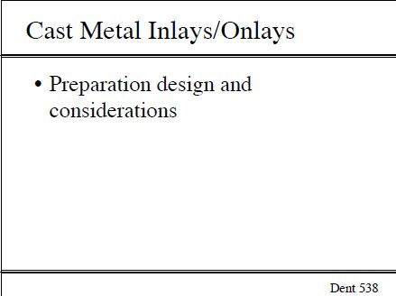
- Inlays: intracoronal preparation (class II :MOD with narrow isthmus /MO /DO)
- ONLAYS :intracoronal preparation with cuspal coverage also we can have extracoronal prep.
- The walls prep in inlays are divergent ,in the past they was making a beveling (flaring) on the cavosurface margins of the box walls and occlusal walls –inorder to do burnishing to the gold margins to get a good sealing with tooth structure during inlays casting
- Nowadays by using ceramics inlays restoration ---we don’t make a beveling on the cavosurface margins ---all what we do ,class II without beveling with divergent walls to allow the path of insertion of the hard object(prosthesis)

- Indications for inlays :
*as any class II :*small carious lesion
*adequate dental support
*low carious rate

Note: all of the intra coronal restoration should have low carious rate ---cuz the margins will be proximally and that might lead to the recurrent caries if we have high carious leasion(very important)

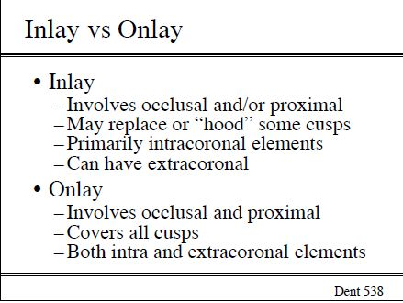

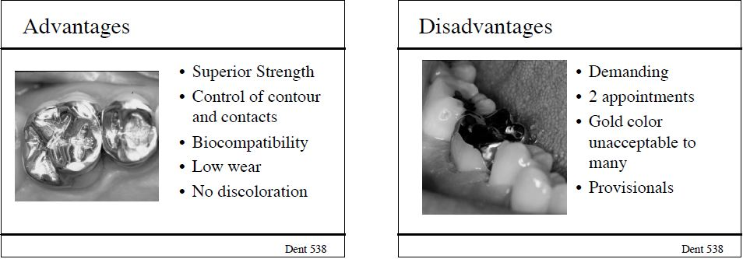

- Contraindication for inlays :
*high carious leasion rate
*small teeth
*badly destructed teeth---they will need full crown coverage

- When you do the flaring/beveling to the proximal + occlusal cavosurface margins we will get the wedging effect problem .

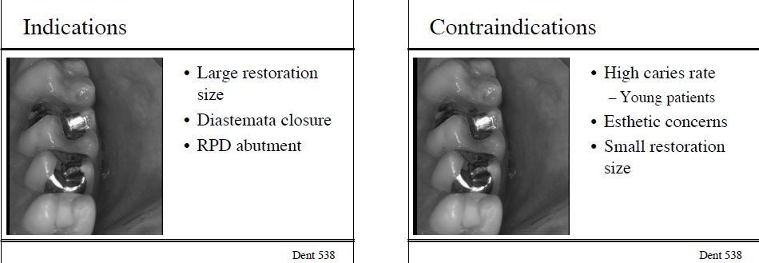

- when you do inlays/onlays to the tooth having RCT ,then if we have awall that is exposed to the occlusal load –this will lead to the tooth fractured –so we always what we do that the RCT tooth will be restored by the full coverage crown .
- wedging effect:when happened ?if we have very thin +long restoration within the crown –مثل كانك بتحط اسفين وبتكسر الشي لنصين .
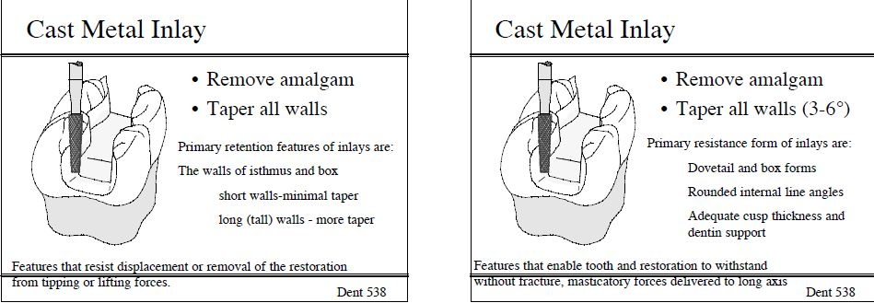
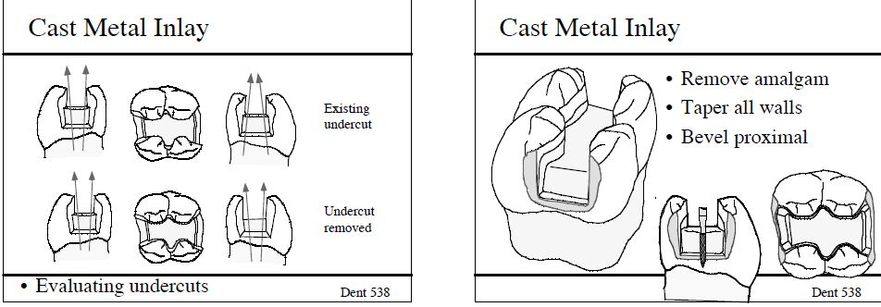
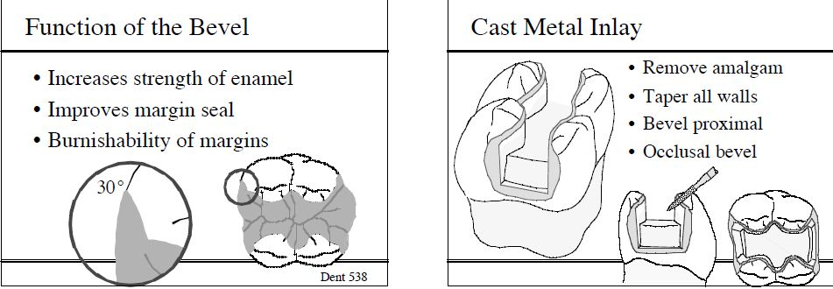
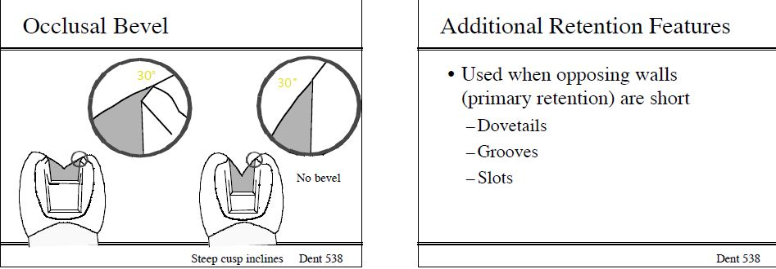
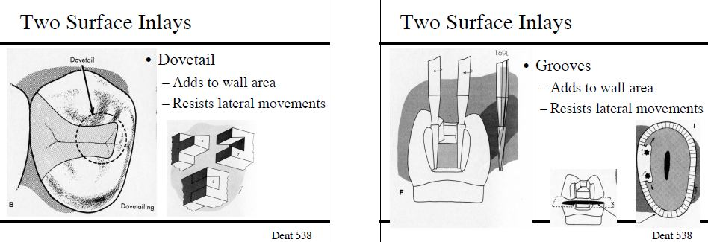
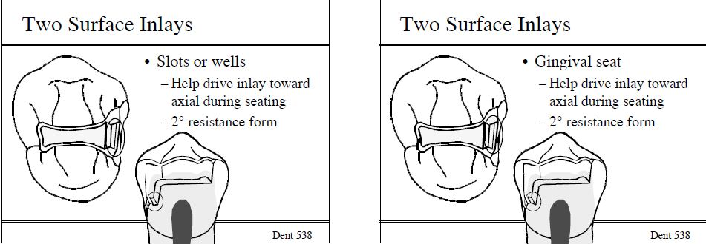
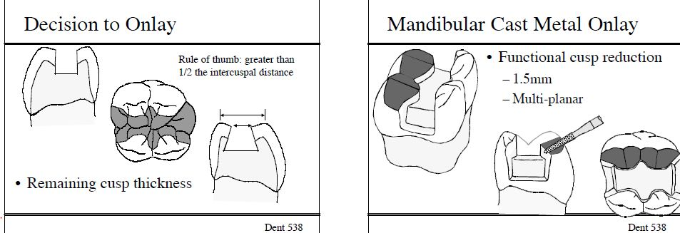
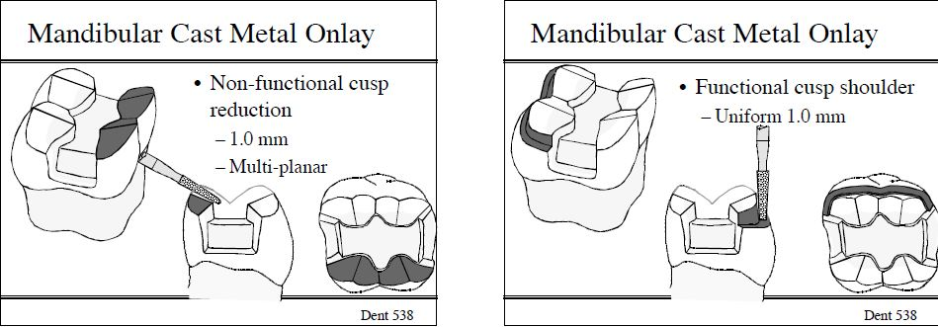
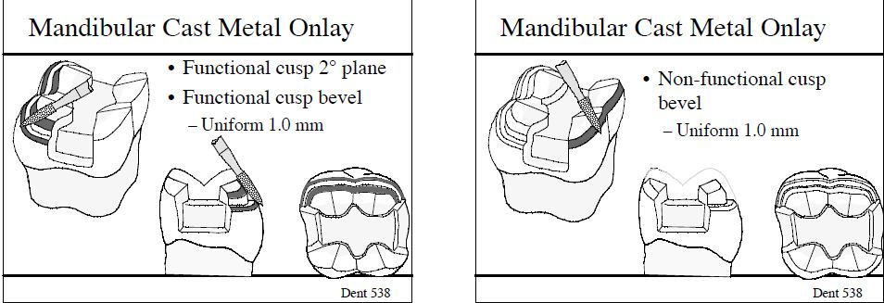
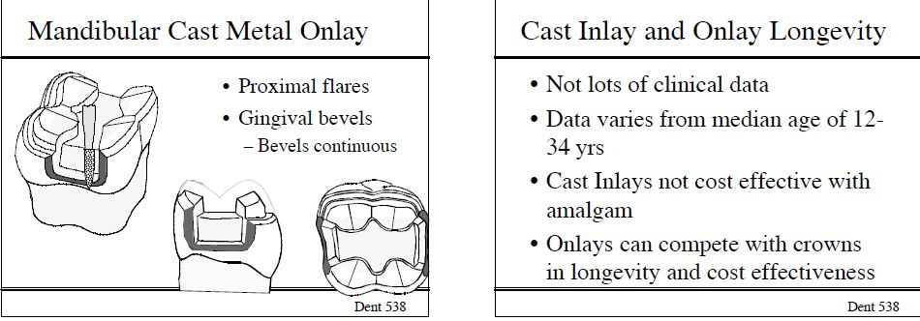
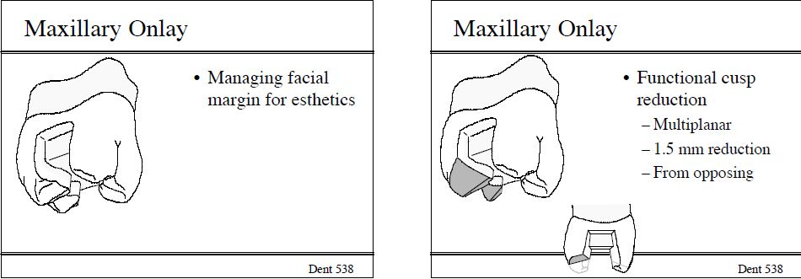
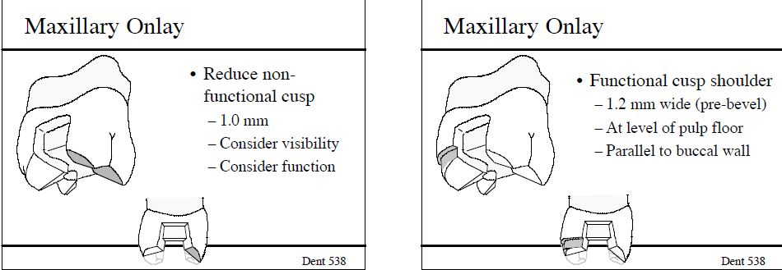
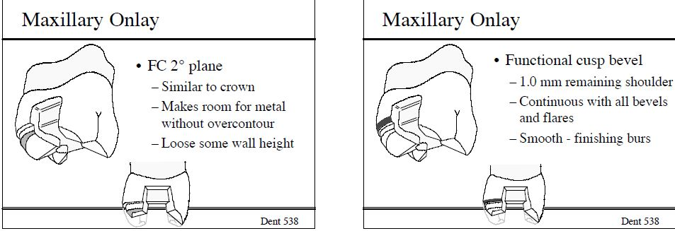
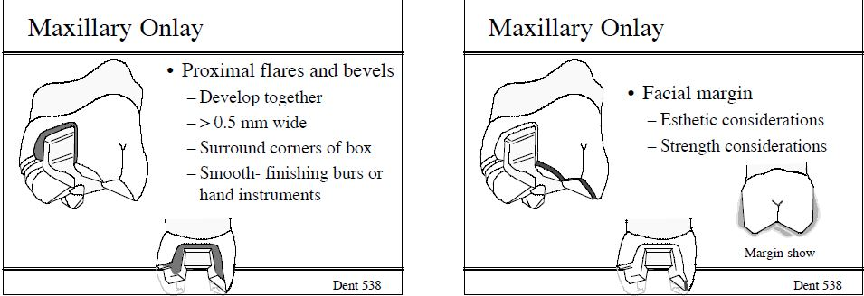
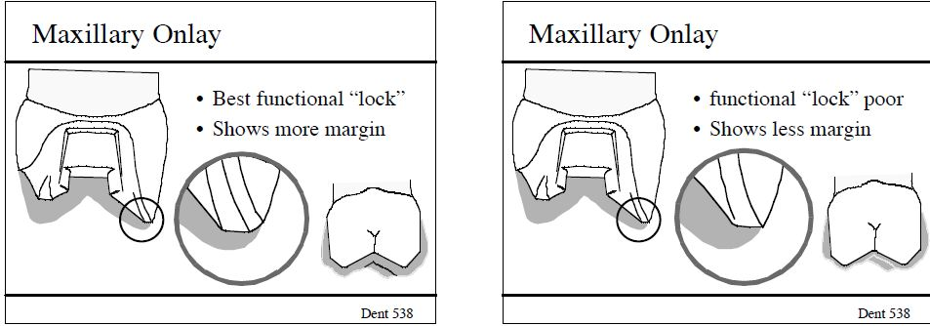
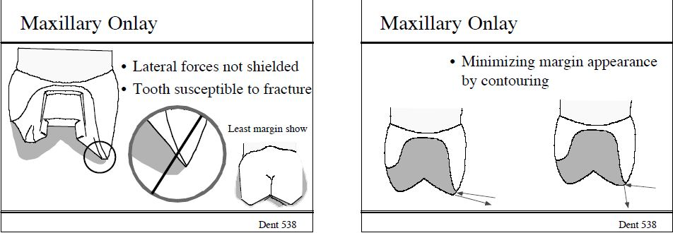

- disadvantages of the inlays:
- gingival extension beyond ideal :gingival extension sometimes will be not ideal (equigingival or supragingival),sometimes we should make our prep. Subgingival .
- less conservative than amalgum --cuz we have a flare /bevel at the margins and divergent walls

- advantages of the inlays :
- no discoloration
- no corrosion
- casting of partial coverage will be with less problems than the full coverage
- Avg longevity of it will be (20)yrs

- In the inlays we use resin-base cement as a stronge bonding agent with the tooth remaining structure
- Preparation :
  - Class II with divegent walls +beveling all around box +occlusal cavosurface margins –to burnish the gold margins
  - Gold margins ---take very thin sections ,burnishing the gold margins will make good sealing with tooth structure
(this allow the gold cast to make a good sealing with tooth structure)
- Internal line angles with roundation for good retention (on the axial walls),without beveling to the cavosurface margins in case of ceramics or composite resin

- Onlays :
*intracoronal restoration with functional cusps coverage (or cuspal coverage)
- We have in onlays –more tooth structure damage ,but in inlays less tooth structure damage .
- We always prefer for RCT teeth to do a full tooth coverage to avoid root fractured .

- Indications:
- Intact buccal wall
- Lingual cusps involved in the caries (FC for upper teeth for example)
Note : we don’t involve the buccal walls for cosmetic /esthetic effect
- MOD –amalgum :بنبدلها ب onlays
- Low carious lesion rate
- Pts request :metal restoration or ceramic restoration

- Contraindications:
- short lengthening of the crown
- high carious lesion rate
- poor plaque control

- advantages :
- longevity
- highest strength in comparison with other restoration '
- support to the FCs

- disadvantages:
- lack of retention cuz the tooth is badly destructed
- less conservative than amalgam cuz we have divegent walls
- gingival extention beyond ideal

- preparation:
- level of intracoronal floor =level of shoulder finishing line of the functional cusp prep.
- Beveling on the cavosurface margins of box +occlusal margins(on gold restoration only_)

Done by :ashwawq kareem and sally al-derawi
Good luck

