Crown and bridge
Dr. moh rbaba
Lec date 10.10.2013
Sheet num 4

Porcelain fused to metal
Introduction
Porcelain fused to metal crowns (or PFM crowns) can be referred to as full-cast crowns which has porcelain fused on most or all parts of the tooth. Metal alloys with a high melting temperature are used to fuse porcelain to the surface and preventing the metal from melting. This ensures the porcelain to bond without changing its color.
When the tooth is prepared for such crowns, a large part of the tooth tissue gets removed making space for porcelain as well as the metal.
Porcelain crowns are the most preferred crowns as they easily match the color of the adjacent teeth better than the metallic crowns. However, they cause more damage to the opposite teeth than the resin and metal crowns. Some cases show that the porcelain portion of the crown can also break or chip off from the teeth.
In receding gums, such crowns are not suitable as the porcelain can start showing distinctively. They are best suited for the back and front teeth.

Porcelain fused to metal pfm (ceramic restoration)
Restorations … pfm,full metal,all ceramic (metal free)
PFM used in long spans because all ceramic (metal free) are brittle although its esthetically acceptable
Cost is option of comparison between both of them
PFM and all ceramic (metal free) are used in case of sub gingival ,But full metal is used in equal and supra gingival
Metal has corrosion and surface not glassed as compared to glazed porcelain soo glazed porcelain is used subginigvally
U should know that old ceramic restorations have alumina oxide which made it brittle

Pfm when we use cr-co .3-.4 or ni-cr we have .6-.7 optimal reduction (semiprecious)
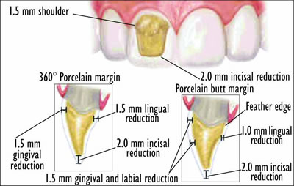
Oclusal and incisal reduction 1-2 mm

Advanteges:
Esthetic
They have a very high rate of success in the long run.

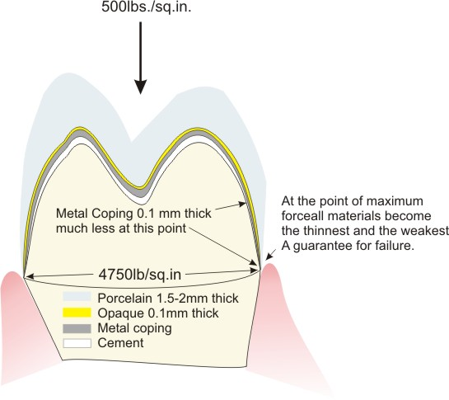

Dis advanteges:
Brittleness-
Expensive -
Reduction more -
Color not like adjacent -
-Occlusion adjustment not easy soooo we make occlusal adjustment when the porcelain in biscuit stage (like cookies :p) in this stage porcelain bkoon rough and not glazy ( articulating paper gives good result here we can see the marke) but when the porcelain is glazy we cant mark it easily with articulating paper so try in is used when porcelain in biscuit stage.

When the patient is allergic to metal we use all ceramic not pfm

In old gold restoration there was a thin ridge that extend labially .. metal will appear when gingival recession occurs
Bevel area where used in old gold and s.alloy restorations ( bevel not used today ) so best way shortness of metal not to appear

Dr showed cross section of pfm :
Here the layers ,,,,
Metal-
-opaque layer
-porcelain body
…The opaque layer is used to mask metal

PFM finish line is wide labially and thin lingully ….. thin metal beyond contact area *
Characterization porcelain means stimulate the natural teeth *
Finish line in PFM is .6 mm *
*When we have wide Finish line extende from pox-prox and lingually thin we will get what is called wing … pfm is wingless because Finish line is decreased gradually
Wing is produced by the difference between labial and lingual preparation
*We know that the angulation affect dislodgment so it should be within 10 degree (taper)
And pfm there is more reduction so take in consideration the pulp champer esp in children large( champer)

*Epithelium attachment: with enamel above CEJ 1mm
C.T attachment :cementum and gum directly (above the alveolar bone) 1 mm
Sulcus is .7 mm… but proximal sulcus is larger because of (papilla)
biologic width= epithelial attachment + c.t attachment = 2 mm
biologic zone = epithelial attachment + C.T attachment + sulcus= 2.7 mm

other names of biologic zone :
dentogingival complex
dentoginigval unit
supra crestal gingival tissue ……….note interdental bone = crestal bone

SAMI = supra alveolar mechanical interface .. not advised to go through all the sulcus half is enough .2-.3 mm
SAMI … eldoctor e5tr3ha :p
specular transmition how porcelain appear with room light
There something called indicial porcelain to stimulate natural tooth
Harmony mean right and lift side are the same

Dr said that we should study the book

Jehad bzour

