Today our lecture is about complete cast coverage (full metal restoration).
Nowadays, full metal is “not the trend”, but it’s still used in some countries where crown and bridge care is provided as part of the health insurance plan -in case there is no ceramic-. The metal is covered with acrylic facing buccally or labially “acrylic jacket”, or with porcelain “porcelain jacket”.
* This is a Full metal gold (gold alloy 70%gold)
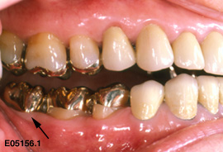

* Porcelain Fused to Metal (PFM)
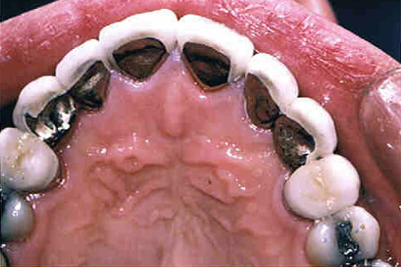
بالنسبة للcore:
Prefabricated posts with composite build up (core) are the strongest and also stronger than cast post because in cast post the post is tapered and so only the cement is holding it in place, while the prefabricated post is reamed by a reamer “held by friction” plus the composite binds to the tooth structure as we know. 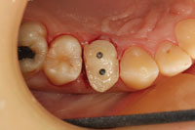
Indications for full metal (or crowns in general):
1-extensive destruction from caries (badly destructed teeth can fracture if we put amalgam or even composite, because of the thin walls remaining and high occlusal forces 300-500 N)
2- Endodontically treated teeth
3-existing heavy restoration
4-necessity or maximum retention and strength
5-to provide contours to receive a removable appliance (like an abutment for co/cr partial denture)
6- Correction of occlusal plane and mal occlusion (like in case of over-erupted teeth, we have to prepare them and put a crown in some cases)
7- Recontouring of axial surface (minor corrections of mal-inclinations)
_________________________________________
Contraindications:
1- In cases with no necessity
2- It’s not exactly pretty! So esthetics too
________________________________________
metal types:
1- precious (like gold and silver) … in this type you can get thin sections up to 0.2 mm and is malleable
2- semi-precious ( like gold ALLOYS)
3-basic
Advantages of full metal:
In full metal we do less reduction than in porcelain fused to metal preparation (because we have two materials in PFM that we need to consider ).. So metal is more conservative and is:
1- Strong
2- highly retentive qualities
3-usually easy to acquire adequate resistance form
_____________________________________
Disadvantages:
1- Removal of large amount of tooth structure (but it’s still the most conservative in comparison with PFM and metal-free crowns)
2- Adverse effect on tissue (like any other material, metal can cause irritation or allergy)
3- Vitality testing becomes difficult to do and not readily feasible
4- Display of metal –esthetics-.
Burs used in reduction (in general):
thick chamfer (we start with it)
thin chamfer (interproximally)
deep chamfer (for finish line)
finishing burs
wheel / flame coarse grit - for rough preparation- ( both used for occlusal or cingulum reduction)
notes: 1-shoulder bur is not needed anymore
2-for full metal preparation purposes we only need thin chamfer ( no need for thick one)
Also in full metal:
occlusal reduction = 1.5 (To withstand occlusal forces)
axial reduction=1 mm
finish line= around 0.5 mm
optimal taper= 6 degrees
accepted taper= from 5 degrees – to 25 or 30 degrees (the retention will be accepted in this range)
-Clinically it’s hard to get optimal taper (6 degrees) , usually we get (20 degrees).
- We don’t account for the cement thickness while preparing the tooth
- The thicker the cement is the lower the frictional force is going to be (so need thin film of cement)
____________
Preparation technique:
1- Start with making occlusal reduction
**follow the anatomy of the tooth unless it’s rotated in order to change its rotation
**make guiding grooves
2- Focus on taper … taper prevents dislodgement (ideally 5-6 degrees )
3-Pulp chamber affects the preparation (the older the person gets the smaller the pulp chamber gets)
4- The finish line ideally is equigingival but if we enter subgingivally the biological width changes (the crown lengthens?)
Finish line ideally has an angle of slightly higher than 90 degrees , the difference between shoulder and chamfer is the fact that chamfer bur gives us a rounded angle .
Most dentists stopped using shoulder bur because it concentrates stresses, and because CAD/CAM doesn’t work well with shoulder. So use deep chamfer
note:
I wrote extra notes for those interested in the question the doc asked and for those who want to know what CAD/CAM machines do
WHAT DO WE MEAN BY THE BIOLOGICAL WIDTH ?
The biological width is defined as the dimension of the soft tissue, which is attached to the portion of the tooth coronal to the crest of the alveolar bone. This term was based on the work of Gargiulo et al.
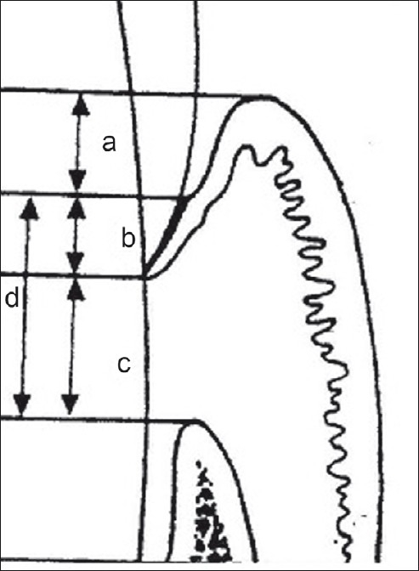
(a) Histological sulcus (0.69 mm), (b) Epithelial attachment (0.97 mm), (c) Connective tissue attachment (1.07 mm), (d) Biologic width (b+c)
_______________________________________________________________
CAD/CAM

CAD/CAM dentistry (computer-aided design and computer-aided manufacturing in dentistry), is a field of dentistry using CAD or CAM technology to provide a range of dental restorations including: crowns, crown lays, veneers, inlays and onlays, fixed bridges, dental implant restorations and orthodontic appliances.
Typically CAD/CAM dental restorations are milled from solid blocks of ceramic or composite resin that closely match the basic shade of the restored tooth. Metal alloys may also be milled or digitally produced.
After decayed or broken areas of the tooth are corrected by the dentist, an image (scan) is taken of the prepared tooth and the surrounding teeth. This image, called a digital impression, draws the data into a computer. Proprietary software then creates a replacement part for the missing areas of the tooth, creating a virtual restoration. This is called reverse engineering. The software sends this virtual data to a milling machine where the replacement part is carved out of a solid block of ceramic or composite resin. Stains and glazes are fired to the surfaces of the milled ceramic crown or bridge to correct the otherwise monochromatic appearance of the restoration. The restoration is then adjusted in the patient’s mouth and cemented or bonded in place.

