Try-in and evaluation of crowns
Before placement ofthe crown permanently in the patient’s mouth , many things must be checked
For PFM : 2 steps for try-in :
1) Metal try in(substructure of crown): if it’s in the right way , then we build porcelain on it .
2) Porcelain try in.
Metal Try in
At the beginning , check it on the cast , because definitely , any problem appears on the working cast will appear also inside the patient’s mouth.
What you check on the cast
( this step needs good light and magnification )
1. Marginal integrity: This includes marginal fit and adequate finish line adaptation.
2. Fit "the crown fitting on the prepared tooth"
Errors that could happen:
Error | Cause | Remedy
No die spacer  (Space needed to  accommodate cement lute ) | 1.Technician not aware of technique or  2.forgot to apply | Lack of spacer results in a tightly fitting crown which may not seat during try in and may ‘lift’ further after cementation
Damaged dies | Finish line chipped because of careless handling or abraded when casting reseated with blebs or overextended margins | Always try and determine why the die is damaged. If the crown does not fit after adjusting blebs or over-extended  margins return it to laboratory
Casting blebs on  fit surface | Air bubbles trapped during investment | Identify under magnification and remove with small round bur

*Fitting surface on the crown and die : shouldn’t be touched by a bur or whatever (holy surface) , the only reason to touch is removal of small blebs (needs good light and magnification)on the crown.
* die is made of stone type 4 or 5 . although wear resistance for them is very high , if you insert and remove dowel pins(metal) many times stone will abrade as a result , the crown will not fit inside the patient’s mouth.
* In case of no die spacer : should be returned to the lab to redo the crown again.(to put die spacer and make a new crown).

Now , you finished checking your crown on the cast and everything is good , next step will be checking the crown inside the patient’s mouth
3 things must be checked :
- marginal integrity
Three options
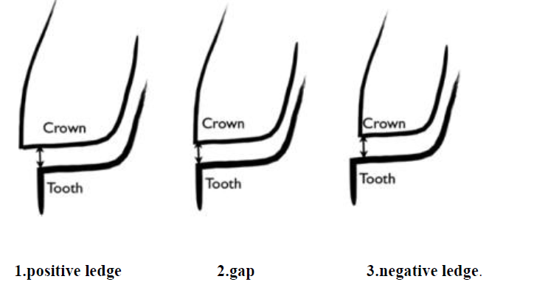

- Stability of your metal coping, no rocking and no rotation. Rocking could be caused by:

- Existing blebs and nodules.
- Metal distortion (happens most commonly in long span bridges and uncommon in single crown ).
Be aware we check stability not retention , because final retention occurs when cement fills the space between the preparation and the crown ,so in this step if the crown is loose not a problem.
- Substructure design (metal framework) : in this step , check the following :
- Clearance(adequate space) for porcelain .
- Connector design : if it’s with adequate dimensions , very thin , very thick ,….
- Pontic design .

Pontic : no prepared tooth underneath (space in the ridge filled with pontic).
4 types of pontic design :
a. Saddle pontic
b. Modified : space lingually , allows cleaning
c. Conical or egg shape: put in the socket immediately after Extraction
d. Hygienic (open) : most hygienic type , patients don’t like it .
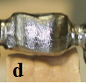
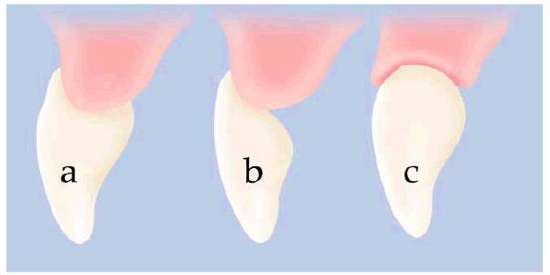

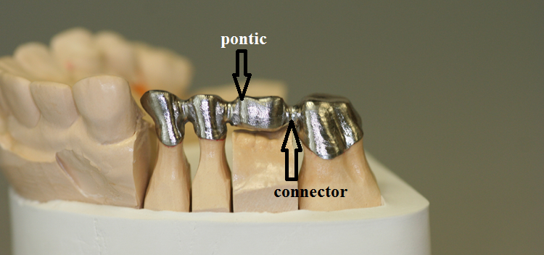

So, after you finished checking metal , send it back to the lab to apply porcelain, unglazed is preferable why ? :
- You can’t modify occlusion with glazed porcelain because articulating paper will not mark on it .
- When doing modifications on glazed porcelain with a bur , you must send it back to lab to reglaze , many times bad effect on porcelain ,also unnatural and glassy appearance .

Next step will be
Porcelain Try In
- First clean your preparation, don't leave any residual cement(which used to cement provisional crown ). To allow seating and because eugenol – containing temporary cement will affect permanent resin cement.
-Check for imperfections on the fitting surface, like blebs or nodules that will prevent full seating of the crown (that should've been checked in the metal try in).
What should we check in porcelain try in
1. Check the proximal contacts: we start by checking contacts; if it didn’t fit correctly we can't check others.
2. Check marginal integrity.
3. Check the occlusion.
4. Check esthetics.
5. Pontic design & connectors.
This sequence is very important to follow: because if you check marginal integrity 1st and there is a gap , the cause may be tight proximal contacts for example .

1. Check the proximal contacts(shape , size , and tightness).
-Proximal contacts should be tight enough to allow unwaxed dental floss to snap easily.
-Location, size and tightness should resemble that of natural teeth , not very wide ,not pinpoint .
-We could locate tight contacts (floss didn’t get easily or that contact prevents the crown to be seated completely) by using disclosing wax, pressure indicating spray or using articulating paper.

1. Tight contacts:
A. Floss didn’t get in, or it didn’t allow the crown to be seated, we put the articulating paper, then we push in the crown , and relief the area of high contact.
B.We remove slowly and try the crown in again until it get seated easily, if you removed quickly, you might remove more than needed and result in to open contact, and in this case you should send it back to the lab.
C.Burs used (high speed diamond burs) & (finishing burs that we use in composite, rubber wheel, disks and stone..Etc.)
-So, How do tight contacts occur?
1. When preparing the dies the technician might have taken from the adjacent tooth, so the crown will have more space on the cast than in the patient's mouth.
2. Small abrasions; when waxing up the preparation, the technician abraded the adjacent tooth Intentionally because tight contact is better than loose contact , so doing that to guarantee presence of contacts (abrasion to the stone).
3. Small micro movements of the die (can’t be seen with naked eye). Make tight contact on one side and open contact on the other side .
- Die on the cast : you can remove it from the cast and insert back (why?) to carve a precise margin .
Ditching : when we carve the prepared teeth just below finish lines to clarify them more.
Aims of ditching : 1. Clarify finish line 2. Determine emergence profile of the crown 3.allow carver to enter this important area
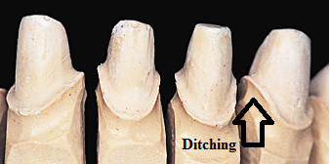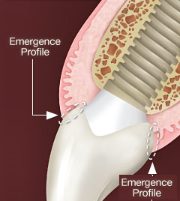
2. Open Contacts:
a. In gold crowns, we can add some of the alloy using solder.
b. In porcelain crowns, we can add another layer by using LOW FUSING ceramic, so it doesn't affect the already set porcelain. because if I used high fusing ceramics to add ,the already existing ceramic will melt.( very important )
c. In metal crowns , must redo the whole crown , you can’t add on a metal crown
2.Marginal Integrity:-
-After checking the proximal contacts, we check marginal integrity in the patient’s mouth using a probe; going back and forth between the tooth and the restoration.
For proximal margins , sometimes you may take radiograph. This method is not accurate 100% .
The best way is clinical judgment .
Poor fit means distance more than 50 microns (which equals the tip of a brand new probe) .
If there’s a catch = error.
Look at this pic , why this problem may happen ? it occurs when the Technician try to make ditching and by fault cut part of already prepared surface , then he do wax-up and final restoration will appear like this (negative ledge).
According to ability to modification :
Positive ledge : trim part of crown.
Negative ledge : you can add and this depends on crown type.for example porcelain crown : add low fusing porcelain , in some materials you can’t add , so you must redo the final impression.
Open ledge = gap : the worst of all , you must redo the impression and all next steps .
If these faults remain : plaque accumulation , gingivitis , periodontitis ,…
Causes of an underextended crown margin(Negative ledge):
1. Poor impression technique. 2. Poor die trimming. 3.Unclear finish line
For underextended crowns we don’t prefer addition, we usually send a new impression back to the lab and make the crown again.
-Causes of an overextended crown margin:
1. Poor impression technique. 2. Poor die trimming. 3.Excessive wax.
For overextended crowns could be adjusted clinically by trimming from axial surface.
trim axially

not from fitting surface = will make open margin

3.Esthetics:-
- We should check Esthetics that includes (Shade, Morphology & Alignment)
Sometimes for anterior teeth we can use burs to adjust the crown inside the patient’s mouth (ex: incisal edge roundation).
Minor changes in shade is possible (light crown may be changed into a darker crown using stains) (what’s light can be darkened, but the dark can’t be lightened) .
Sometimes just in all-ceramic crowns we can use a darker cement that could make the shade better (darker as I want). This is applicable in impress (glassy) porcelain = very translucent.
But zerconia is very opaque , so anything underneath will not affect its color.

4.Occlusion: -
-You should always check your occlusion on unglazed porcelain .
- High occlusal contacts may cause:
1. Pain to the patient.
2. Occlusal trauma ( & mobility of teeth ).
3.Fracture.
4.Displacement.
How to check occlusion : for example : you will apply a 3-unit bridge (5.6.7),patient has the 4 on the same side : before you insert the bridge : check the contact point on the 4 and also these on the opposite side , then you insert the bridge , the contact points on the 4 and these on the opposite side must appear again , using articulating paper , any high occlusal contacts must be trimmed until reaching the previous contacts .
*Start with maximum intercuspation , then check occlusion at lateral movements .
*When I design my brigde on canine guidance , then any contact on canine must be trimmed to prevent any contact on it.
*The aim of occlusal checking to have harmonious and even contacts on all teeth.
*Shim stock : very thin layer (thinner than articulating paper),used to check occlusion , when the patient closes his teeth on it can’t move = tight maximum intercuspation which’s a good thing I want.
*For anterior teeth : if the patient’s teeth have light contact in maximum intercuspation , then on you porcelain teeth apply the same light contact . this will guarantee the harmony between your restoration and the already existing teeth .
*Avoid infraocclusion : will cause overeruptoin of opposing teeth ,later will cause occlusal interferences( these interferences may : 1. Tolerated by the patient. 2. Wear on cusp tip tha has interference 3. Mobility = occlusal trauma 4. Tenderness. 5. In very severe cases , muscles and TMJ problems 6. Fracture for your porcelain ).

5.Pontic design and connector:-
-Check your pontic design and the cleansibility of your embrasures , at the same time , these embrasures don’t interfere with esthetics .
Make sure that interdental brush enters easily in spaces , or may use super floss to clean area under pontic .
6. finishing and polishing :
If you made just small touch on the occlusal surface, you can polish it in the clinic using composite finishing diamonds ,then rubber points and finishing pastes , but if more than this , send it back to the lab to polish it.
For metal : rubber and stone polishing .
For porcelain : inside furnace by heat (glazing), rough porcelain may break or it will abrade opposing teeth .

