Conservative lec #4
Dr. Jamal Aqrabawi
Date: 20/10/13

Today we'll start talking about anesthesia, anesthesia is very important while treating the root canals to control the pain, it will earn the patient confidence and cooperation and influence the patient desire to save the offending tooth.
Pain is a major complain that bring patients to dentists clinics, so pain is very important to us as endodontics, you can't work on patient while he is in pain, if you can't get him numb, you will send him home.
There are some factors affecting endodontic anesthesia:
1) Comprehension and anxiety:
Most of the patients have anxiety toward dental treatment, they used to hear horror stories about root canal treatment.
They have fears because they don't know how the procedure will be.
These emotions play a role in their perception and affect how they react with pain.
So comprehension and anxiety are very important to take in consideration when we're going to numb the patient.
2) Fatigue:
Patients experience fatigue in our clinics because they didn't eat or sleep properly, as a result they will have decreased ability to manage the stress.

3) Tissue inflammation:
It causes a decreased threshold of pain perception, this is called "allodynia phenomenon"
This means a tissue that is inflamed is more sensitive and reactive to aa mild stimulus, simple touch on the inflamed tissue will cause a big reaction. "allodinal phenomena"
4) Previous unsuccessful anesthesia:
This will lead the patient to think that anesthesia doesn't work with him, he will start telling you that one shot isn't enough to get me numb or anesthesia doesn't work with me and things like that.

If the patient has one of the following medical conditions, he shouldn't receive local anesthesia with vasoconstriction:
Cardiac disease, myocardial infarction, stroke with the previous six months, severe hypertension, uncontrolled heart failure.
All these conditions contraindicate giving the pt. local anesthesia with epinephrine (vasoconstrictor).
Pts. With Hodgkin disease or breast cancer are at risk of radiation induced coronary artery disease, therefore, reduced dose of local anesthesia with vasoconstrictors should be considered.
Mandibular anesthesia is done through inferior alveolar nerve block, which will anaesthetize half of the mandible, in addition long buccal nerve block is helpful to anaesthetize lower molars, and some think that no need to do it but actually it helps a lot.
How to know if the pt. is numb or not?
We check the lip numbness but it's not an indication for pulpal anesthesia. (If the lip is numb that doesn't always mean that the pulp is numb).
But if the lip isn't numb that always means the pulp isn't (failure of anesthesia).
In the maxillary anesthesia we use the infiltration, within 5-7 mins will reach a good anesthesia and it lasts for 20-30 mins in the anterior teeth and from 30-45 mins in the posteriors.
The infiltration for the upper teeth is easy but you have to make sure to reach the root not the half way, you have to be close to the apical foramen.

We have different anesthetic agents like Lidocaine and Xylocaine we'll not go for their details.
One important thing about a local anesthetic called Articaine is it's produced recently by the U.S in 2000 and will give a better anesthesia, many studies proved that it's safe and effective, it's the newest dental local anesthesia.
Imagine that infiltration anesthesia in the LOWER 2nd molar with Articaine will work and give us a good anesthesia in 63% of cases.
So that's good when we can't give ID block we give Articaine infiltration.
In endodontic treatments we have what's called supplementary anesthesia, there are three types of it:
1) intraligamental
2) intraosseous
3) intrapulpal.
If we gave ID block and the lip got numb but the pulp didn't, we choose one of these three methods.
The intraligamental injection
success rate is (50-96) %, intraligamental injection doesn't mean we inject the periodontal ligament, actually we enter through the ligament, we bend the needle and enter the sulcus , we go deep then we do the injection, and it's not a continuous injection because we have a resistence from the tissues, we use intermittent term of injection (pressure then release), on the four sides (lingual, mesial, buccal, distal).
So in this method we don't anaesthetize the periodontal ligament we anesthetize the cribriform plate around it.
It's painful in the anterior teeth while in the posteriors it causes a mild discomfort.
The onset is immediate; you can start immediately after this injection.
No significant change in the heart rate or blood pressure occurs after this injection.
We can use our regular needle (we bend it and do the injection), but it has a special gun for this type of injection, it's called the pressure syringe.
Intraosseous injection
-it is immediate
- The key of success is to ensure the flow of the solution into the cancellous bone
Here we're going to anaesthetize Intraosseous (from its name) so it will go to the bone,
How we will transfer it to the bone?
The best time to use an intraosseous injection is when the lips are numb after an IAN nerve block
It’s a supplemental injection after we did the IAN block after the pulp gets anaesthetize, and then we did the Intraosseous
We don't want to do the intraligamental, because we don't have the pressure gun and the syringe, so we will try the intraosseous.
It has two types of instruments:
1- Needs a drill (perforator), 2- and 27 gauge ultra short needle.
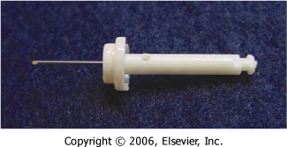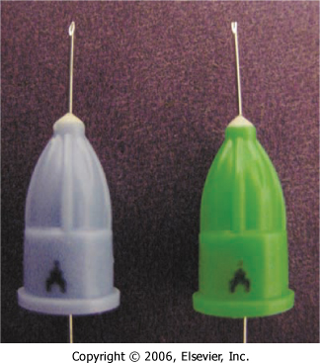
The optimal location for injection is always distal to the tooth except in the case of second molars where the bone is too dense distally.
So we want to anaesthetize 1st molar, we have bone perforator (it sits on a slow speed handpiece) it is like a small "Nail".
Intraosseous injection:
-no significant changes on blood pressure.
-it causes less pain than intraligamental injection. And compared to infiltration, it has a quicker onset and a shorter duration.
-postoperative complications include swelling and exudates at the side of the perforation (but it is transient things and subset very easily).
- Intraosseous injection is very effective one.
Has two types of systems (instruments):
-the Stabident system
- the X-Tip
As an endodontists, there is no way that you can work on the patient while he is in pain, we should do everything possible in order to numb the patient (if you can't, send them home)
The Stabident system:
is composed of a driven perforator (attach it to a SS HP) we come to the buccal&mesial area of the lower 1st molar, we operate the handpiece an drill with this small "nail" and perforate through the gum and the bone, so we make an opening that will make a passage for the needle and we make injection for the anesthesia (it will give you a good anesthesia for the bone) and it will go to the cancellous bone around the tooth.
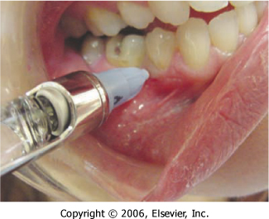
The X-Tip:
Has a tip that separates into two parts, the guide sleeve and the drill. After the perforator guides the sleeve through the cortical plate, they are separated to leave the sleeve in place to guide the needle insertion. (So it has a definite clinical advantage)
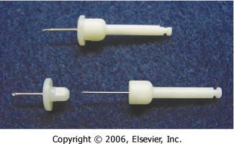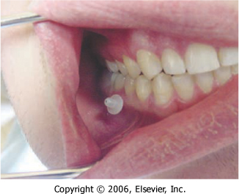
Either system produces moderate to severe pain upon perforation and solution injection in patients with irreversible pulpitis. Less pain is reported when the tooth is asymptomatic.
Both systems are equally effective.
Intrapulpal injection:
The needle is placed and the injection is made directly over the sensitive and vital pulp.
We give IAN block (doesn't work) and I don't have the instrument for the intraosseous and the pressure syringe for the intraligamental so we give intrapulpal
Intrapulpal injection you will hurt the patient a little bit ex.
You are drilling and you reach the dentine and the patient start to feel a little discomfort we will make a small slot to the pulp with the bur so we can now insert the needle into the pulp chamber and push the anesthesia into the pulp so the pulp gets numb (notice here that the pressure when we inject is the responsible for making the numbness not the anesthesia) so now rapidly we drill fast with the bur to remove all the coronal pulp, because the intrapulpal anesthesia won't last for long
So whenever there is a discomfort in the canals when you are cleaning them you give intrapulpal and rapidly with the file remove the remaining pulp tissue
Intrapulpal injection:
-provide profound anesthesia because it is delivered under pressure.
-the onset is immediate.
-It is indicated when there is a vital pulp only.

Management of specific clinical situations
Ex. If a patient comes to the ER and he has a swelling in the mandible and he is in deep pain, what will you do for him?
-injection into the abscess or Intrapulpal is CONTRAINDICATED
We do an incision and drainage (in mandible we give IAN block – but in maxilla we go mesially&distally(periphery) infiltration to the swelling and make the injection) it's not profound (because we have inflamed tissue) but at least we can make the incision and drainage and relive the patient from the pain (because the pressure of the pus on the nearby nerve causes the pain) – then we put the patient on antibiotic (augmentin "amoclan") for 5-7 days and then we do the root canal treatment of the offending tooth.
Augmentin: work on aerobic & anaerobic bacteria (for old 625 " 1*3 " – for kids 325 " 1*3 ")
Incision and drainage emergency treatment for a patient who is in severe pain and agony.

Done by:
Rakan Khtoum & Omar Fodeh

