The equipment (armantarium) for administration
The equipment for administration of L.a
Syringes:
consists of barrel (body) and piston (plunger) attached to it from one end and a needle adapter (screw hub or convertible tip) on the other end to which the double ended needle is fixed.
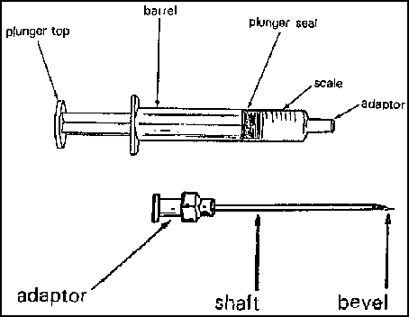
Types of dental syringes:
- Non-disposable:
- Breech – loading cartridge syringe:
**The term Breech loading involves that the cartridge is inserted into the barrel from the side.
The first type is
- Breech loading , metallic (autoclavable) or plastic (disposable):
Cartridge type aspirating , non-aspirating cartridges are no longer being used in dentistry

And the second type
- Breech loading metallic:
Cartridge type self-aspirating, much more complex and expensive than aspirating. Depends on the rebound , it uses the elasticity of the rubber diaphragm in the cartridge to obtain the required negative pressure alone, the diaphragm rest on metal projection inside the syringe that direct the needle into the cartridge, in other words it builds up it’s own negative pressure.

When we want to do a nerve block we must do aspiration before, if we used the primitive needle and applied negative versus positive pressure(take blood into the cartridge) and had blood in the cartridge we stop and change the place of the needle if no blood was seen we continue and give the L.A, technology provided us with self-aspirating needle , this needle know by itself if it is in a pore of a vessel or if it is in the right place)
Some short people face problems with aspirating needle as it is all about using the thumb rest and thumb so they can use the self-aspirating.

- Top-loading cartridge syringe:
You break a joint and insert the cartridge, the cartridge is inserted into the barrel from the end opposite to the needle hub.

- More info about the Aspirating syringe type:
- Has a device named harpoon (check the drawing in the next page) which is attached to the end of the piston (plunger) & is used to penetrate the thick stopper of the cartridge. The other side of the cartridge is called the Aluminum cap diaphragm that goes towards the side with the needle.
- Positive pressure applied to the piston, to force the needle through the tissue or the local anesthetic into the needle lumen.
- Negative pressure will force the blood from the blood vessel into the needle lumen then it will appear the cartridge.
- First you have to do a small positive pressure then a negative one to check if you’re inside a blood vessel.
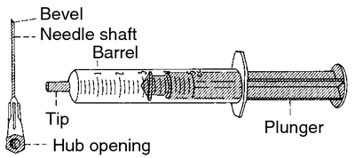
harpoon

- Pressure syringes:
Needs more pressure.
It’s size used to be large but know small.
they completely enclose the glass cartridge there by protecting the patient from cartridge shutters (Because there is excess pressure high chance for fracture)
They may be required for use only for PDL injections or intra legamental anesthesia.
3)disposable syringes :
For irrigation, taking blood or iv.
Sometimes you don’t have a syringe and u need to administer local…U can do it with them….the local anesthetic solution is in a box with a certain concentration you withdraw a certain volume using this syringe (try to match the conc. With the vol.) and then administer it.
Safety plus = ultra-safety plus syringes (as in the picture below)…very expensive…more complex…their special characteristic is that the moment you finish injection and then bring it outside the patient mouth…it’ll close automatically or it has plunger on the side held by your finger>>>so that when u finish, u release ur finger and the plunger closes on. Needle sheathed and ready for use. Mostly, it’s diposable.
SO they don’t have needle stick injury.
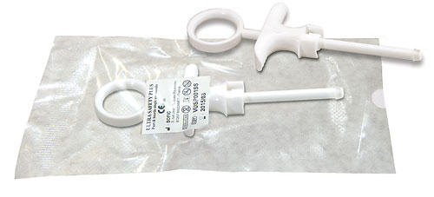
-Jet injector syringe = Jault injector = for patients with phobia. Looks like a pencil (picture below). Administers local through holes (just like the springers used in agriculture). No needle. By Exerting pressure against tissues + the holes>> this will push the local inside. Better than topical but step before needle… u need to exert more jault (pressure) on a certain area.
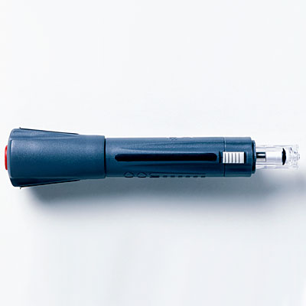

*ADA criteria for syringes:
-Durable, & tolerate sterilization unless they are disposable.
-They should load a variety of carpules and needles
-They should be unexpensive.
-Lightweight & simple use with one hand.
-They should provide for effective aspiration.

Beware sometimes needles are bent and wouldn’t enter properly into the diaphragm..and then u come and apply excessive pressure and thus breaking the carpule…happens a lot.

Needles:
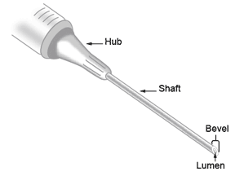
3 parts: Bevel – shank – hub.
Bevel has a wide knowledge behind it…manufacturers actually have many ideas of cross sections and sizes of bevels…and it’s the part that penetrates tissues so they need to modify it in a way to be most comfortable and least invasive.
Shank is related to length of needle (from bevel to hub) & it forms the diameter and gauge (gauge: diameter of internal lumen of the needle & its reversibly related to number) So 30 G and 25G >>> 25G is larger….
In infiltration use short needles & in blocks use long needles.
Size of the face is important when administering local anesthesia because in certain cases the patient might get diplopia and blurred vision but its temporary and reversible and the patient will panic.
Hub: which will be set over the adapter. Never ever reach the hub during administering the local anesthesia because if u reach the hub, the needle will break or get a deflection. Hub is the weakest portion of the needle.
Short needle in 20’s & long needle in 30’s.
-Advantage of a smaller gauge 25 over 27g or 30g (smaller over larger):
25 is larger so less deflection, greater accuracy, less chance of needle breakage (as it gets thinner, it will break easier), easy aspiration.
No difference in patient comfort whether using 25g or 30g…so we prefer to use 25g for the mentioned advantages.
If I want to make many pierces (injections), change the needle so that u don’t dull the needle.( & thus u don’t cause trauma).
Ultra short 10g….long 32g…avg 25g.
If there’s resistance, don’t press against resistance; otherwise, needle will break in the tissues. If it got broken and one side is visible, you bring forceps (couldn’t understand which type) and bring it out…if not visible,& refer the case to a maxillofacial surgeon. Or take (take 2 x-rays) and refer the case to a maxillofacial surgeon.
Carpules’ parts:
- Rubber punge.
- Glass or plastic cylinder.
- Diaphragm
- Metal cap
Beware of putting the carpule in the syringe upside down.
Constituents of carpule are important!
Question: why they used to heat carpule before? (dr said go find out the answer from the book).

Prepared by:
Tareq Al Amad
Anas Taee

